ASSESSOR GUIDE

FNSTPB412

**Establish and maintain payroll systems**

**Assessment 2 of 3**

Project



**Tax Practitioners Board (TPB) BAS agent registration**

In Australia, if you want to provide BAS services for a fee or other reward, you must be registered with the Tax Practitioners Board (TPB).

To become a registered BAS agent, you must satisfy specific qualifications and experience requirements set out in the Tax Agent Services Regulations 2022 (TASR).

You may apply to register as a BAS agent through one of two options outlined in the TASR (item 101 or 102), depending on your experience.

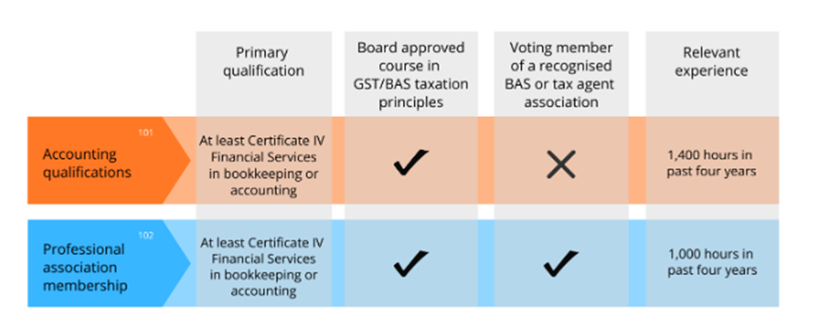

**Summary of qualifications and experience requirements**

* Item 101 - Accounting qualifications
  + A Certificate IV Financial Services (or a higher award) in bookkeeping or accounting from a registered training organisation or an equivalent institution
  + Board approved course in basic GST/BAS taxation principles (GST/BAS course)
  + 1,400 hours of relevant experience in the past four years.
* Item 102 - Professional association membership
  + A Certificate IV Financial Services (or a higher award) in bookkeeping or accounting from a registered training organisation or an equivalent institution
  + Board approved course in basic GST/BAS taxation principles (GST/BAS course)
  + A voting member of a recognised BAS or tax agent association
  + 1,000 hours of relevant experience in the past four years.

**What are board approved courses?**

Board approved courses are nationally recognised units that have been approved by the Tax Practitioners Board (TPB) for registration purposes.

FNSTPB411 - Complete business activity and instalment activity statements, and FNSTPB412 - Establish and maintain payroll systems are included in this FNS40222 Certificate IV in accounting and bookkeeping qualification. Together they meet the TPB approved course in basic GST/BAS taxation principles (GST/BAS course) academic requirements for registration as a BAS agent.

More information on [BAS agent registration](https://www.tpb.gov.au/qualifications-and-experience-bas-agents) can be found on the TPB website.

**Education requirements of the Tax Practitioners Board (TPB)**

This assessment is designed to meet the education requirements of the Tax Practitioners Board (TPB), which stipulates that a significant amount (at least 40%) of the assessment must be completed under some form of independent supervision.

Tasks that must be completed under independent supervision are:

* Task 4d
* Task 4e
* Task 4f
* Task 4g
* Task 4h

Please refer to the additional independent supervision instructions.

**Assessment Instructions**

**Task overview**

For this assessment, you are required to establish the payroll requirements and configure a MYOB file for OZ Office Supplies. Whilst doing this, you must demonstrate your ability to comply with legal and regulatory requirements and OZ Office Supplies policy and procedures.

**Resources and Equipment Required:**

* Access to learning materials on the learning portal
* Access to a computer, the internet and email
* Access to a suitable simulated computer workstation environment
* Access to Microsoft Word
* Access to MYOB
* Photo, audio, and video recording equipment (e.g. phone, camera, etc.)
* Basic calculator (handheld or on a computer)
* Webcam and headset (for watching/listening to videos, webinars etc.)

This assessment task is divided into five (5) tasks. Some tasks have multiple parts. Read each assessment task carefully before typing your response in the space provided or attempting the task in MYOB.

**Additional resources and supporting documents**

To complete this assessment, you will need:

* Company & Payroll Information
* Payroll Policy & Procedures (from Assessment 1)
* Chart of Accounts
* Employee Information
* Time Sheet Summary May 20YY
* Email Template
* ATO Weekly Tax table for the current financial year(If you are completing this assessment in July 2024, you will need to access the Weekly tax tables that apply from 1 July 2024.

<https://www.ato.gov.au/tax-rates-and-codes/tax-tables-overview>

**Dates used to complete the assessment in MYOB.**

Ensure that all transactions are recorded in MYOB for the financial year corresponding with the year in which you complete the assessment unless instructed otherwise.

*For example, if you complete this assessment in July 2024, the financial year is 1 July 2024 – 30 June 2025. Therefore, you must enter transactions for this financial year unless otherwise specified.*

* The financial year notations used in all provided instructions and templates are:
  + - 20YY: The current financial year
    - 20YY plus 1 or 20YY + 1: One year after the current financial year

**Assessment Information**

**Submission**

You are entitled to three (3) attempts to complete this assessment satisfactorily. Incomplete assessments will not be marked and will count as one of your three attempts.

All questions must be responded to correctly to be assessed as satisfactory for this assessment.

Answers must be typed into the space provided and submitted electronically via the LMS. Hand-written assessments will not be accepted unless previously arranged with your assessor.

**Reasonable adjustment**

Students may request a reasonable adjustment for assessment tasks.

Reasonable adjustment usually involves varying:

* the processes for conducting the assessment (e.g. allowing additional time)
* the evidence gathering techniques (e.g. oral rather than written questioning, use of a scribe, modifications to equipment)

However, the evidence collected must allow the student to demonstrate all requirements of the unit.

Refer to the Student Handbook or contact your Trainer for further information.



 Please consider the environment before printing this assessment.

**Assessment Summary**

For this assessment, you are required to establish the payroll requirements and configure a MYOB file using the company and employee data for OZ Office Supplies. Throughout the assessment, you must demonstrate your ability to comply with legal and regulatory requirements and OZ Office Supplies policy and procedures.

**Resources and Equipment Required:**

* Access to learning materials on the learning portal
* Access to a computer, the internet and email
* Access to Microsoft Word
* Access to a six-month trial version of MYOB Business Essentials™
* OZ Office Supplies Chart of Accounts
* OZ Office Supplies Company & Payroll Information
* OZ Office Supplies Payroll Policy & Procedures
  + - OZ Office Supplies Employee Information
    - OZ Office Supplies Time Sheet Summary May 20YY
    - OZ Office Supplies Email Template
    - ATO Weekly Tax table for the current financial year(If you are completing this assessment in July 2024, you will need to access the Weekly tax tables that apply from 1 July 2024.

<https://www.ato.gov.au/tax-rates-and-codes/tax-tables-overview>

OZ Office Supplies is a new company that commenced trading on 01 May 20YY. They have engaged you as their payroll officer to set up and manage their payroll system using the cloud-based accounting software package MYOB Business Essentials™.

For this assessment, you will assume the role of Kelly James. You are a registered business activity statement (BAS) agent with the Tax Practitioners Board (TPB) and have experience working with similar businesses. Your experience includes:

* providing payroll services that a BAS agent can provide
* knowledge of legislation about National Employment Standards (NES) and legislative requirements regarding payroll payments
* knowledge of state and modern awards and employment agreements.

**Background Information**

OZ Office Supplies Pty Ltd is a retail stationery goods business. The company sells and distributes office supplies across Australia from a retail outlet store and warehouse.

They have employed five staff:

* A manager
* An office administrator
* A NSW sales representative
* A merchandiser
* A warehouse store person.

OZ Office Supplies will pay their staff weekly, with the first pay period being Monday, 22 May 20YY, to Sunday, 28 May 20YY. Wages are paid on a Monday for the previous week.

To assist you in setting up the new payroll system and paying the wages for the week ending 29 May 20YY, you have been provided with the following additional information:

* Company & Payroll Information
* Payroll Policy & Procedures (retained from Assessment 1)
* Chart of Accounts
* Employee Information
* Time Sheet Summary May 20YY
* Email Template
* ATO Weekly Tax table for the current financial year(If you are completing this assessment in July 2024, you will need to access the Weekly tax tables that apply from 1 July 2024.

<https://www.ato.gov.au/tax-rates-and-codes/tax-tables-overview>

Review OZ Office Supplies company and employee information. You will need to use this information when setting up the payroll system. Also, review OZ Office Supplies Payroll Policy and Procedures. These must be considered and followed throughout this assessment.

**Task 1**

For this assessment task, you must research and identify the scope of services you can provide in your role as the Payroll Officer.

1. Describe the scope of payroll services that a BAS agent can provide. Include a link to the websites you used in your research.

[Approximate word count: 180 words]

1. Describe the circumstances where a payroll service provider does not need to register as a Tax or BAS Agent. Include a link to the websites you used in your research.

[Approximate word count: 170 words]

**MARKING GUIDE**

The candidate must:

1. Describe the scope of payroll services that a BAS agent can provide and include a link to the websites they used in their research.
2. Describe the circumstances where a payroll service provider does not need to register as a Tax or BAS Agent and include a link to the website they used in their research.

|  |  |
| --- | --- |
| Scope of payroll services that a BAS Agent can provide.  (Approximate word count: 180 words) | The candidates’ responses **must cover** the following points.  BAS agents can:   * Apply to the Registrar for an ABN on behalf of a client. * Code transactions, tax invoices and transferring data onto a computer program for clients through processes that require interpreting or applying a BAS provision. * Confirm figures to be included on a client’s activity statement. * Complete activity statements on behalf of an entity or instruct the entity which figures to include. * Provide advice about or confirm the withholding tax obligations for a client's employees. * Provide services declared BAS services through a legislative instrument issued by the TPB. * Prepare and provide an income statement that may include reportable fringe benefits amounts and the reportable employer superannuation contributions. * Register or provide advice on registration for GST or PAYG withholding. * Provide services under the Superannuation Guarantee (Administration) Act 1992 to the extent that they relate to a payroll function or payments to contractors. * Advice about a SGC liability, including calculating the liability and preparing the SGC statement. * Advice about the offsetting of late payments of superannuation contributions against the SGC.   [BAS Agents | TPB](https://www.tpb.gov.au/bas-agents) |
| Circumstances where a payroll service provider does not need to register as a Tax or BAS Agent.  (Approximate word count: 170 words) | The candidates’ responses **must cover** the following points.  A payroll service provider does not need to register as a Tax Agent or BAS Agent if:   * The services provided are considered to be ‘in-house services. This includes arrangements where there may be a cost recovery and/or shared services arrangement in place for the provision of the services by entities regarded as in-house service providers. * The services are not provided for a fee or other reward. * The services provided do not meet the tax agent service definition (including BAS service). Such services include, for example: -   + data entry, providing the data entry does not require the interpretation or application of a taxation law   + coding of transactions based on instructions provided   + processing of payments   + the transmission of data to the Commissioner through Standard Business Reporting (SBR) enabled software, providing the data transmission does not require the interpretation or application of a taxation law,   + preparing bank reconciliations   + determining State/Territory obligations or entitlements (including payroll tax and WorkCover).   [Bookkeeper vs BAS Agent (icb.org.au)](https://www.icb.org.au/BAS-and-BAS-Agents/What-is-a-BAS-Agent/Bookkeeper-vs-BAS-Agent) |

**Task 2**

For this assessment task, you must locate and record the details of two local experts who could assist you if you need help setting up and processing the OZ Office Supplies payroll. Provide the names of the individuals or companies, their contact details, and the services they provide. The local experts must be located in the state you currently reside.

[Approximate word count: 180 words]

**MARKING GUIDE**

The candidate must provide the details of two local experts in the state they reside in who could help them if assistance was required with payroll services. For example, candidates could identify certified MYOB consultants at the following link, and according to the area they are located in,[Enterprise Partners | MYOB Australia](https://www.myob.com/au/enterprise/resources/partners). The person or organisation listed by the candidate must have payroll expertise.

A sample answer is provided below.

|  |
| --- |
| Two local experts who could contact to assist you in setting up and processing payroll in your state. |
| **The BookSitters**  The BookSitters Head Office  Units 1 & 2 / 94 Main St, Mittagong NSW 2575  Office Phone: 02 4861 4572  [Experts in MYOB Essentials - The BookSitters - % MYOB Essentials](https://www.thebooksitters.com.au/myob-essentials/)  The BookSitters bookkeeping services bring together more than 20 years of bookkeeping experience and over 25 years of business experience. As Silver MYOB bookkeeping partners, they have been using the software for over 15 years.  Their services include:   * Bookkeeping software set up * Payroll * BAS agent services   Candidates could also search the TPB register, which contains the registration details of tax and BAS agents within a 25 km distance. [BAS Agents | TPB](https://www.tpb.gov.au/bas-agents)  **CTM**  CT Matters  SYDNEY  02 9362 0804  info@ctmatters.com.au **Certified MYOB consultant & partner** CTMatters can help set up and support MYOB software. Their services include:   * Single Touch Payroll software, * onboarding new employees * managing payroll * setting up rostering and employee timesheets. |

**Task 3**

1. Name and explain the legislation that covers notice of termination and final pay for Australian workers. (Include the division, part and chapter)

[Approximate word count: 50 words]

**MARKING GUIDE**

1. Candidates' responses will likely include different wording than the sample answers provided. However, the acceptable responses must:

•be within the specified word limit

•reflect the exemplar answers below.

1. Access the Fair Work Ombudsman website and identify how much notice OZ Office Supplies’ employees must be given if their employment is to be terminated.

[Approximate word count: 70 words]

**MARKING GUIDE**

1. Candidates' responses must match the sample answer below.
2. Outline OZ Office Supplies' obligations to the terminated employee if OZ Office Supplies decides to pay the employee out rather than let them work out their notice period.

[Approximate word count: 75 words]

**MARKING GUIDE**

1. Candidates' responses will likely include different wording than the sample answers provided. However, the acceptable responses must:

•be within the specified word limit

•reflect the exemplar answers below.

1. Explain OZ Office Supplies' review procedure for termination payments before paying the employee their final pay.

[Approximate word count: 220 words]

**MARKING GUIDE**

1. Candidates' responses will likely include different wording than the sample answers provided. However, the acceptable responses must:

•be within the specified word limit

•reflect the exemplar answers below.

|  |
| --- |
| a. Name and explain the legislation that covers notice of termination and final pay for Australian workers. |
| Division 11 of Part 2-2 of Chapter 2 of the *Fair Work Act 2009* covers termination of employment.  The legislation lists the grounds on which an employee can or cannot have their employment terminated and the process by which termination can be disputed. |
| 1. Identify how much notice OZ Office Supplies’ employees must be given if their employment is to be terminated. |
| |  |  | | --- | --- | | Period of continuous service | Minimum notice period | | 1 year or less | 1 week | | More than 1 year - 3 years | 2 weeks | | More than 3 years - 5 years | 3 weeks | | More than 5 years | 4 weeks |     An employee has to get an extra week of notice if they’re over 45 years old and have worked for the employer for at least two years.  [Notice of termination & redundancy pay - Fair Work Ombudsman](https://www.fairwork.gov.au/tools-and-resources/fact-sheets/minimum-workplace-entitlements/notice-of-termination-and-redundancy-pay#notice-of-termination) |
| 1. OZ Office Supplies' obligations to the terminated employee if OZ Office Supplies decides to pay the employee out rather than let them work out their notice period. |
| If the employer pays out the notice, the amount paid to the employee must equal the total amount the employee would have been paid if they worked until the end of the notice period. This includes:   * incentive-based payments and bonuses * loadings * monetary allowances * overtime * penalty rates * any other separately identifiable amounts.   If the employer pays out the notice, the employee does not accrue any annual leave for the notice period they were paid out for.  [Notice of termination & redundancy pay - Fair Work Ombudsman](https://www.fairwork.gov.au/tools-and-resources/fact-sheets/minimum-workplace-entitlements/notice-of-termination-and-redundancy-pay#notice-of-termination) |
| 1. OZ Office Supplies review procedure for termination payments before paying the employee their final pay |
| All termination payments above $1,500.00 must be reviewed and evaluated by the Finance Manager. The process for reviewing termination payments is as follows:   1. Gather necessary documentation: The Finance Manager must be provided with all relevant documentation related to the termination payment, including the employee's contract, relevant company policies, and documentation related to the termination itself, such as a termination letter or severance agreement. 2. Review the termination payment: The Finance Manager should thoroughly review the payment to ensure it complies with all applicable laws and regulations and OZ Office Supplies policies and procedures. This may involve reviewing calculations to ensure the payment amount is accurate, verifying that the payment is being made for a valid reason, and ensuring that any tax implications have been adequately accounted for. 3. Provide recommendations: Based on the Finance Manager's evaluation, they should provide recommendations for any necessary changes or corrections to the termination payment. This may involve communicating with the relevant parties, such as the payroll office or legal counsel, to ensure that any necessary adjustments are made before the payment is processed. 4. Final approval: Once any necessary changes have been made, the Finance Manager should provide final approval for the termination payment to be processed. This involves signing off on the payment documentation. |

**Task 4**

This assessment is designed to meet the education requirements of the Tax Practitioners Board (TPB), which stipulates that a significant amount (at least 40%) of the assessment must be completed under some form of independent supervision. Tasks that must be completed under independent supervision are:

* Task 4d
* Task 4e
* Task 4f
* Task 4g
* Task 4h

For this task, you must set up a MYOB Business Essentials™ online file for OZ Office Supplies.

To complete this task, you must undertake the following steps:

**Task 4a**

Download a copy of the following information provided by OZ Office Supplies:

* OZ Office Supplies Payroll Policy and Procedures
* OZ Office Supplies Employee Information

You must refer to these documents throughout this assessment.

**Guidance to Assessors About This Task**

This task is designed to ensure candidates can demonstrate the ability to configure a payroll system with data provided by an employer. To complete this task, candidates must use the payroll functionality in MYOB Business Essentials™ and refer to OZ Office Supplies Policies and Procedures and Employee Information.

The candidate is to assume the role of the payroll officer for OZ Office Supplies. They are provided with the following documents, which they must refer to assist them in configuring the payroll system.

* OZ Office Supplies Payroll Policy and Procedures. The purpose of this document is to provide Candidates with the OZ Office Supplies procedure for processing payroll and their record-keeping and security requirements. It also outlines how payroll discrepancies are addressed.
* OZ Office Supplies Employee Information. The purpose of this document is to provide Candidates with the personal and payroll information for OZ Office Supplies' five staff. This information will be used to set up the employee card.

**Task 4b**

Refresh your learning in the LMS on how to set up payroll in MYOB Business

**Guidance to Assessors About This Task**

Candidates must have a good understanding of how to set up payroll in MYOB Business. They are encouraged to refresh their learning in the LMS before starting the setup. Tasks 4d – 4h are designed to meet the education requirements of the Tax Practitioners Board (TPB) and must be completed under independent supervision.

**Task 4c**

To complete this assessment, you will need to configure a MYOB File.

Follow the instructions below to set up a file for OZ Office Supplies using MYOB Business.

Use the email address you use to access your Swinburne Open Education course, and when asked, ‘What is your role in the business?’ select ‘Student or teacher’.

**Step 1**

Go To <https://www.myob.com/au/campaign/education-trial> and select ‘Get started.’

**Step 2**

Enter the email address you use to access your Swinburne Open Education course.

**Step 3**

Add your first name, last name, and phone number and set your password.

**Step 4**

Access the MYOB software.

**Step 5**

Add the ABN 26 0086 721 79 and select next.

**Step 6**

* Check your business name is correct (OZ Office Supplies)
* Tick **Yes,** the business is registered for GST
* From the drop-down menu, select **Company** as the business type.

**Step 7**

* From the drop-down menu, select **Retail** for your business's industry
* Select **Student or teacher** as your role in the business
* Select **Yes,** the business has employees.

Once you have done this, select **Finish set up**. You will then be redirected to the MYOB dashboard.

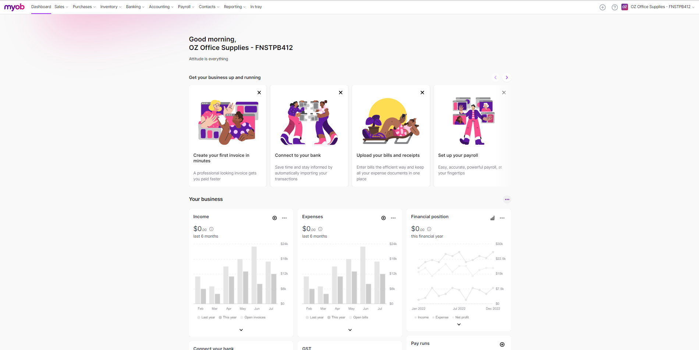

**Step 8**

Select the Accounting tab, and from the drop-down menu, select **Chart of accounts**.

And then, select **Import chart of accounts**.

Import the OZ Office Supplies Chart of Accounts

You will receive an email from MYOB once your file has been imported.

**Step 9**

Configure business details.

In the top right-hand corner, click on the business name. From the drop-down menu, select Business settings.

Use the company information in FNSTPB412_02_Project_Company&PayrollInformation to update:

* Business details
* Industry details
* Contact details
* Financial year details

Once you have completed the setup, use the snipping tool to capture a screenshot of the business settings. Paste the screenshots into the table below.

|  |
| --- |
| Business details |
| MARKING GUIDE  The Candidate submission **must agree** with the sample answer below.   |
| Industry details |
| MARKING GUIDE  The Candidate submission **must agree** with the sample answer below.   |
| Contact details |
| MARKING GUIDE  The Candidate submission **must agree** with the sample answer below.   |
| Financial year details |
| MARKING GUIDE  The Candidate submission must reflect the current financial year. For example, if they are completing this assessment in July 2024, the screenshot provided by the student will show:   * Current financial year – 2025 * Last month of financial year – June * Financial Year 1 July 2024 to 30 June 2025 * Opening balance date – May 2025 * Cannot record transactions before 1 May 2025. |

**Task 4d contributes to the education requirements of the Tax Practitioners Board (TPB), Board approved course in basic GST/BAS taxation principles and must be completed under independent supervision. Please refer to the additional independent supervision instructions.**

**Task 4d**

Using the background information for OZ Office Supplies (provided at the beginning of this assessment document) and the company and payroll information provided in FNSTPB412_02_Project_Company&PayrollInformation, complete the following:

* Configure the payroll settings
* Link the payroll accounts. Use Kelly James and [payroll@ozofficesupplies.com.au](mailto:payroll@ozofficesupplies.com.au) as the email settings for all emails sent on your behalf from MYOB. This includes invoices, quotes and payslips (payroll).

Once you have completed the setup, use the snipping tool to capture a screenshot of the following payroll settings:

* General payroll information
* Superannuation funds
* Pay slip email defaults

and Linked Account details. Paste the screenshots into the table below.

**Assessor Instructions**

**Payroll Settings**

The candidate must select ‘Payroll settings’ from the drop-down menu next to the company name. Under the payroll settings tab, the candidate needs to populate the following templates.

* General payroll information
  + Details
  + Timesheets
* Superannuation funds
* Employment classification
* Payslip email defaults
  + Email settings

The information below has been provided to the candidate in FNSTPB412_02_Project_Company&PayrollInformation

**Details**

The default Full–time employee weekly hours are set at 38.

The tax tables revision date, which shows the current tax tables used in payroll, is automatically updated by MYOB. **Assessor, please note:** Tax rates are updated periodically, and any updates to the tax tables will affect the sample answers provided.

**Superannuation funds**

The default superannuation fund for OZ Office Supplies is AMP MYLIFE MYSUPER. The Candidate will need to set this up. To do this, they need to select ‘create superannuation fund’. The Candidate must select AMP MYLIFE MYSUPER from the fund name drop-down menu. The Name, SPIN/USI and Fund ABN will be prepopulated. The Candidate must add the Employer membership number – 1234567. After adding the superannuation fund, Candidates must select this as the default superannuation fund.

**Timesheets**

OZ Office Supplies employees do not use timesheets to track employees' hours. When the Candidate is required to enter payroll data, they will be provided with a weekly summary of each employee’s hours and any leave they have taken. The payroll week starts on a Monday.

The information below has been provided to the Candidate in the company and payroll information.

**Employment classifications**

The employment classifications are award classifications assigned to employees in the employee card. MYOB contains construction employment classifications by default. Candidates do not need to change these until later in the assessment when they enter employee information into MYOB.

**Payslip email defaults**

Payslips are emailed. The email includes a default email message. The Candidate must include a subject relevant to payroll.

|  |
| --- |
| Payroll Settings:  **MARKING GUIDE**  The Candidate submission **must agree** with the sample answers below. |
| **General Payroll Information** |
|  |
| **Superannuation Fund Details** |
|  |
| Payslip email defaults |
|  |

**Linking the payroll accounts**

Under the ‘Accounting’ tab, the Candidate must select ‘Manage linked accounts’ from the drop-down menu and navigate to the ‘Payroll’ tab. The Candidate must check and update the required accounts for processing payroll with the information provided in the company and payroll information. (See below)

**MARKING GUIDE**

The Candidate submission **must match** with the sample answer below.

|  |
| --- |
| Linked Payroll Accounts: |
|  |

**Task 4e Contributes to the education requirements of the Tax Practitioners Board (TPB), Board approved course in basic GST/BAS taxation principles and must be completed under independent supervision. Please refer to the additional independent supervision instructions.**

**Task 4e**

Research and familiarise yourself with the relevant state and modern awards OZ Office Supplies employees are paid under. Create a profile for each employee using the information provided in the relevant award and the FNSTPB412_02_Project_EmployeeInformation

**Assessor Instructions**

To create a new employee, the Candidate must go to the payroll menu, choose ‘Employees’ from the drop-down menu, and click ‘Create employee’. The Employee self-onboarding will appear. Candidates must skip this and add the employee details for the five employees.

The table below lists the details that **must** be entered on each tab. This information is provided to the Candidate in FNSTPB412_02_Project_EmployeeInformation

**OZ Office Supplies Pty Ltd**

**Employee Information**

|  |  |  |  |  |  |
| --- | --- | --- | --- | --- | --- |
|  | **Employee 1** | **Employee 2** | **Employee 3** | **Employee 4** | **Employee 5** |
| Last name | Anderson | Xing | Cox | Alvarado* | Ritson |
| First name | Alex | Ben | Kris | Taylor | Codie |
| Employee Card ID | OZOS0-1 | OZOS0-2 | OZOS0-3 | OZOS0-4 | OZOS0-5 |
| Address | 5 Sydney Way | 2 Karawang Street | 5 Knight Street | 2 Grevillea Street | 4 Chapman Avenue |
| City | Sydney | Sydney | Sydney | Eastern Creek | Leura |
| State | NSW | NSW | NSW | NSW | NSW |
| Postcode | 2000 | 2000 | 2000 | 2766 | 2780 |
| Email | alexa@gmail.com | ben.xing@outlook.com | Kriscox1993@hotmail.com | tsalvarado146@gmail.com | codieritson11@hotmail.com |
| Phone | 0427 282 989 | 0412 345 989 | 0487 342 898 | 0401 809 093 | 0431 949 141 |
| Position | Manager | Office Administrator | Sales Representative | Merchandiser | Warehouse Storeperson |
| Award Classification | General Retail Industry Award [MA000004]  [General Retail Industry Award [MA000004] - Fair Work Ombudsman](https://www.fairwork.gov.au/employment-conditions/awards/awards-summary/ma000004-summary) | General Retail Industry Award [MA000004] Retail Employee Level 2  [General Retail Industry Award [MA000004] - Fair Work Ombudsman](https://www.fairwork.gov.au/employment-conditions/awards/awards-summary/ma000004-summary) | Commercial Sales Award [MA000083] – Commercial Traveller  [Commercial Sales Award [MA000083] - Fair Work Ombudsman](https://www.fairwork.gov.au/employment-conditions/awards/awards-summary/ma000083-summary) | Commercial Sales Award [MA000083] - Merchandiser  [Commercial Sales Award [MA000083] - Fair Work Ombudsman](https://www.fairwork.gov.au/employment-conditions/awards/awards-summary/ma000083-summary) | Storage Services and Wholesale Award [MA000084] Storeworker grade 3.  [Storage Services and Wholesale Award [MA000084] - Fair Work Ombudsman](https://www.fairwork.gov.au/employment-conditions/awards/awards-summary/ma000084-summary) |
| DOB | 20/5/1972 | 19/4/1982 | 19/5/1993 | 24/01/1999 | 26/3/1995 |
| Gender | Female | Male | Female | Unspecified | Male |
| TFN | 111 111 111  Please note all employees would have an individual TFR. However, for this MYOB exercise, they need to be the same. | 111 111 111  Please note all employees would have an individual TFR. However, for this MYOB exercise, they need to be the same. | 111 111 111  Please note all employees would have an individual TFR. However, for this MYOB exercise, they need to be the same. | 111 111 111  Please note all employees would have an individual TFR. However, for this MYOB exercise, they need to be the same. | 111 111 111  Please note all employees would have an individual TFR. However, for this MYOB exercise, they need to be the same. |
| TFN Status | Has provided TFN | Has provided TFN | Has provided TFN | Has provided TFN | Has provided TFN |
| Residency status | Australian Resident for tax purposes | Australian Resident for tax purposes | Australian Resident for tax purposes | Non-resident for tax purposes in Australia (417 Working Holiday visa) from Brazil | Australian Resident for tax purposes |
| Tax detail | Tax-free threshold | Tax-free threshold and Student Loan | No Tax-Free Threshold | Foreign Resident | Tax-free threshold |
| Tax rebates per year | $1,655.00 | N/A | N/A | N/A | N/A |
| Extra Tax per Pay | N/A | $70.00 | N/A | N/A | N/A |
| Start Date | 22 May 20YY | 22 May 20YY | 22 May 20YY | 22 May 20YY | 22 May 20YY |
| Employment Basis | Permanent  Full - Time | Permanent  Full - Time | Temporary  Casual | Temporary  Part-Time | Permanent  Full - Time |
| Salary Package | Salary - $80,000.00 per year  Annual Leave  Personal Leave  Annual Leave Loading  First Aid Allowance $12.23 per week | Salary – $47,257.60 per year  Annual Leave  Personal Leave  Annual Leave Loading | Hourly pay rate  Mon – Fri: $31.05  Sat Rate: $43.47  Sun Rate: $55.89  Commission  Uniform Allowance: $3.75 per week based on 3 days. | Hourly pay rate  Mon – Fri: $23.10 (ordinary hrs of work)  Sat Rate: $34.65 (overtime rate)  Sun Rate: $46.20 (overtime rate)  Per KM Travel Allowance: 0.91 per km  Uniform Allowance: $6.25 per week based on 5 days.  Annual Leave  Personal Leave  Annual Leave Loading | Salary - $47,788.00 per year  Annual Leave  Personal Leave  Annual Leave Loading  First Aid Allowance $14.19 per week |
| Superfund | AMP MYLIFE MYSUPER | AMP MYLIFE MYSUPER | AMP MYLIFE MYSUPER | MERCER EASY SUPER | REST INDUSTRY SUPER |
| Super membership No. | 012 002 | 012 876 | 012 855 | 442 324 | 998 345 |
| Super category | Superannuation Guarantee  on Ordinary Times Earnings (OTE) and First Aid Allowance | Superannuation Guarantee  on Ordinary Times Earnings (OTE)  $50 per week Salary Sacrifice Super | Superannuation Guarantee  on Ordinary Times Earnings (OTE) + Commission | Superannuation Guarantee  on Ordinary Times Earnings (OTE) | Superannuation Guarantee  on Ordinary Times Earnings (OTE) and First Aid Allowance |
| Entitlements category | Annual Leave  Personal Leave | Annual Leave  Personal Leave | N/A | Annual Leave  Personal Leave | Annual Leave  Personal Leave |
| Union fees | 10.00 p/w - Deduction | 10.00 p/w - Deduction | N/A | 10.00 p/w - Deduction | 10.00 p/w - Deduction |
| Payment method | Electronic | Electronic | Electronic | Electronic | Electronic |
| Bank a/c | BSB 111-111  A/C 226644  Alex Anderson ($200 each pay)  BSB 111-111  A/C 229876  A Anderson & G Anderson (balance of weekly payment) | BSB 222-222  A/C 336677  Ben Xing | BSB 111-000  A/C 334455  Kris Cox | BSB 123-000  A/C 9387775  TC and PL Alvarado | BSB 034-011  A/C 464719111  Codie Ritson ($150 each pay)  BSB 034-011  A/C 464717676  Codie Ritson (balance of weekly pay) |

* Taylor Alvarado is single with no dependents and holds a 417 Working Holiday visa. He does not have a STSL debt nor is he claiming a claiming a Medicare levy exemption or reduction
* Smart Books is not registered as an employer of WHMs.
* Smart Books must withhold tax at the foreign resident tax rates starting at 32.5%.

Assessor Additional information

* Taylor Alvarado’s personal leave must be set up as Personal leave Part-time hourly. 30hrs x 2 weeks = 60 hrs / 52 = 1.15384 hrs per pay period.

* Taylor Alvarado’s annual leave must be set up as Annual leave Part-time hourly. 30hrs x 4 weeks = 120 hrs / 52 = 2.30769 hrs per pay period. The leave balance must be shown on the payslip.

The hourly rate and allowance shown in the OZ Office Supplies Pty Ltd Employee Information are based on the 2024 FY awards. The students must use the award rates and allowances applicable to the current financial year.

**Task 4f contributes to the education requirements of the Tax Practitioners Board (TPB), Board approved course in basic GST/BAS taxation principles and must be completed under independent supervision. Please refer to the additional independent supervision instructions.**

**Task 4f**

Assign payroll items to employees’ cards to calculate their standard pay. When you have completed entering all the employee information, open the cards for each employee and check the information you have entered into MYOB for each employee is correct. This means it agrees with the employee information provided to you in FNSTPB412_02_Project_Employee Information. Edit any errors.

Use the snipping tool to capture a screenshot of each employee's standard pay and paste the screenshot into the table below.

**Marking Guide**

In MYOB, an employee’s pay components, such as wages, superannuation, leave, and taxes, are called pay items. Base Salary, Base Hourly, Annual Leave Pay, Personal Leave Pay, Annual Leave Loading, Superannuation Guarantee and PAYG are default pay items that have been set up. The Candidate must assign payroll items to each employee’s card to calculate their standard pay. They must also identify the additional pay items that need to be created and assign them to employees’ cards.

* Commission – Assigned to Kris Cox
* Union Fees – Assigned to Alex Anderson, Ben Xing, Taylor Alvarado and Codie Ritson
* Uniform Allowance – The uniform allowance is exempt from PAYG - Assigned to Kris Cox and Taylor Alvarado
* First Aid Allowance – First Aid Allowance is taxable as considered part of OTE and is not exempt from the superannuation calculation - Assigned to Alex Anderson and Codie Ritson.
* Personal Leave pay – Assigned to Alex Anderson, Ben Xing, Taylor Alvarado and Codie Ritson

Annual Leave Accrual Salary – Assigned to Alex Anderson, Ben Xing, Taylor Alvarado and Codie Ritson.

To finalise the payroll setup, the Candidate must open the cards for each employee and check the information they have entered into MYOB against the employee information provided in the FNSTPB412_02_Company & Payroll Information to make sure it is all correct.

|  |
| --- |
| Alex Anderson Standard Pay |
| MARKING GUIDE  The:   * Wages category * Deductions * Taxes * Leave * Expenses   in the candidate submission **must agree** with the sample answer below. However, the amounts are based on the 2024 award. These will vary based on the 20YY award the candidate uses.    Paid above award pay rate. |
| Ben Xing Standard Pay |
| The:   * Wages category * Deductions * Taxes * Leave * Expenses   in the candidate submission **must agree** with the sample answer below. However, the amounts are based on the 2024 award. These will vary based on the 20YY award the candidate uses.    A screenshot of a computer screen  Description automatically generated |
| Kris Cox Standard Pay |
| The:   * Wages category * Deductions * Taxes * Leave * Expenses   in the candidate submission **must agree** with the sample answer below. However, the amounts are based on the 2024 award. These will vary based on the 20YY award the candidate uses. |
|  |
| Taylor Alvarado Standard Pay |
| The:   * Wages category * Deductions * Taxes * Leave * Expenses   in the candidate submission **must agree** with the sample answer below. However, the amounts are based on the 2024 award. These will vary based on the 20YY award the candidate uses. |
|  |
| Codie Ritson Standard Pay |
| The:   * Wages category * Deductions * Taxes * Leave * Expenses   in the candidate submission **must agree** with the sample answer below. However, the amounts are based on the 2024 award. These will vary based on the 20YY award the candidate uses.    A screenshot of a computer  Description automatically generated  A screenshot of a computer screen  Description automatically generated |

**Task 4g Contributes to the education requirements of the Tax Practitioners Board (TPB), Board approved course in basic GST/BAS taxation principles and must be completed under independent supervision. Please refer to the additional independent supervision instructions.**

**Task 4g**

HR have sent you the timesheet summary report for 28 May 20YY.

**OZ Office Supplies Pty Ltd**

**Timesheet Summary 22/05/20YY – 28/05/20YY**

**Timesheet summary for the week ending 28 May 20YY**

|  |  |  |  |  |  |
| --- | --- | --- | --- | --- | --- |
| Employee Name | Alex Anderson | Ben Xing | Kris Cox | Taylor Alvarado | Codie Ritson |
| Ordinary Hours | Base Salary | Base Salary | Base Hourly   * Monday 8 hours * Tuesday 7 hours * Wednesday 8 hours | Base Hourly   * Tuesday 6 hours * Wednesday 6 hours * Thursday 6 hours * Friday 6 hours * Saturday 6 hours   135 kms travel allowance | Base Salary |
| Annual Leave | 0 | 0 | 0 | 0 | 0 |
| Annual Leave Loading | 0 | 0 | 0 | 0 | 0 |
| Personal Leave | 0 | 0 | 0 | 0 | 0 |
| Commission | N/A | N/A | $175.50 | N/A | N/A |
| First Aid Allowance | Yes |  |  |  | Yes |
| Uniform Allowance |  |  | $3.75 | $6.25 |  |
| Union Fees | $10.00 | $10.00 |  | $10.00 | $10.00 |
| Salary Sacrifice Super |  | $50.00 |  |  |  |

Using the information in the timesheet summary and the <https://www.ato.gov.au/tax-rates-and-codes/tax-tables-overview> or the [ATO tax withheld calculator](https://www.ato.gov.au/Calculators-and-tools/Host/?anchor=TWC&anchor=TWC/questions#TWC/report), manually calculate the payroll amount for each employee for the week ending 28 May 20YY in the manual payroll templates below.

**Marking Guide**

The Candidate must use the manual payroll template to calculate the payroll for each employee for the week ending 28 May 20YY. Once they have manually calculated the payroll, they must enter the payroll into MYOB and review the payroll data to confirm both sets of data agree. If the Candidate cannot identify and correct any discrepancies between the two sets of payroll data, they must contact you, the trainer, to discuss. Any errors made during the MYOB setup will be carried through to Assessment 3 if not corrected.

The candidate submission **must agree** with the sample answer below. However, the amounts are based on the 2024 award. These will vary based on the 20YY award the candidate uses.

|  |  |  |  |  |  |
| --- | --- | --- | --- | --- | --- |
| **Manual Payroll Template** | | | | | |
| Employee Name | Alex Anderson | | Week Ending | | 29 May 20YY |
| **Gross Wages** | | **Amount** | | **Earnings Subject to Super** | |
| Base Salary | | $1538.46 | | $161.54 | |
| Base Hourly | |  | |  | |
| Commission | |  | |  | |
| **Allowances** | |  | |  | |
| First Aid Allowance | | $12.23 | | $1.28 | |
| Uniform Allowance | |  | |  | |
| **Gross Earnings** | | **$1550.69** | |  | |
| **Less Deduction** | |  | |  | |
| Union Fees | | $10.00 | |  | |
| Salary Sacrifice Super | |  | |  | |
| PAYG | | $321.04 | |  | |
| **Net Wages** | | **$1219.65** | |  | |
| **Superannuation Calculation** | |  | |  | |
| **20YY Rate X Ordinary Time Earnings (OTE)** | | | | $1550.69 x 10.5% = $162.82 | |
| **Salary Sacrifice Super** | | | |  | |
| **Total Super** | | | | $162.82 | |
|  | | | | | |

**Assessor, please note** the PAYG is calculated using the weekly tax table and the [ATO ready reckoner](https://www.ato.gov.au/Rates/Weekly-tax-table/?anchor=readyreckoner#readyreckoner) to calculate the tax offsets. Manual PAYG calculation is $352.00 – ($30.00 +$1.00) = $321.00. (taking into account an annual tax rebate of $1655.00)

The sample answer is based on the 2024 award. This will vary based on the 20YY award the candidate uses.

|  |  |  |  |  |  |
| --- | --- | --- | --- | --- | --- |
| **Manual Payroll Template** | | | | | |
| Employee Name | Ben Xing | | Week Ending | | 29 May 20YY |
| **Gross Wages** | | **Amount** | | **Earnings Subject to Super** | |
| Base Salary | | $908.80 | | $95.42 | |
| Base Hourly | |  | |  | |
| Commission | |  | |  | |
| **Allowances** | |  | |  | |
| First Aid Allowance | |  | |  | |
| Uniform Allowance | |  | |  | |
| **Gross Earnings** | | **$908.80** | |  | |
| **Less Deduction** | |  | |  | |
| Union Fees | | $10.00 | |  | |
| Salary Sacrifice Super | | $50.00 | |  | |
| PAYG | | $183.00 | |  | |
| **Net Wages** | | **$665.80** | |  | |
| **Superannuation Calculation** | |  | |  | |
| **20YY Rate X Ordinary Time Earnings (OTE)** | | | | $908.80 x 10.5% = $95.42 | |
| **Salary Sacrifice Super** | | | | $50.00 | |
| **Total Super** | | | | $145.42 | |
|  | | | | | |

**Assessor, please note** the salary sacrifice super deduction is not taxed for PAYG purposes. PAYG is only calculated in the Gross Earnings less the Salary Sacrifice Super. Although Ben has a HELP debt, he does not earn above the compulsory repayment threshold, and therefore, OZ Office Supplies is not required to deduct a compulsory repayment amount. Manual PAYG calculation is $908.80 - $50.00 = $858.80. Ben has elected to have $70.00 additional tax deducted from his weekly salary. ($113.00 + $70 = $183.00)

The sample answer is based on the 2024 award. This will vary based on the 20YY award the candidate uses.

|  |  |  |  |  |  |
| --- | --- | --- | --- | --- | --- |
| **Manual Payroll Template** | | | | | |
| Employee Name | Kris Cox | | Week Ending | | 29 May 20YY |
| **Gross Wages** | | **Amount** | | **Earnings Subject to Super** | |
| Base Salary | |  | |  | |
| Base Hourly | | $714.15 | | $74.99 | |
| Commission | | $175.50 | | $18.43 | |
| **Allowances** | |  | |  | |
| First Aid Allowance | |  | |  | |
| Uniform Allowance | | $3.75 | |  | |
| **Gross Earnings** | | **$893.40** | |  | |
| **Less Deduction** | |  | |  | |
| Union Fees | |  | |  | |
| Salary Sacrifice Super | |  | |  | |
| PAYG | | $245.00 | |  | |
| **Net Wages** | | **$648.40** | |  | |
| **Superannuation Calculation** | |  | |  | |
| **20YY Rate X Ordinary Time Earnings (OTE)** | | | | $889.65 x 10.5% = $93.41 | |
| **Salary Sacrifice Super** | | | |  | |
| **Total Super** | | | | $93.41 | |
|  | | | | | |

**Assessor, please note uniform allowance is exempt from PAYG, and Kris Cox has not claimed the tax-free threshold.**

The sample answer is based on the 2024 award. This will vary based on the 20YY award the candidate uses.

|  |  |  |  |  |  |
| --- | --- | --- | --- | --- | --- |
| **Manual Payroll Template** | | | | | |
| Employee Name | Taylor Alvarado | | Week Ending | | 29 May 20YY |
| **Gross Wages** | | **Amount** | | **Earnings Subject to Super** | |
| Base Salary | |  | |  | |
| Base Hourly | | $554.40 | | $58.21 | |
| Saturday Rate | | $207.90 | |  | |
| Commission | |  | |  | |
| Per KM Travel Allowance | | $122.85 | |  | |
| **Allowances** | |  | |  | |
| First Aid Allowance | |  | |  | |
| Uniform Allowance | | $6.25 | |  | |
| **Gross Earnings** | | **$891.40** | |  | |
| **Less Deduction** | |  | |  | |
| Union Fees | | $10.00 | |  | |
| Salary Sacrifice Super | |  | |  | |
| PAYG | | $288.00 | |  | |
| **Net Wages** | | **$593,40** | |  | |
| **Superannuation Calculation** | |  | |  | |
| **20YY Rate X Ordinary Time Earnings (OTE)** | | | | $58.21 | |
| **Salary Sacrifice Super** | | | |  | |
| **Total Super** | | | | $58.21 | |
|  | | | | | |

Assessor, please note:

* Uniform allowance is exempt from PAYG.
* SG is not payable on per KM Travel Allowance.
* Working Holiday Makers on [subclass 417 Working Holiday Visa](https://visaenvoy.com/working-holiday-visa-subclass-417/) or [Subclass 462 Work and Holiday Visa](https://visaenvoy.com/work-and-holiday-visa-subclass-462/) are considered to be foreign residents for tax purposes. The following Tax rates will apply. [Individual income tax rates | Australian Taxation Office (ato.gov.au)](https://www.ato.gov.au/Rates/Individual-income-tax-rates/#Foreignresidents)
* The sample answer is based on the 2024 award. This will vary based on the 20YY award the candidate uses.

Based on the ATO’s Tax withheld for individuals calculator, the amount of tax payable is $332.00. Wages are rounded to the nearest dollar for this calculation.

[Report | Tax withheld for individuals calculator](https://www.ato.gov.au/Calculators-and-tools/Host/?anchor=TWC&anchor=TWC/questions#TWC/report)

The sample answer is based on the 2024 award. This will vary based on the 20YY award the candidate uses.

|  |  |  |  |  |  |
| --- | --- | --- | --- | --- | --- |
| **Manual Payroll Template** | | | | | |
| Employee Name | Codie Ritson | | Week Ending | | 29 May 20YY |
| **Gross Wages** | | **Amount** | | **Earnings Subject to Super** | |
| Base Salary | | $919.00 | | $96.50 | |
| Base Hourly | |  | |  | |
| Saturday Rate (x1.5) | |  | |  | |
| Commission | |  | |  | |
| Per KM Travel Allowance | |  | |  | |
| **Allowances** | |  | |  | |
| First Aid Allowance | | $14.19 | | $1.49 | |
| Uniform Allowance | |  | |  | |
| **Gross Earnings** | | **$933.19** | |  | |
| **Less Deduction** | |  | |  | |
| Union Fees | | $10.00 | |  | |
| Salary Sacrifice Super | |  | |  | |
| PAYG | | $139.04 | |  | |
| **Net Wages** | | **$784.15** | |  | |
| **Superannuation Calculation** | |  | |  | |
| **20YY Rate X Ordinary Time Earnings (OTE)+Per KM Travel All** | | | | $97.98 | |
| **Salary Sacrifice Super** | | | |  | |
| **Total Super** | | | | $97.98 | |
|  | | | | | |

The sample answer is based on the 2024 award. This will vary based on the 20YY award the candidate uses.

Process the payroll in MYOB and check that the figures agree with your manual calculation. If your figures do not agree:

* check your manual calculations again
* check your setup in MYOB is correct.

If your figures still do not agree, contact your trainer to discuss. Any errors made during the MYOB setup will be carried through to Assessment 3 if not corrected.

**Task 4h Contributes to the education requirements of the Tax Practitioners Board (TPB), Board approved course in basic GST/BAS taxation principles and must be completed under independent supervision. Please refer to the additional independent supervision instructions.**

**Task 4h**

Review OZ Office Supplies payroll procedure.

Process the payroll for the week ending 28 May 20YY.

Draft an email to the Finance Manager, Roh Sales, using the email template FNSTPB412_02_Project_Email Template seeking approval to finalise the payroll for the week ending 29 May 20YY.

In MYOB, generate a Pay run Activity Report and Payroll Verification Report. Take a screenshot of the reports and include them in the body of the email. Upload the email with your assessment.

[Approximate word count: 50 words + report]

**MARKING GUIDE**

The Candidate must:

* Use the Time Sheet Summary to process payroll for the week ending 28 May 20YY by completing steps one to four as outlined in OZ Office Supplies Payroll Policy and Procedures.
* Draft an email to the Finance Manager seeking approval to process the payroll for the week ending 29 May 20YY. They must include a screenshot of the Payrun Activity Report and Payroll Verification Report in the body of the email.

A sample answer is provided below.  The amounts in the report are based on the 2024 award. These will vary based on the 20YY award the candidate uses.

.

Email Template

|  |  |  |
| --- | --- | --- |
| To: |  | Finance Manager – Roh Sales |
| From: |  | Payroll Officer – Kelly James |
| Subject: |  | MYOB Payroll Reports for the Week ending 28/05/20YY |
| Attachments: |  | Click or tap here to enter text.  Click or tap here to enter text.  Click or tap here to enter text. |

Good afternoon Roh. Below is a copy of the MYOB Payroll Activity Report and the Payroll Verification Report for the pay week ending 28/05/20YY. Could you please review the payroll data and approve it for processing? Please let me know if you have any questions.

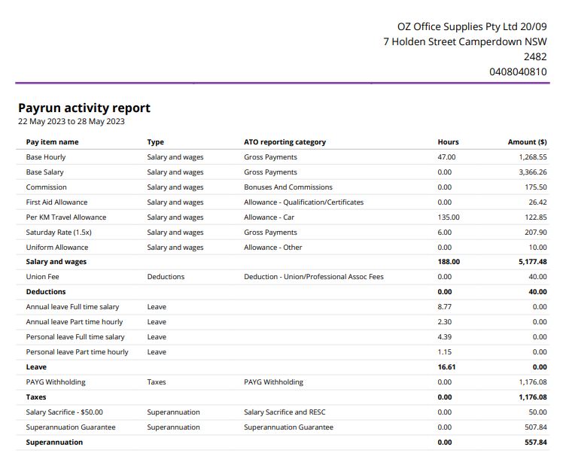

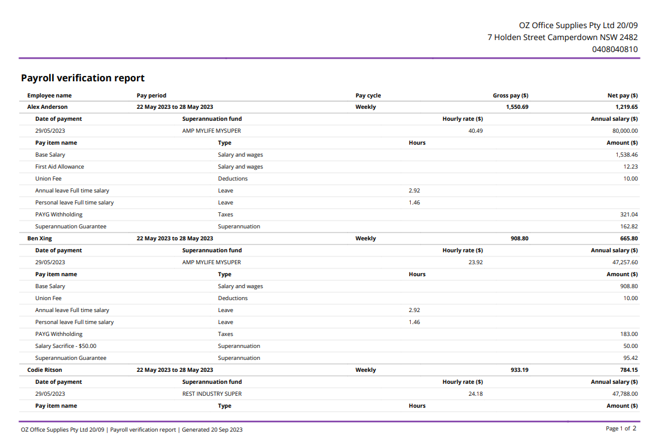

Kind regards

Kelly James

Payroll Officer

7 Holden Street Camperdown NSW 2482

Phone 0408 040 810

payrollofficer@ozofficesupplies.com.au

**Task 5 Single Touch Payroll (STP)**

a. Explain what is meant by Single Touch Payroll (STP)?

(Approximate word count: 50 words)

b. List the steps anyone who processes payroll for OZ Office Supplies using MYOB must complete to set up STP reporting from their own account.

(Approximate word count: 300 words)

|  |
| --- |
| a. What is Single Touch Payroll? |
| MARKING GUIDE  The Candidate's response must reflect the sample answer below.  Single Touch Payroll (STP) is an Australian Government initiative aimed at simplifying and streamlining the payroll reporting process for employers. It requires employers to report their employees’ payroll information, including salaries, wages, and superannuation contributions, to the Australian Taxation Office (ATO) in real-time, every time they pay their employees. |
| List the steps anyone who processes payroll for OZ Office Supplies using MYOB must complete to set up STP reporting from their own account. |
| MARKING GUIDE  The Candidate's response must reflect the sample answer below.   1. Make sure you've got your ABN handy and click **Start**. 2. At the **Your role** step, choose **Someone from the business**and click **Next**. 3. At the **Declaration information** step, enter your details, including your business's ABN, name and contact details and click **Next**. As you selected **Someone from the business** in step 2, you'll skip the **Add clients** step. 4. At the **Notify ATO** step, you need to let the ATO know you're using MYOB for payroll reporting:    1. Get the **Software ID**. This number is shown on screen at this step in MYOB and is unique to you, and you can't share it - each client and agent will have their own. If you use the wrong Software ID, the ATO will reject your reports.    2. Choose how you want to notify the ATO.       1. Option 1. Phone the ATO on 1300 85 22 32       2. Option 2. Create a notification in Access Manager 5. Once you've notified the ATO that you're using MYOB software, click **I've notified the ATO**and in the confirmation message that appears, click **Send**. 6. At the **Transferring BMS ID** step, select whether your business has reported via STP in the current payroll year using other payroll software. See the FAQ below for more info about this. If your business    1. has NOT reported via STP in other payroll software       1. Select **No**.       2. Click **Next**.    2. HAS reported via STP in other payroll software       1. Select **Yes**.       2. Enter the **Previous software BMS ID**. For help finding this, see the FAQ below.       3. Click **Report previous BMS ID**.       4. When prompted to send your payroll information to the ATO, enter your details and click **Send**.   And that's it — you're done!  You can now click **Go to STP reporting,** where you can [view your Single Touch Payroll reports](https://help.myob.com/wiki/display/ar/View+Single+Touch+Payroll+reports). Or you can close the web browser and go back to using AccountRight.  [Notify the ATO you're using MYOB for Single Touch Payroll reporting - MYOB AccountRight - MYOB Help Centre](https://help.myob.com/wiki/display/ar/Notify+the+ATO+you%27re+using+MYOB+for+Single+Touch+Payroll+reporting#expand-Imsomeonefromthebusiness) |

**Assessment checklist:**

Candidates must have completed all activities within this assessment before submitting. This includes:

|  |  |  |
| --- | --- | --- |
|  | | |
| Task 1 | a. Scope of services that you can provide as the Payroll Officer (Assessment Document)  b. Circumstances where a payroll service provider does not need to register as a Tax or BAS Agent | ☐  ☐ |
| Task 2 | Information on two local experts (Assessment Document) | ☐ |
| Task 3 | a. Legislation that covers notice of termination and final pay for Australian workers  b. Notice period OZ Office Supplies’ employees must be given if their employment is to be terminated  c. OZ Office Supplies' obligations if they pay the employee out rather than let them work out their notice period.  d. OZ Office Supplies' review procedure for termination payments. | ☐  ☐  ☐  ☐ |
| Task 4 | c. Screenshot of business settings  d. Screenshot of payroll settings and linked payroll accounts  f. Screenshot of standard pay for:   * Alex Anderson * Ben Xing * Kris Cox * Taylor Alvarado * Codie Ritson   g. Manual Payroll Template (Assessment Document) for:   * Alex Anderson * Ben Xing * Kris Cox * Taylor Alvarado * Codie Ritson   h. Email to Finance Manager, which includes a Payrun activity report and the Payroll verification report for the week ending 28/05/20YY. | ☐  ☐  ☐  ☐  ☐ |
| Task 5 | a. What is single touch payroll (Assessment Document)  b. Steps anyone who processes payroll for OZ Office Supplies using MYOB must complete to set up STP reporting from their own account. (Assessment Document) | ☐  ☐ |



**Congratulations, you have reached the end of Assessment 2!**

**©UP Education Australia Pty Ltd 2024**

Except as permitted by the copyright law applicable to you, you may not reproduce or communicate any of the content on this website, including files downloadable from this website, without the permission of the copyright owner.