**Activity 3A**

**Understanding your culture**

Consider the following image and its headings:

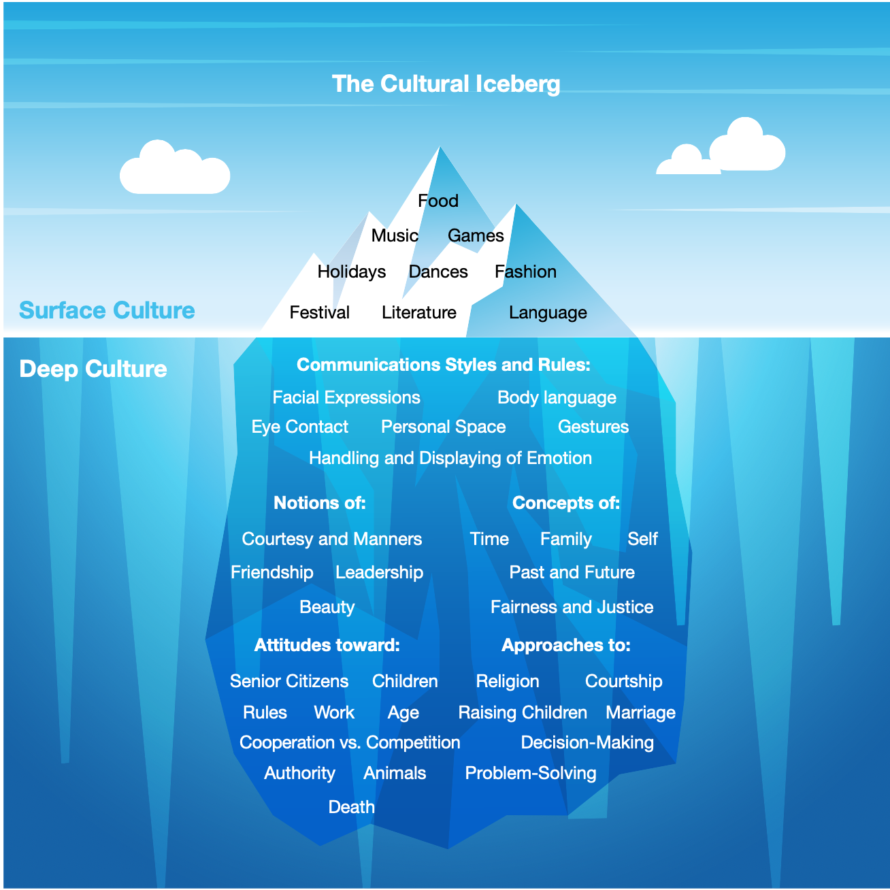

**Create a mind map or list using your own headings for the unique elements of your culture that are the most meaningful to you. Under each heading write words or phrases that provide detail for and expand upon the heading.**

**At the end of this activity your mind map should resonate with your own cultural beliefs and provide a visual representation of the important things to you in your own culture.**