**Module 3 Activity Worksheet 2**

Refer to the electrical plan below to answer the following questions.

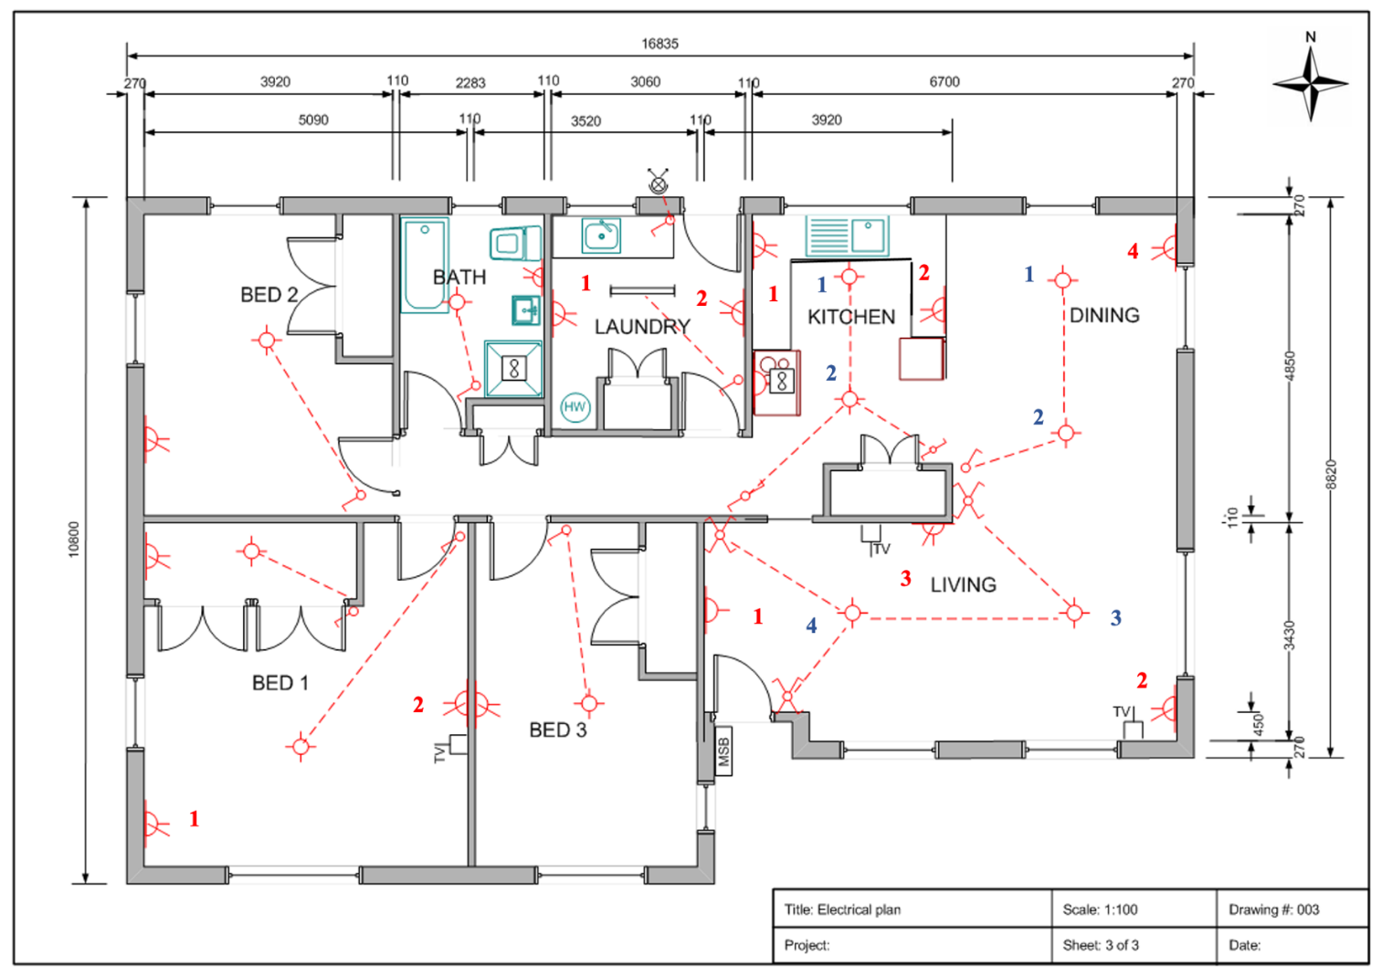

(<https://emedia.rmit.edu.au/dlsweb/Toolbox/electrotech/toolbox1204/resources/04diagrams/02architectural/03floor_plan.htm>)

**Questions:**

1. For the floor plan provided (scale 1:100) determine the location of the socket outlets shown. List and record the following information for each outlet in the table provided. (Where there is more than one outlet per room, socket outlets have been numbered.)

* Outlet details (e.g., single 10A or double 10A)
* Room in which the outlet is located (e.g., lounge, kitchen, bedroom 1 etc)
* Location details including measurement (e.g., western wall, 500mm from NW corner)

|  |  |  |
| --- | --- | --- |
| **Outlet details** | **Outlet location /room** | **Location details** |
|  |  |  |
|  |  |  |
|  |  |  |
|  |  |  |
|  |  |  |
|  |  |  |
|  |  |  |
|  |  |  |
|  |  |  |
|  |  |  |
|  |  |  |
|  |  |  |
|  |  |  |
|  |  |  |

1. For the same floor plan provided determine the location of the light points shown. List and record the information for each point in the table provided. (Where there is more than one light point in a room, points are numbered.)

* Type of light (e.g., wall mounted, fluorescent etc).
* Switching details (e.g., single way, two way)
* Room in which the point is located (e.g., lounge, kitchen, bedroom 1 etc)
* Location details – actual measurement not required (e.g., middle of ceiling)

|  |  |  |  |
| --- | --- | --- | --- |
| **Light type** | **Switching details** | **Point location /room** | **Location details** |
|  |  |  |  |
|  |  |  |  |
|  |  |  |  |
|  |  |  |  |
|  |  |  |  |
|  |  |  |  |
|  |  |  |  |
|  |  |  |  |
|  |  |  |  |
|  |  |  |  |
|  |  |  |  |
|  |  |  |  |
|  |  |  |  |

1. For the same floor plan, determine the location of the main switchboard, hot water service, two exhaust fans, three televisions and the cook top. List and record the information in the table provided:

* Point type (e.g., HWS).
* Room in which the point is located (e.g., kitchen, bedroom 1 etc).
* Location details – actual measurement not required (e.g., south wall).

|  |  |  |
| --- | --- | --- |
| **Point type** | **Point location /room** | **Location details** |
|  |  |  |
|  |  |  |
|  |  |  |
|  |  |  |
|  |  |  |
|  |  |  |
|  |  |  |
|  |  |  |