## How to use your eye ointment

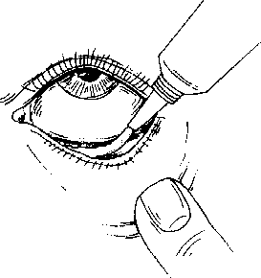

###### What is an eye ointment?

Eye ointments are a sterile preparation of medicine. They are applied inside the lower eyelid to produce a local effect directly on the eye.

###### How to use your eye ointment.

1. Wash your hands.
2. Sit in front of a mirror so you can see what you are doing.
3. Take the lid off the ointment.
4. Tip your head back.
5. Gently pull down your lower eyelid and look up.
6. Hold the tube above the eye and gently squeeze a 1cm line of ointment along the inside of the lower eyelid, taking care not to touch the eye or eyelashes with the tip of the tube.
7. Blink your eyes to spread the ointment over the surface of the eyeball.
8. Your vision may be blurred when you open your eyes - DON'T rub your eyes. The blurring will clear after a few moments if you keep blinking.
9. Wipe away any excess ointment with a clean tissue.
10. Repeat this procedure for the other eye if you have been advised to do so by your doctor or pharmacist.
11. Replace the lid of the tube.
12. Take care not to touch the tip of the tube with your fingers.
13. If you are using more than one type of ointment, wait for about half-an-hour before using the next ointment, to allow the first to be absorbed into the eye.
14. If you are also using eye drops use them first, and then wait for five minutes before applying the eye ointment.

###### Other useful advice

* + Some people find it easier to have someone else put their eye ointment in for them.
  + Do not share your eye ointment with other people.
  + If your vision is blurred after using your eye ointment, wait for it to clear before driving or using hazardous machinery.
  + CONTACT LENSES: if you normally wear contact lenses, don't wear them while using eye ointment unless your doctor, pharmacist or optician has told you otherwise.
  + STORAGE: some (but not all) eye ointments need to be stored in the fridge. Check that you know where to store your eye ointment.
  + EXPIRY: never use your eye ointment after the expiry date, as it may be contaminated with dirt or bacteria. Eye ointments containing a preservative should be thrown away four weeks after opening. Follow the printed instructions given with your ointment. Write the date you open your eye ointment on the tube, so you know when to throw it away.
  + Some people may find their eyes sting immediately after use. This will normally only be for a short time. If the irritation is severe or if the eye ointment seems to make your symptoms worse, discuss the matter with your doctor or pharmacist. If you notice anything unusual, tell your doctor or pharmacist.
  + Always use the ointment according to the printed label or as instructed by your doctor or pharmacist.
  + Once you have finished the treatment course, carefully dispose of any remaining ointment.