Sportique Pty Ltd Practice Exercise
- Use the Error Checking function to check for errors in the worksheet.
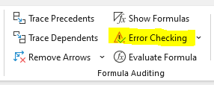
- Provide a screenshot of any formulas that you identify as incorrect.
Formulas you identified as incorrect
- Correct the errors and save the file.

