Project Management Fundamentals

Participant Manual

Swinburne Professional  
Education for Working Professionals

PO Box 218, H69  
Hawthorn VIC 3122

**P** 1800 633 560  
**E** indenrolments@swin.edu.au  
**W** www.swinburne.edu.au/professional/

These materials have been developed for the use of the Swinburne University of Technology. Swinburne reserves the right to cancel, suspend or modify the materials.

CRICOS 00111D – TOID/RTO 3059

The materials may not be duplicated without the written agreement of Swinburne Professional, Swinburne University of Technology, PO Box 218, H69, Hawthorn 3122 – Phone 1800 633 560 – Email swinburneprofessional@swin.edu.au

Version 2.2 – 11 September 2018

© September 2018 – All Rights Reserved

Contents

Introduction 1

Unit overview 2

Course Project 3

Project Management 5

The Project Lifecycle 7

Initiating the Project 9

Governance requirements 9

Defining your scope 10

Benefits and objectives 12

Other definitions 14

Stakeholder identification and analysis 15

Planning the Project 19

Project updates and registers 19

Defining activities and milestones 20

Capturing timeframes and dates 22

Understanding the resources required 24

Identifying project quality 26

Developing your communications plan 26

Managing the Change 29

Individual transitions 30

End of Day One 32

Managing the Risks 33

Risk breakdown structure 33

Consequences and likelihood 34

Building the register 34

Implementing the Project 37

Managing expectations and scope creep 37

Building the team 38

Team dynamics 39

Execution and monitoring 43

Closing the Project 47

Finalising the work 47

Evaluating the project 49

Reflection and Plan 52

Notes and Ideas 53

Appendix A: Gantt Chart Template 56

Appendix B: RACI Matrix 57

Appendix C: Return on Investment (ROI) 58

References 59

Introduction

Welcome to the Undertake Project Work course. This workshop has been designed to provide you with the fundamentals for undertaking simple projects within your organisation.

Project Management is a complex and detailed specialisation that requires skills and capabilities in a range of competencies, many of which are honed through years of experience in the field. This course is a primer for people who need to understand the fundamental components of managing workplace projects, usually alongside their daily tasks.

Learning outcomes

Through this course you will develop the skills and knowledge to:

* Define a project and its scope
* Liaise with stakeholders and consider their needs in your planning
* Develop a complete project plan, including risk, quality and change requirements
* Implement and monitor your project plan for effective outcomes
* Complete the project, undertaking a review and lesson capture.

National accreditation pathway

This course is based on the BSBPMG522 Undertake project work unit of competency that contributes to the Diploma of Business.

The course provides optional assessment for pathway accreditation towards a Diploma level unit delivered in fast-track mode.

Course Project

Moving a Corporate Office

AlphaBeta Corporation is a supplier of consulting services and products to government and private industry. It has experienced considerable growth in the last 12 months, going from 80 employees to 150. This growth means that their current corporate offices are no longer adequate for their needs; four months ago they rented additional space across the road for 45 staff. Further to this, they anticipate that the organisation will continue to grow to possibly 200 people within the next 18 months, possibly reaching 280 in the next five years to align to their Strategic Plan to expand their corporate offerings and market share.

As a result of this situation, the Executive and Board of AlphaBeta have decided to relocate their corporate offices to a new location. The new site has already been chosen, it is 20 minutes out of the city, and will comfortably support their anticipated growth for the next five years.

The organisation has appointed a dedicated Project Manager and team to manage the Corporate Relocation Project. The project is responsible for:

* Ensuring that the new corporate offices are appropriately designed and set up to support the needs of the organisation – including offices and other working spaces; reception; meeting rooms and AV; break areas and equipment; other facilities (restrooms, first aid, stationery storage etc.); ICT cabling and other requirements; document and records storage. Their remit also includes: interior design choices, OHS compliance of spaces and furniture, and a range of requirements for break areas and other employee concerns.
* Identifying all items that **will be moved** into the new facility, and organising the removals processes.
* Identifying all items that **will not be moved** to the new facility, and organising disposal, sale or donation of these items.
* Organising the make good handover of the current facility back to the landlord, and finalising the leases on the main corporate office and the temporary space across the road.
* Ensuring business continuity throughout the move.
* Communicating and engaging staff in the process.

The Executive are anticipating that this will take six months to complete, but they have not authorised a final budget at this stage.

The Project Team consists of:

* Project Manager
* Business Analyst
* Change/Communications Manager
* Five Project Officers.

The project reports to a Relocation Steering Committee, and a business reference group is being established to ensure that the requirements and concerns of the five business units are factored into the low-level decisions.

While you will be working on the entire project for the scoping document, you will need to focus on one aspect of the project for the project plan development. In your group, you need to identify which aspect of the project you will focus on for the detailed tasks. Suggestions include:

* the fit out of the new corporate office
* the removal and make good of the current corporate offices
* selection and procurement of external design services and OHS compliance of products
* design and delivery of the meetings rooms and associated AV.

You will need to confirm this with your facilitator.

Project Management

In your small group, consider the questions below and write down your responses on post-it-notes (one response per post-it-note).

* Place your post-it-notes on the appropriate flip chart paper on the wall.
* Use the space below to record your responses for future reference.

What is a project?

What is project management?

What makes a project succeed?

What makes a project fail?

What do project managers manage?

The Project Lifecycle

A project is a *temporary* activity designed to deliver a defined outcome. It has a defined:

* Beginning and end
* Scope and resources
* Goal, or goals, outside business as usual operations.

A project is a unique activity, which is often delivered by a team that doesn’t usually work together. A project is usually deemed successful if it achieves its objectives within the time, cost and quality constraints agreed in the plan.

Developing a new piece of software to improve your business processes, moving to a new office building, the relief effort after a natural disaster, expanding your business into a new geographic market – are all projects.

And all projects must be managed to deliver their defined results on-time and on-budget; integrated to the business as usual components of the organisation.

Overview

Projects vary in size and complexity. All projects can be mapped to the following generic lifecycle:

Stakeholder consultation and communication

Risk Management

Strategic Monitoring and Review

Alongside the stages in the lifecycle, there are three processes that run throughout the project and are essential components to its successful delivery. These are the engagement with your stakeholders, the identification and management of the project risks and processes to strategically monitor and review the organisational environment and its impact on the project.

The image below outlines the high-level deliverables, activities and staffing across a generic project lifecycle structure. Each stage in the lifecycle has a gate, defined deliverables, that must be completed before you can move onto the next stage.

Let’s take a few minutes to discuss this before we get into the specifics.

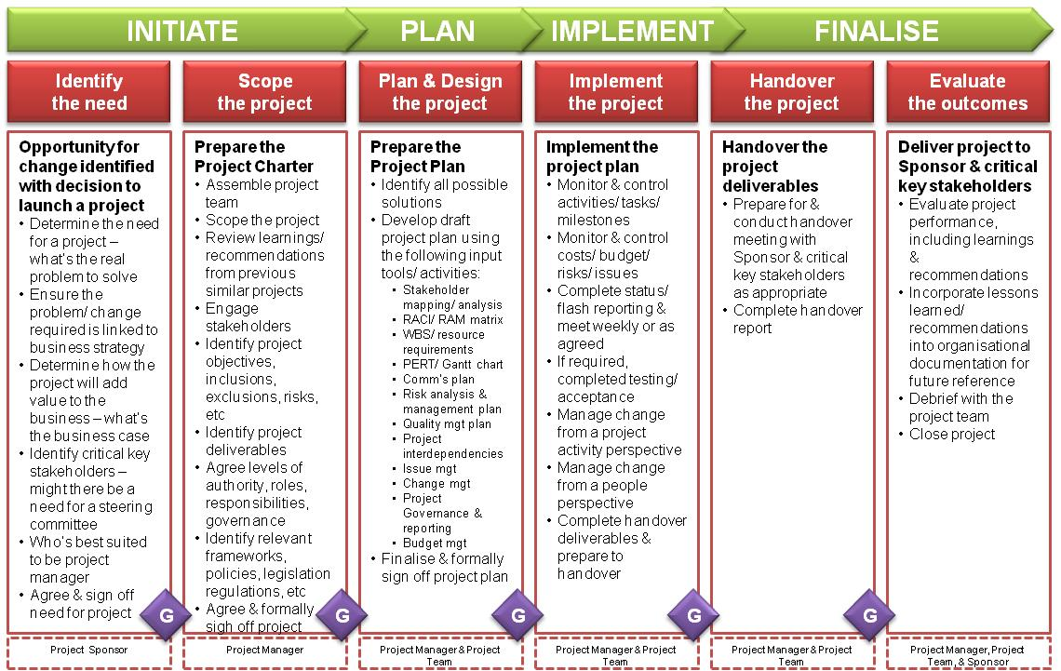

Initiating the Project

Before a project can commence, you need to develop a document that provides the organisation with a clear reason for needing the project, and high-level detail on the scope of the work to be undertaken. This is usually developed through a business case, or similar project initiation template.

Your project initiation document needs to provide decision makers with a reason for supporting and funding your project. It should clarify what the project is about and what it will deliver to the organisation. You could commence this process by answering the following high-level questions:

* What is the driving need of the project? What problem/issue is it solving; or opportunity it is taking advantage of; or legislative/regulatory need is it meeting?
* What does the project aim to achieve?
* What activities would achieve this desired outcome?
* Who does the project affect? Who are the other stakeholders?
* What is the scope of activity of the project?
* What is not included in the scope of this project?
* What resources would be required to complete these activities?
* What would the anticipated timeframe be to complete the activities?

Organisations use some form of charter, project initiation document, scope or brief to define and capture agreement on the scope and governance of your project. We’re going to refer to this as defining your scope.

Governance requirements

Project governance is an oversight function that is aligned with the organisation’s governance model and that encompasses the project lifecycle. A project governance framework provides the project manager and team with structure, processes, decision-making models and tools for managing the project, while supporting and controlling the project for successful delivery.

These structures provide a comprehensive, consistent method of controlling the project and ensuring its success by defining and documenting and communicating reliable, repeatable project practices. It includes a framework for making project decisions, defines roles, responsibilities, and accountabilities for the success of the project. It also determines the effectiveness of the project manager. A project’s governance is defined by and fits within the larger context of the portfolio, program, or organisation sponsoring it but is separate from organisational governance.

Project governance involves stakeholders as well as documented policies, procedures, and standards, responsibilities and authorities. Examples of the elements of a project governance framework include:

* project successes and deliverable acceptance criteria
* process to identify, escalate, and resolve issues that arise during the project
* relationship among the project team, organisational groups, and external stakeholders
* project organisation chart that identifies project roles
* processes and procedures for the communication of information
* project decision-making processes
* process for project stage/phase gate reviews (before proceeding to the next stage/phase)
* process for review and approval for changes to budget, scope, quality, and schedule which are beyond the authority of the project manager
* process to align internal stakeholders with project process requirements.

While project governance is the framework in which the project team performs, the team is still responsible for planning, implementing, controlling and closing the project. The project governance approach should be described in the project management plan.

Project governance accountabilities

Many projects run into trouble because they do not have clear accountabilities. A RACI or RASCI matrix is a great way to define your governance accountabilities up front.

A RACI matrix

A RACI (Responsible, Accountable, Consulted, Informed) matrix describes how the project roles are involved in the delivery of tasks, activities and deliverables.

* Responsible – the role(s) who will do the work to achieve the task
* Accountable – the role with ultimate responsibility for the completion of the task or deliverable. There can only be one accountable person per task or deliverable
* *Support – Depending on the project, you could also include Support and create a RASCI matrix*
* Consulted – the people whose opinions are sought, usually experts. (Two-way communication)
* Informed – the people who need to be kept up-to-date on the progress or completion of the task or deliverable. (One-way communication).

A template and more information is provided in ***Appendix B***.

Defining your scope

There is no formal list of content for a project charter or other scoping document. Your organisation might have a template, or it will be up to you to create one. The following template includes the common requirements.

Knowing what you need to complete the scope will help you identify the work you need to conduct.

Your Project Scope effectively becomes the executive summary of your project plan, and the contract for what you will deliver in your project. It needs to contain enough detail to be meaningful, but it is not the project plan. It is the document that is usually developed to seek authorisation to continue with your project, at least to the Planning stage.

The following are usually developed in collaboration with key stakeholders and subject matter experts – who will also be involved in the planning process.

|  |  |  |  |  |  |
| --- | --- | --- | --- | --- | --- |
| **Project Name** | What you plan on calling the project within the organisation | | | | |
| **Project Sponsor** | The delegate who will own and support the project | | | | |
| **Project Manager** | You | | | | |
| **Project Governance** | Simple statement about the governance structure – particularly noting any Steering Committees or other bodies that have a role in oversight or decision making. | | | | |
| **Project Description** | A brief description of the project. Don’t get too caught up in the details here, it’s often best to explain it in simple words about the problem it is solving or the opportunity it is taking. You could include the vision statement here too. | | | | |
| **Project Outcomes** | See note below on Outcomes – these are the long-term benefits that the project will deliver to the organisation. | | | | |
| **Alignment to Organisational Goals and other Projects** | Where does this fit into the goals in your Strategic Plan? Does it align to the delivery or outcomes of other projects? Include that here. | | | | |
| **Project Goals and Objectives** | See note below on Goals/Objectives. Remember SMART. | | | | |
| **Resources and Budget** | Since you have not completed actual tenders or procurement plans, this is a best guess for the information you have right now – but it should be altered after the final budget and resources have been approved.  Include budget for external expenditure, people resources, equipment and other physical resources required. | | | | |
| **Deliverables** | A simple list of what you will be delivering as part of the project. This is not your full work breakdown structure, just the high-level deliverables.  Remember to think broadly, if you are delivering a new IT system are you also delivering training and manuals? | | | | |
| **Inclusions** | What is included in the scope of the project? Think about whether it will cover the entire organisation, or only select units. Consider the deliverables above and what you might want to be explicit about. | | | | |
| **Exclusions** | This is extremely important to define early; what is **not** in your scope? This will help you avoid scope creep. Even if you think it is obvious that you aren’t doing something, spell it out for everyone else. | | | | |
| **Assumptions** | What have you assumed will be available or will be happening to make this project work? This could include simple things like, *The finance unit will provide the team with a SME for the duration of the project.* If you are relying on another part of the business to complete a project or activity, then include it here as well. | | | | |
| **Constraints** | What are your known constraints within this scope? Capture them here so people know you have taken certain issues into consideration. This could include availability of people, peak season timings, deconflicting projects etc. | | | | |
| **Key Risks** | You are only including what you see as the major risks for the successful delivery of the project. You might have already identified them in the assumptions and constraints, but spell the key ones out here – you do not need mitigation strategies in the Scoping document. | | | | |
| **Key Stakeholders** | Who are you Key stakeholders? Who is going to be primarily affected by the project? Who needs to be involved in any aspect of the delivery? Who do you require support from? List out your Key Stakeholders here, not the analysis of them. | | | | |
| **Responsibilities**  *Reporting, accountability and limit of authority* | What are your responsibilities as the Project Manager. Include reporting requirements, your personal responsibilities and what you need to seek approval for. | | | | |
| **Proposed Start Date** |  | **Proposed Completion Date** | |  | |
| **Signature of Project Manager** |  | | **Date** | |  |
| **Signature of Sponsor/Manager** |  | | **Date** | |  |

Benefits and objectives

Importantly, every project needs a well-defined purpose and set of objectives. These statements not only provide detail to decision makers, but they will become a fundamental aspect of communication and broader understanding of the project’s scope.

The purpose of the project is the answer to the question, “what is it aiming to achieve?”. This is a very broad statement but think about what your project is uniquely attempting to deliver to the organisation. Most often, projects are developed to solve a problem within the organisation, which makes their purpose easier to define. Does the project:

* Improve the efficiency of a business process?
* Remove redundant and unreliable systems?
* Allow the organisation to better accommodate its workforce?
* Allow the organisation to meet legislative requirements?

Framing it as the problem you are solving for the organisation is often a great way to start.

You need to understand the difference between these terms:

**Outcome** **(or Benefits)** – this is what the business, staff, or customers gain from the project

**Objective (or Goal)** – this is what you are aiming to achieve and should be written SMART.

Outcomes

The outcomes are usually written as To statements – “To promote…” “To provide…” “To improve…”. For example, *“To provide clarity around procurement”* or *“To improve the safety of warehouse operations”.*

Importantly, these are high-level statements that express the benefits to the organisation. You must have at least one Objective for each Outcome, so you can measure your success.

Activity: What are the outcomes?

Using the Project agreed upon in your group, define at least two Outcomes for your project.

Objectives

As part of your project initiation and definition, you will develop a range of objectives or *goals*. It is important that these statements are clear and well-defined. This will help guarantee everyone is working towards a common end state and defines how the success of the project will be measured.

One way of developing these statements is the use of the SMART goal framework:

|  |  |
| --- | --- |
| **SPECIFIC** | Make the desired goal as specific as possible, avoid generalisations |
| **MEASURABLE** | How you will measure it – what can you measure? Is it indicative of project intent? |
| **ACHIEVABLE** | Consider the activities in the project and whether it’s doable |
| **RELEVANT** | Does this goal align to the purpose of the project? |
| **TIMEBOUND** | The date you will achieve the goal |

An example of how this might look:

* unSMART goal: Provide the organisation with state of the art meeting rooms.
* SMART goal: In the new office we will provide five meeting rooms that will support the majority of meeting requirements for the organisation, with integrated AV systems – as outlined in consultation with key stakeholders and IT.

Activity: Project goal

Using your Project, develop a SMART project goal that will help achieve your outcome above.

Other definitions

Assumptions

According to PMBOK, an assumption is *A factor in planning process that is considered to be true, real or certain often without any proof or demonstration.* There are things that, through experience or known processes, you can presume will be true for your project.

Importantly, all project assumptions are potential risks and need to be stated clearly for everyone involved in the project.

Constraints

According to PMBOK, a constraint is *A limiting factor that affects the execution of a project, program, portfolio or a process*. The might be imposed by stakeholders, the environment or other organisational factors.

Importantly, constraints need to be considered in the planning and delivery of the project and can often compete against each other. For example, a constraint in available resources, which requires you to hire an industry specialist, could directly conflict with the budgetary constraints. The project manager is required to balance and deconflict these matters.

Deliverables

A deliverable is any product, service or result that must be provided to complete the project and achieve its outcomes. There are different categories of deliverables, best described as Internal and External. Internal are the deliverables required for the project to run (project management materials, reviews etc.); external are the deliverables for the users, clients or customers (systems, products, services etc.),

Stakeholder identification and analysis

The project initiation phase also requires the identification of key stakeholders, and their interest/ involvement in the project. The stakeholder analysis developed in the initiation phase will be expanded in the planning phase, and we will focus our discussion when we reach that part of the process.

Remember though, a stakeholder analysis must be conducted in the initiation phase to ensure you fully understand the impact of the project on people and groups inside and outside your organisation.

Influence and interest

**3**

**1**

**2**

**4**

High

High

Low

**Vested interest in your project**

**Power and influence over the success of your project**

* Quadrant 1: High/High – these stakeholders have a high vested interest in the successful delivery of your project, usually because it will impact what they do or how they work with you. They also have high influence over the success of your project, largely because they have a role within it. This could be as a Project Sponsor, a team member, the manager of a team you need something from to ensure delivery.
* Quadrant 2: High/Low – these stakeholders still have a high interest in the successful delivery of your project, but their ability to influence the success of it is low. These are likely to be people at the end of a value chain, or people who will use what you are implementing but they are not part of the implementation itself. These could be staff who will use the new system, but they are not part of the project to deliver it.
* Quadrant 3: Low/High – these stakeholders have a low interest in the delivery of the project, usually because there is no or minimal impact on their work or how they engage with you. However, they still have high influence over the success of the project because they have a role to support or deliver it – this could be the Finance Manager who will provide you with your budget allocation and process invoices.
* Quadrant 4: Low/Low – these stakeholders have low interest and low influence for your project. They are the groups or individuals with no vested interest in the project and no role in its delivery. This could be people who receive your services or products, who do not have to change their actions or behaviours.

Activity: Who are your stakeholders?

Using the agreed project and the template on the next page, come up with the list of stakeholders for your project. Complete the Name, Overview, Must haves and support columns in the table – the idea is to come up with a description about what their stake in the project is, what they might want to see included and their perceived level of support.

* For support they are either: Strongly Against (SA), Against (A), Neutral (N), Supportive (S), Strongly Supportive (SS).
* Then, decide which quadrant your stakeholders are in and put that in the Influence column. Use the quadrant numbers to make it easier.

Activity: Engaging stakeholders

Considering their influence, how will you engage with them? Do they need the ability to contribute? If so, what is your Engagement strategy? Complete the Engagement column in the table.

Remember: the engagement plan is more than only communication. It might include other activities like site visits, demonstrations, training etc.

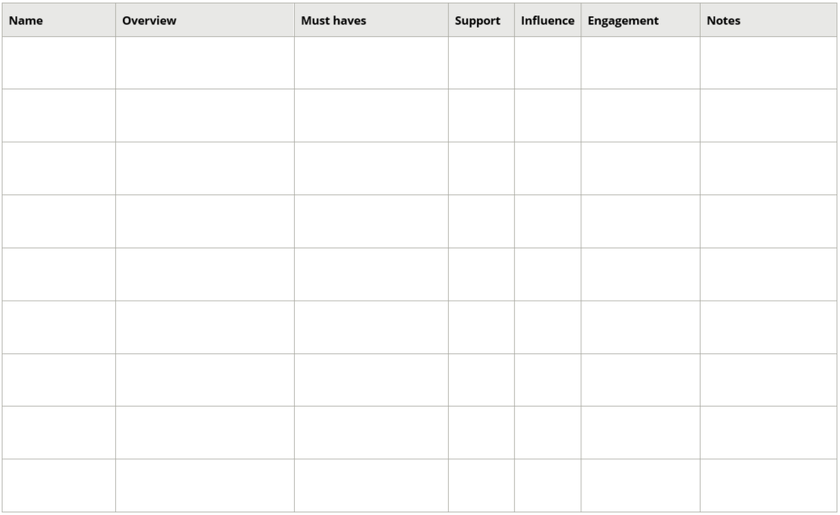

Once all stakeholders have been identified, you can use the Stakeholder Commitment Curve to assess and define their level of commitment towards your project. It shows us the two paths that can be taken to achieve stakeholder commitment to a project.

Commitment grows from the bottom of the curve to the top and can branch in two directions. The left-hand branch represents a project where commitment is attained because it has to be done. This type of commitment is known as compliance.

The right-hand branch represents a project which is embraced because they want it to happen and see benefit in a positive outcome. This is where real “hearts and minds” commitment occurs.

Along each path there are phases stakeholders pass through and how you manage them through these processes will influence the final outcome.

Stakeholder Commitment Curve

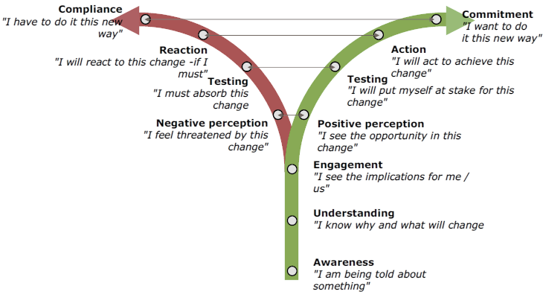

Planning the Project

Once your project is approved and established, you should start to develop a more detailed understanding of the requirements of your project. The Project Management Plan is the mechanism most organisations use to capture:

* Detailed analysis of the project stakeholders, requirements and strategies
* Detailed definitions of the work, which will include the work breakdown structure and deliverables
* Detailed estimates of project resources and timeframes:
  + Resources include people, expertise, materials, facilities, equipment, money etc.
  + Timeframes include capturing the milestone delivery, dependencies and developing a critical path
* Project risks which identify the owners, mitigation or management strategies
* Project quality strategies, guidelines and management activities
* Communication strategies and plans for the project.

Project updates and registers

Alongside the project management planning documents, the Project Team will create and manage a set of reporting and management documents to support the process. The organisation and size of the project will drive the amount and detail of this documentation. But during the implementation phase of the project, the team will usually manage:

* Project report to appropriate governance bodies
* Project Issues Register
* Project Risk Register
* Project Budget
* Project Gantt Chart
* Content calendar/schedule for communications.

The following sections are all part of the planning process. Some of them also extend into the implementation phase of the project.

Defining activities and milestones

To appropriately manage the scope of your project you need to include a detailed list of:

* **All** the work required, and
* **Only** the work required.

Part of this was already developed and identified in your initiation phase. During that phase, you developed a high-level definition of the project scope, resources, timeframes and deliverables.

A significant part of the scope management process is to refine these high-level requirements into granular scope definitions, scope control plans and a work breakdown structure (WBS).

There are a range of actions and planning processes you will undertake in this stage. For now, our next task is to clearly define the project milestones, which creates a detailed understanding of timings and resources for the project and is the catalyst for the more detailed WBS.

A milestone is a particular point in the project that is used to measure progress towards the ultimate goal. They can include: review or input dates, budget checks, due dates for major deliverables and many more activities, events or processes.

Initial WBS planning – using sticky notes

What is it?

Planning your work breakdown structure with sticky notes is a process tool that can be used to create a high-level milestone plan at the beginning of any project.

Why use it?

It helps steer and support key decisions around a project. It can help you plan and decide:

* What to do
* When to do it
* Who will do it
* How long it will take.

When to use it?

Planning your milestones with sticky note is done in the early stages of a project when it is important to establish your WBS. We do this for a number of reasons:

* To assess the project’s feasibility
* To look for interdependencies with other projects
* To review resource requirements
* To assess and develop a financial case
* To sequence and structure tasks.

Who uses it?

This process can be used by either an individual, or a small group of people who are working together on a project – it is preferable to get a group of people together who are specialists in their areas and are more likely to identify area you would not have considered.

Activity: Your sticky notes

Watch the video Project Planning with Sticky Notes (https://youtu.be/80c-LRRJ0W8) and try it for yourself using your Project:

* You will need: flip chart paper, post-it-notes, textas and sticky tape.

My insights

1. Plan with your team – start with the project name and brief them into the activity
2. Brainstorm work packages – get the group to do a sticky for each activity or deliverable they can think of
3. Group work packages into streams – structure the sticky notes into groups of activities/tasks and give the stream a name
4. Check for completeness – review using the 100% rule, whether you have included all required deliverables for the complete product/system/service
5. Check for clarity – confirm understanding, renaming packages or streams to make it clearer if required
6. Keep a record – take a photo or the structure on paper.

Capturing timeframes and dates

After identifying all the milestones, the amount of time required to complete them, and the responsible people in the organisation – you can develop a Gantt chart with dependencies.

Gantt chart

A Gantt chart is a tabular and visual representation of tasking, like the image below. It allows people to better visualise the timeframe for the project, where the milestones sit, and the current status of tasks.

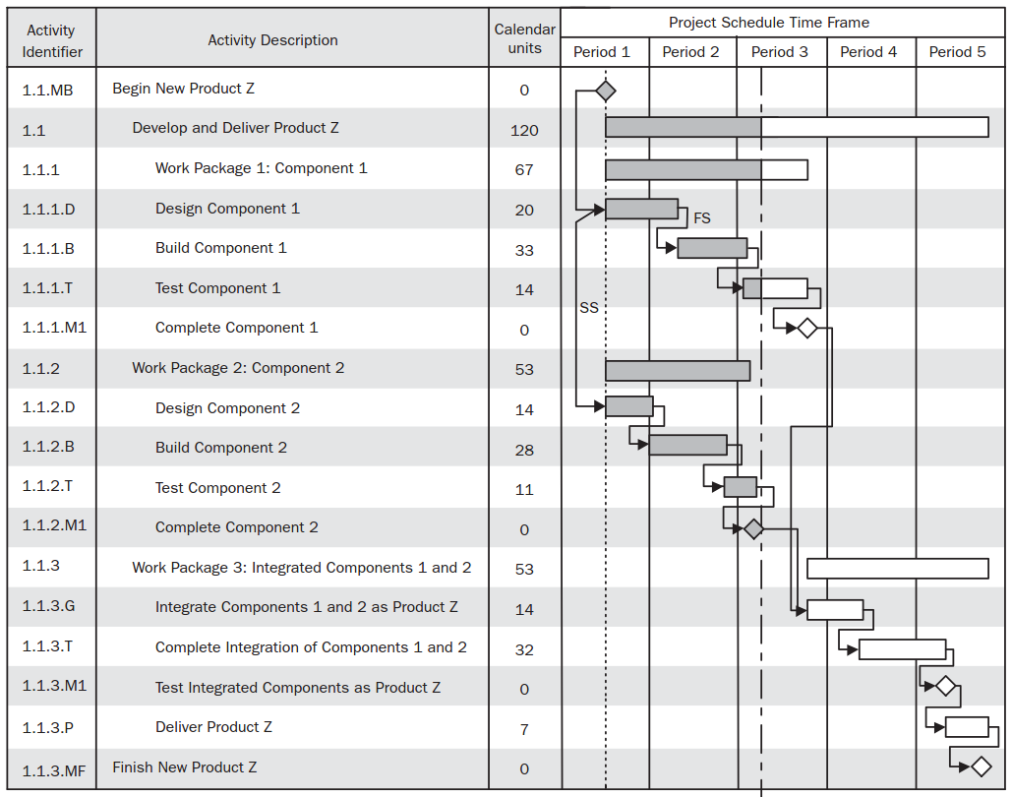

If you are using sophisticated project management software, there are a range of details you can identify in the system: start and end times; dependencies of the activities; the resources allocated to the activity, and whether they are overtasked; the percentage complete, etc.

Importantly, the dates and dependencies allow these systems to automatically monitor the flow on effects of delays in activities that later activities rely upon. If you are managing this manually, you might miss some of these connections.

Estimation issues

Most people work on an ***optimism bias*** when they calculate the time an activity will take. Further to this, project managers often fail to consider the project management requirements for a task. When you are learning to estimate, add 50 percent to your initial concept and you will probably come close to the figure – remember to review this at the end to improve your estimation skills.

Activity: Create your Gantt chart

In your group, run an abbreviated process for your project and create your Gantt chart (use Gantt chart template below – there is another copy in your appendices).

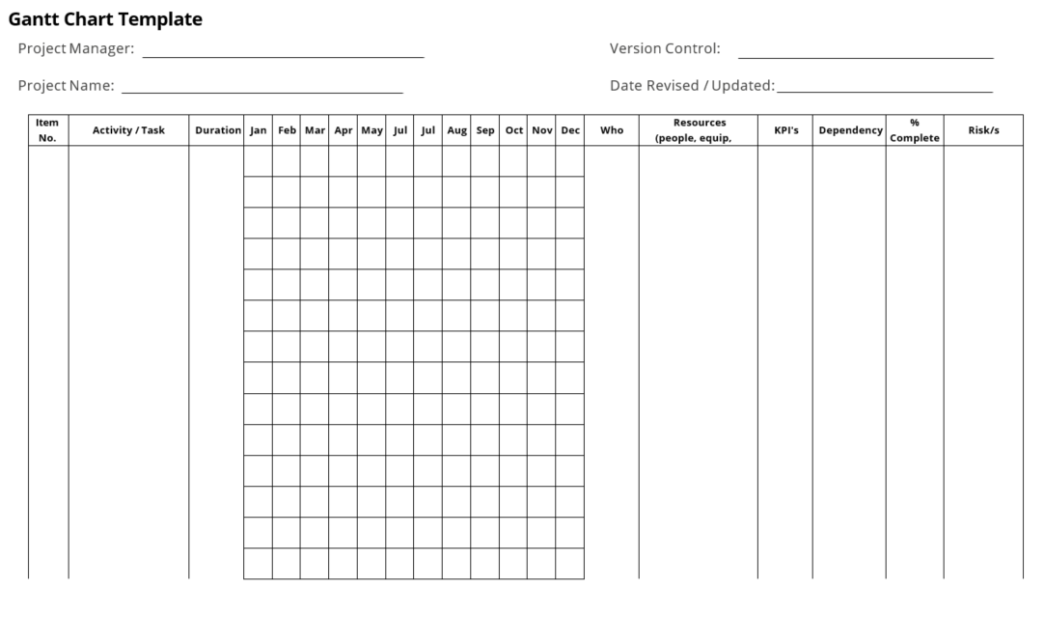

Understanding the resources required

Once you have defined the discrete pieces of work required to deliver your outcomes and objectives, you can work out the resources required for your project. You should have done a high-level budget for the Project Scope, but this is where you get more detailed again.

Your resources will include things like:

* Project Team members – can include skills and knowledge required for each deliverable and the hours, to help you determine the team makeup
* External procurement for deliverables – the consultants, experts, products and services you need to purchase as part of your deliverables. This could be things like the software and specialist IT professionals, or office equipment and removalists
* Insurances – where you might need this for the activities you are conducting
* Supporting materials – communication and training collateral required to conduct the project and keep people informed
* Facilities and resources – rooms, AV resources and similar required for use in communication, training and housing the project team.

Ongoing costs

It’s also important at this time to define the ongoing costs that might be associated with the ‘business as usual’ handover of your project. Things like annual licensing fees, rental fees, insurances and warranties etc. You should have an estimate of this in your Initiation document, so as this is clarified in the planning and delivery phase you need to capture it for handover.

Activity: Defining your resources

Using the template on the next page, define your resources for your Project. Where you are unsure of costs, make a best guess for now – you could try Google for a general idea, depending on what it is.

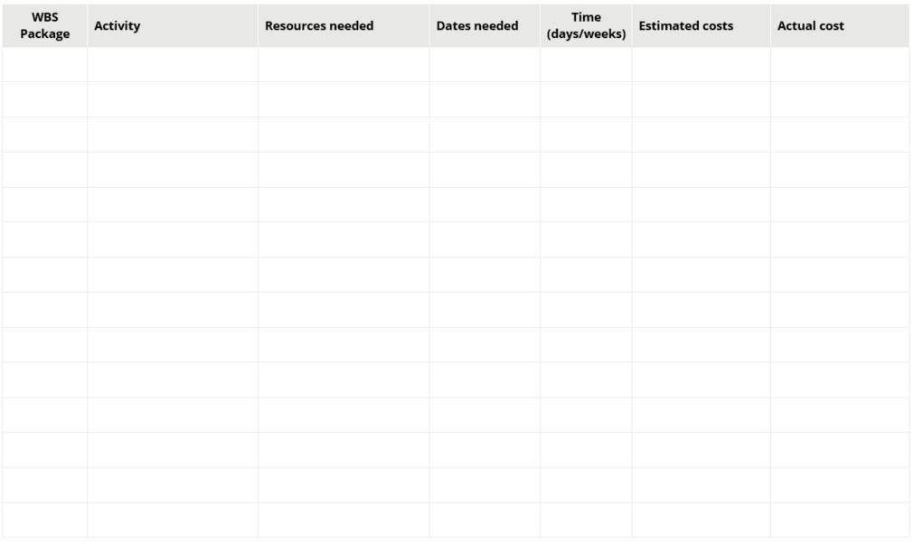

Once you have completed this activity, you can validate the initial Scope of your project. In particular, whether you can deliver the identified deliverables (WBS), within the estimated timeframe (Gantt chart), with the anticipated budget and identified staff (resources).

A Note on Project Integration

As you progress through the planning process, you need to continually review the potential impact of your new decisions on previous decisions. For example, the risk mitigation strategy you choose might require additional funds or resources, so these will need to be adjusted.

Identifying project quality

It is important for you to define how you will evaluate and maintain quality assurance for your project. Certain projects will require a very explicit and compliant assurance program, especially projects that are being delivered to a certain quality standard – like construction or some manufactured products.

The quality process could mean you will manage and review the following details.

* Issues raised by you governance body, sponsor, team, contractors and stakeholders
  + Formal Issues Register process. You would need to define how these issues are captured by your team, documented, resolved and communicated back to the original reporter.
* Whether the deliverables received are fit for purpose and meet the stated requirements
  + Outline the review process, who will be involved, how the deliverable will be evaluated and what will happen if it does not meet the brief.
* A formal Change or Variation request process to appropriately capture, review and implement required variations to the plan
  + Outline the process for requesting a change (form); how these are reviewed, and by whom; and how changes are formally captured and relevant people notified.
* Project management processes and performance through an identified audit program
  + Plan for, conduct and capture quality audits on the performance of the project, to ensure identified processes and procedures are being followed.
* Records and other requirements for documentation for the project, and for the business as usual operation/maintenance of the deliverables
  + Outline where and how project documents/records will be stored and which records will be transitioned to the business owner on completion.

Developing your communications plan

The biggest issue with projects is the ambiguity and uncertainty of the change they are creating. Therefore, as the project manager, it’s important for you to provide certainty and clear messages about what is actually going happen, and when.

Nature abhors a vacuum. If you are not communicating, someone else will – and that’s where the misinformation and disinformation begins.

To achieve this, you need to develop a detailed communication plan. This will take the information you developed for your stakeholders, to develop a more detailed picture about what communications they will receive, how they will receive it and how often that will happen.

Project lifecycle and communications

Communications can seem so obvious to us, that at first it may seem unnecessary to give much time to planning one’s approach. However, given all the attributes that impact on how we receive messages it is imperative that we know where communication is vital, what our approach will be, and address the preferred communication style and therefore needs, of each and every one of our stakeholders.

Be assured, particularly for major projects that poor communications planning will almost certainly impact negatively on outcomes. The diagram below depicts where communications plays an important role in the project lifecycle.

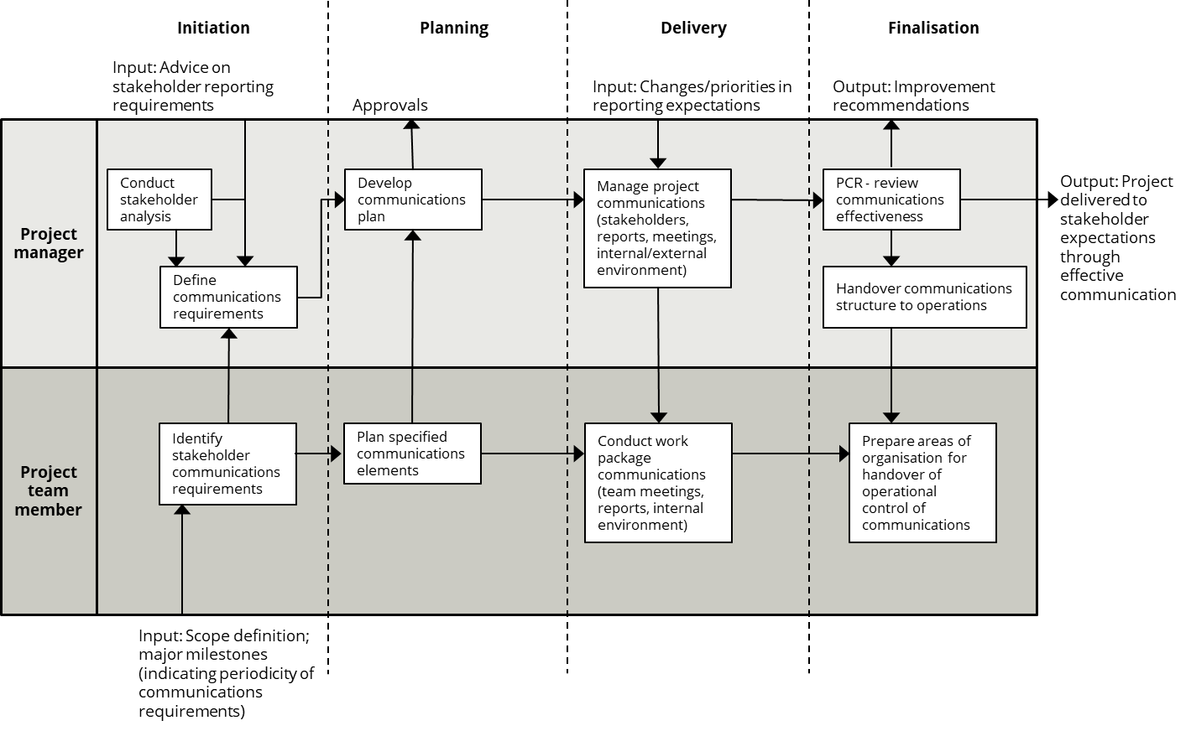

Diagram source: A Handbook of Project Management: A Complete Guide for Beginners to Professionals. 2013

Activity: Identifying the messages

Using your Project, what are the key messages for your stakeholders? Define three key messages that incorporate the need for the change, benefits of change and at least one action they need to take.

You then need to understand what sort of communications you are going to develop and who needs which messages, and when.

Activity: Who needs what?

Using your stakeholder analysis and the key messages outlined above, provide a brief overview of the communication plan for your Project. *Note: the what is the general topic of the communications, in a large project you might develop a list of all the What’s first before you start this process.*

|  |  |  |  |
| --- | --- | --- | --- |
| **To whom** | **What**  **e.g. status report, next step msg, overview, why the change etc.** | **Method**  **e.g. email, phone, meeting** | **When/ How often** |
|  |  |  |  |
|  |  |  |  |
|  |  |  |  |

Once you have developed this outline, you would include each of these communication requirements in your project schedule/Gantt chart. These are usually grouped together, but it’s important to include them in case a piece of communication relies on an activity being completed. If it’s not together, then you run the risk of not updating communication dates when deliverable dates change.

Remember, to support your positive change, people need to have trust and confidence in the project.

Managing the Change

Change management is an essential part of project management, which focuses on helping people through the changes through communication. The core of change is to create the compelling reason for change, understand your stakeholder wants and needs, and develop a ‘project’ to manage the change – including a change strategy and communication plan. But it’s important to understand some of the basic principles.

There are many models for managing change within organisations; Kotter’s Eight Steps is one of the more popular and enduring models. It goes from Step 1: Create Urgency, through to Step 8: Anchor the changes in corporate culture, and it is largely the same as every other change model that has been used since the 1990s.

|  |  |
| --- | --- |
| **Step 1** | Create urgency |
| **Step 2** | Form a powerful coalition |
| **Step 3** | Create a vision for change |
| **Step 4** | Communicate the visions |
| **Step 5** | Remove obstacles |
| **Step 6** | Create short term wins |
| **Step 7** | Build on the change |
| **Step 8** | Anchor changes in corporate culture |

**Kotter’s Eight Steps**

You can see how this aligns to the standard project management methodology, but the focus of change is people, where the focus of the project is tasks.

The key principles to remember are:

* Create a shared vision for the change
* Identify the stakeholders and their role/impact in the change
* Communicate the change – often, at different levels so everyone can appreciate what it means for them
* Embed the change into ‘how we do things around here’.

Activity: Your vision

Using the agreed Project, develop the vision for change in your project.

*Change is an organisational activity – transition is an individual process to adapt to the change.*

Individual transitions

Bridges’ Transition Model is the most popular methodology used to consider the impact of change on individuals. The basic idea is that once the organisational change commences, the individual’s internal transition to the ‘New Beginning’ can also begin. As you can see from the three stages below, Bridges’ model is predicated on the fact that change creates a loss for individuals, and that there has to be some inner turmoil and stress before they can transition into the changed environment.

It is based on the premise that you are always losing something or having to let go. This will lead people through a process of grief, which has to be acknowledged and worked through before they can start rebuilding an acceptance of the new thing… or does it?

Everyone has a different appetite for change, and that can alter based on the nature of the change and what else is going on in their lives. People usually sit somewhere on a continuum of seeing the opportunities in a change, or seeing the risks in the change. Understanding that you will help you tailor your communications to ensure you acknowledge and respond to the more risk averse staff.

Further to this, there are legitimate reasons that people might be resisting the change. Gibbons’ Holistic Model of Resistance to Change demonstrates that resistance is not simply because “they don’t understand the change” or “they just don’t like change”.

|  |  |
| --- | --- |
| Cause | They resist because… |
| Rational | …they possess insufficient or wrong facts, or disagree with reasoning based on those facts – they might agree with the premise but dispute the conclusions. |
| Habitual | …they have a will to change, but habitual behaviours produce a lack of adoption or relapse. |
| Emotional | …they are angry at or afraid by the proposed change – “Will I be able to do this?” “Will I lose my job?” “How dare they?” |
| Identity | …they see change as a threat to “who I am” or how they see themselves – you might be removing their power or changing a process that labels them an ‘obstacle’ to getting things done. |
| Ideological | …the change is contrary to values (theirs or the organisations), a philosophical stance, or their morals. |
| Social | …there are social disruptions to important relationships or loyalty to others harmed by the change (e.g. the survivor effects), nonlinear network effects on information transmission (virality, influencers). |
| Cultural | …organisational norms, meaning social mimicry, rituals, language and values that reinforce old (undesirable) patterns of individual thinking and behaving. |
| Political | …political allegiances, change in power structures, or loss of perceived power, influence, control or autonomy. |

Adapted from Gibbons (2015)

Activity: Addressing resistance

Your facilitator will give you two causes to discuss. Looking at why people resist, can you come up with a couple of methods to help you guide people through this resistance? Share with the group.

End of Day One

Take a moment to list the three most valuable things you took from today – an idea, a method, a resource. Include a brief explanation of where you plan to use it back in your workplace.

|  |
| --- |
|  |
|  |
|  |

Managing the Risks

One of the more important elements of project management is to identify, assess and prioritise the potential risks to the activities, resources, schedules and other aspects of the project. Once the risks have been identified and evaluated, the risk management process assists the Project Manager in minimising, mitigating, monitoring and controlling the probability and impact of these events.

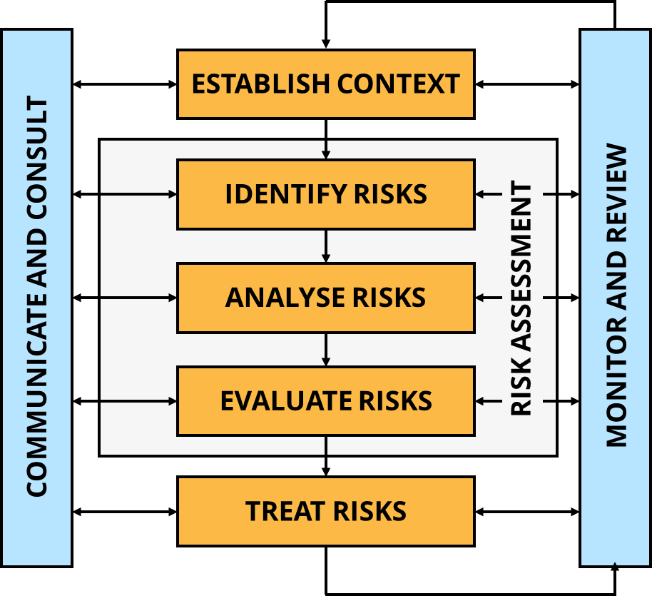

AS/NZS ISO 31000:2009 Risk management

Projects can experience positive and negative impacts from risks, although we generally tend to focus on the potential negative impacts. Importantly, a project might be affected by known and unknown risks – where an unknown risk is an event that impacts the project but had not been identified previously.

Risk breakdown structure

PMBOK includes the following Risk Breakdown Structure (RBS) figure, which *…lists the categories and sub-categories within which risks may arise for a typical project.*

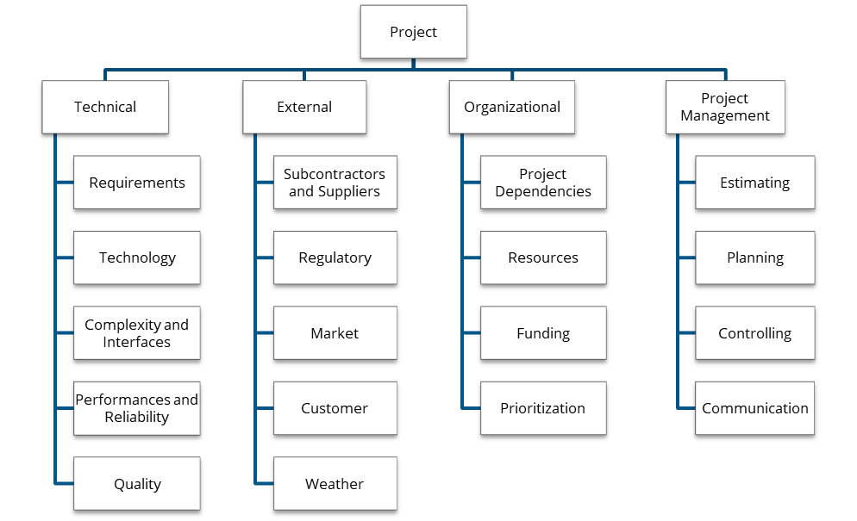

Consequences and likelihood

Consequence (Impact) – How severe could the outcomes be if the risk event occurred?

Likelihood (Probability) – What’s the chance of the risk occurring?

|  |  |  |  |  |  |
| --- | --- | --- | --- | --- | --- |
| **Consequence**  Likelihood | **Insignificant**  **1** | **Minor**  **2** | **Moderate**  **3** | **Major**  **4** | **Severe**  **5** |
| 1 – Almost certain | **M** | **M** | **H** | **VH** | **VH** |
| 2 – Likely | **M** | **M** | **H** | **H** | **VH** |
| 3 – Possible | **M** | **M** | **M** | **H** | **VH** |
| 4 – Unlikely | **L** | **M** | **M** | **H** | **H** |
| 5 – Rare | **L** | **L** | **M** | **M** | **H** |

Building the register

This is best done in a group, like your Work Breakdown Structure. Since you are unlikely to be aware of all the potential risks for all the activities, it’s important to include your key stakeholders in the development of your risk register.

* Hold a meeting to discuss the risks – encourage your meeting participants to be as creative as they can with the statement “what could go wrong?”
* Capture all the ideas as ‘potential risks’ – don’t dismiss anything at this stage.
* Go through the brainstormed ideas and evaluate whether they are actual risks – you will likely remove some of the more creative ones from the list.
* Assess the Likelihood and Consequence of each one as a group – do not allow either of these to be downplayed by members of the group. *Understand that biases might be at play, and people might have an unconscious bias about the likelihood or consequence of an action.*
* Once rated, conduct an activity to deal with the risks – most often this will be mitigation strategies.

The organisation has four possible responses to a risk:

* **Avoid**: used for high likelihood and consequence events; requires replanning to avoid the risk entirely.
* **Transfer**: for low likelihood but high consequence events; requires finding another party to take the risk, like and insurer or contractor for specific services.
* **Mitigate/Reduce**: for high likelihood but low consequence events; identification of actions that can reduce the probability through active management, communication, etc.
* **Accept**: only for low likelihood and consequence events; doesn’t require any additional actions.

A Note on Reviewing Risks

As indicated in the lifecycle graphic, risk management is a process that underpins all four phases of a project. That means you need to build in ongoing risk reviews and maintain your risk register as a live document throughout the implementation and closure phases.

Activity: Start the risk process

Using your Project, develop a list of six potential risks, use at least a couple of the categories above. In the following table, evaluate their Consequence/Likelihood and decide on a course of action to mitigate them.

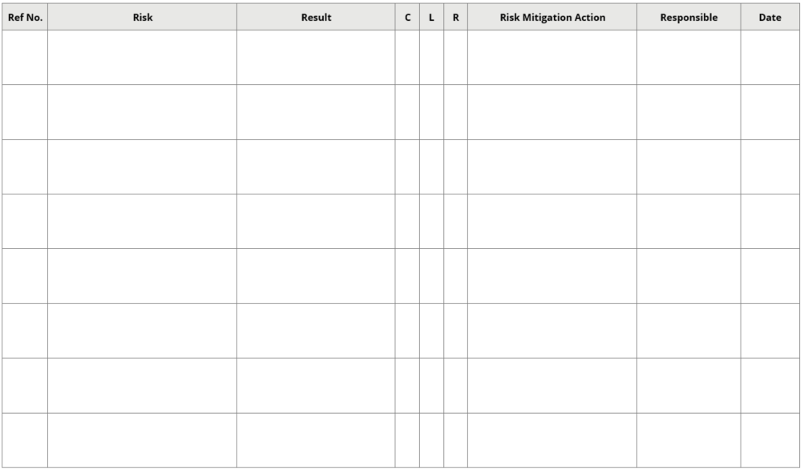

Implementing the Project

**SCOPE**

**COST**

**TIME**

Managing expectations and scope creep

As the Project Manager, it is your role to manage the expectations of your stakeholders and manage the deliverable scope of your project. Communication and engagement are the key for this, but it’s important to remember that communication is a two-way street:

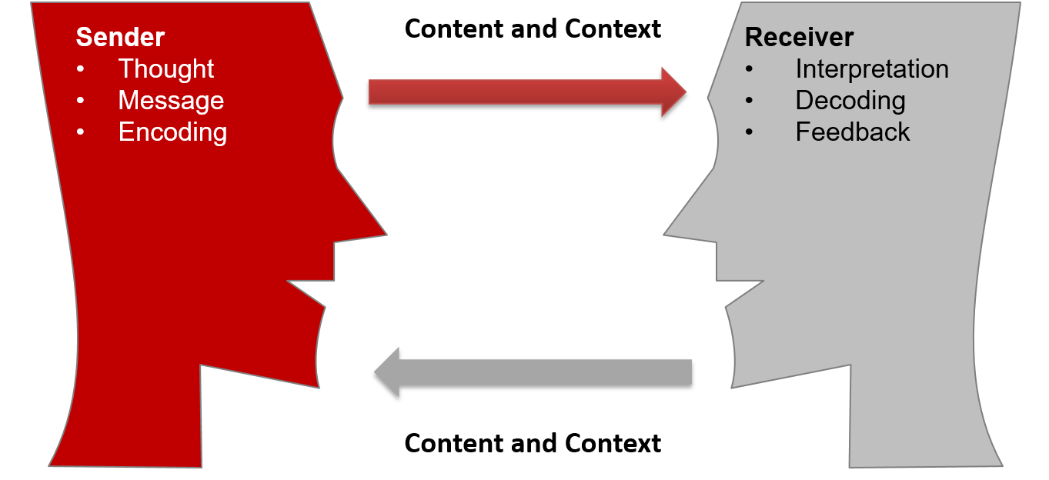

While you might think your message is clear, the receiver will interpret your message and decode it based on their internal view – *they might hear what they want to hear, and not what you said to them at all!*

It is vital to continually check their understanding of your message, to provide it in different forms and be explicit about what is and is not part of your project – and exactly when that will or will not occur.

Building the team

Project roles

|  |  |
| --- | --- |
| Sponsor | Assist with clearly defining the project outcomes.  Review and approve the project scope.  Executive level support focusing on outcomes and organisational impact.  Provide the project team with the time and resources required to deliver the project.  Conduct appropriate reviews of project progress.  Meet with the project team as requested.  Remove any organisational roadblocks.  Ensure ongoing organisational support throughout delivery. |
| Manager | Develop and seek approval for the project scope and detailed project plan.  Establish and motivate the project team to perform their allocated tasks.  Control the allocation of resources and use of funds to achieve the project.  Keep all stakeholders, and the sponsor, informed and happy with progress.  Analyse and manage project risks and identified issues.  Finalise the delivery of the project and organise the acceptance and handover to the operational area.  Evaluate the project and capture the lessons learnt for the organisation. |
| Team | Provide advice and support to the project manager throughout the development, implementation and closure of the project.  Complete their assigned tasks to achieve the planned outcomes of the project.  Liaise with appropriate stakeholders and flag any issues for resolution.  Ensure deliverables meet the quality requirements outlined in the plan, and raise issues as required.  Provide frank feedback in the evaluation process. |

All managers of people need to ensure that their team members understand their roles and responsibilities – projects are no different. Early engagement of team members, which allows them to participate in the project planning phase, is a great way to establish and inform your team. Where this is not possible, you need to ensure your induction processes and documentation cover these requirements adequately.

Activity: Stating their roles

Consider the information in your project plan – how can you use these resources to ensure your staff understand the purpose of the project and their roles and responsibilities delivering it?

As well as ensuring individuals understand their roles and responsibilities, it’s important to get the team working together as quickly as possible. You could use Tuckman’s team development model to help move your team to the Performing stage – which is where you need them to be.

Team dynamics

Activity: The Challenge

Participate in “The Challenge” and as the group debrief occurs, record your insights below

My insights

Tuckman’s team development model

|  |  |  |  |  |
| --- | --- | --- | --- | --- |
| Team dynamics can make or break the success of a project. Remember that:  Each step builds on the previous one  Each step prepares for the performing stage  Skipping any step negatively impacts performing  With every new challenge, the process repeats  Teams can move back and forth between stages. | | | | Plan for next task/ project/year  Members review/ assess the work/ project/year  Task/project completion |
| Adjourning |
|  | | | Achieve effective & satisfying results  Members find solutions using appropriate controls | Recognise & celebrate successes  Move on to next project/team etc |
| Tasks | | | Performing |  |
|  | | Members agree about roles & processes for problem solving | Members work collaboratively  Members care about each other  The group establishes a unique identity  Members are interdependent |
|  | | Norming |  | |
|  | Identifying power & control issues  Gaining skills in communication  Identifying resources | Decisions are made through negotiation & consensus building |
| Storming |  | | |
| Establish base level expectations  Identify similarities  Agreeing on common goals | Expressing differences of ideas, feelings, & opinions  Reacting to leadership  Members independent or counter-dependent | Behaviours | | |
| Forming |  | | | |
| Making contact & bonding  Developing trust  Members dependent |

Descriptions and actions for each stage as they relate to each other

|  |  |  |
| --- | --- | --- |
| Stage 1 Forming | * Individuals are not clear on what they’re supposed to do * The vision and goals aren’t owned by the group * Wondering where they’re going * No trust yet | * High learning * No group history; unfamiliar with group members * Norms of the team are not established * People check one another out * People are not committed to the team |
| Stage 2 Storming | * Roles & responsibilities are articulated * Agendas are displayed * Problem solving doesn’t work well * People want to modify the team’s vision or goals * Trying new ideas * Splinter groups may form * People set boundaries | * Anxiety abounds * People push for position & power * Competition is high * Cliques drive the team * Little team spirit * Lots of personal attacks * Level of participation by members is at its highest (for some) and its lowest (for some) |
| Stage 3 Norming | * Success occurs * Team has all resources for doing the job * Appreciation & trust build * Purpose is well defined * Feedback is high, well received & objective * Team confidence is high * Leader reinforces team behaviour | * Members self-reinforce team norms * Hidden agendas become open * Team is creative * More individual motivation * Team gains commitment from all members on direction & goals. |
| Stage 4 Performing | * Team members feel very motivated * No surprises * Little waste * Very efficient team operations * Team members have objective outlook * Individuals take pleasure in the success of the team – big wins * Individuals defer to team needs | * “We” versus “I” orientation * High pride in the team * High openness and support * High empathy * High trust in everyone * Superior team performance * OK to risk confrontation |
| Stage 5 Adjourning | * Retrospective thoughts & discussions * Anticipate future | * Plan on improvements/ changes etc * May be a sense of mourning |

|  |  |  |  |
| --- | --- | --- | --- |
| **Action steps  Forming to Storming** | **Action steps  Storming to Norming** | **Action steps  Norming to Performing** | **Action steps Performing to Adjourning** |
| * Set a mission & vision * Set goals * Establish roles * Recognise need to move out of “forming” stage * Leader must be directive * Figure ways to build trust * Define a reward structure * Take risks * Bring group together periodically to work on common tasks. * Assert power appropriately * Decide to be on the team | * Team leader should actively support & reinforce team behaviour, facilitate the group for wins, create positive environment. * Leader must ask for & expect results * Recognise, publicise team wins * Agree on roles & responsibilities. * Buy into objectives & activities * Actively listen to each other * Set & take team time together * Everyone works to set a supportive environment * Have the vision: “We can succeed!” * Request & accept feedback * Build trust by honouring commitments | * Maintain traditions * Praise & flatter each other * Self-evaluate without a fuss * Share leadership role in team based on who does what the best * Share rewards and successes * Communicate all the time * Share responsibility * Delegate freely within the team * Commit time to the team * Keep raising the bar – new, higher goals * Be selective of new team members; train to maintain the team spirit | * Discuss the task/work/ project/initiative * Celebrate successes & learnings * Plan & implement transition to next... |

Adapted from Tuckman’s Team Development Model

Activity: Team dynamics and my current (work) project

From a team dynamic perspective, what does this mean for the Project Manager and for project success?

Activity: Getting the skills

Review your Project and list the specialist skills you might require to deliver your project. How would you bring those skills into your team? Consider consultants, other staff in the organisation, training etc.

| **Skills** | **Who and/or How** |
| --- | --- |
|  |  |
|  |  |
|  |  |
|  |  |
|  |  |
|  |  |
|  |  |

Execution and monitoring

**Project**

Adapted from Cole, 2016

While it’s important to develop a robust project plan, the key to managing a project is the control and monitoring of its implementation. This is when the hard work begins; as issues arise, risks are realised, delays creep in, team members become challenging, stakeholders become problematic and the project deliverables are realised.

As mentioned in the planning phase, the project team should define and develop a range of documents that are used to assist the delivery of the project. These include:

|  |  |
| --- | --- |
| Project report to appropriate governance bodies | As well as keeping your governing body up to date, this report is used to escalate issues and seek executive support for resolving issues, risks, unforeseen budget impacts, communications and anything else that is affecting your ability to deliver on time and budget. |
| Project Issues Register | Used to capture any identified issues that might impact on the delivery within time, budget and identified quality. These issues could be identified by the team, or by other stakeholders. It’s a monitoring tool to help manage potential problems and their resolution. It is also part of your change management, identifying lack of, or reduced, support from areas of the business. |
| Project Risk Register | The Risk Register should be regularly reviewed to capture any newly identified risks, and their mitigation strategies. It should also be maintained to remove risks once they are no longer relevant to the project. Maintaining an awareness of risks and their strategies will ensure you are prepared to act should a risk occur. |
| Project Budget | The Project Manager needs to actively manage the budget and expenditure of the project. Some organisations might not be set up to easily capture and identify project expenditure. Regardless of this, the Project Manager must find a way to regularly capture all outgoing costs against the budgeted figures, so they can take appropriate action in the case of unexpected costs or overspending. |
| Project Gantt Chart | The Gantt Chart is a simple way to capture the progress of the project against the identified tasks, deliverables and milestones. The team can use this document to easily understand the impacts of delays, and their flow on effect to the remaining tasks and deadlines. It is particularly important to monitor this in relation to communications and key messages, so you can provide appropriate updates to stakeholders if delays occur. |
| Content calendar/schedule for communications | As noted above, this needs to be managed alongside the Gantt Chart to ensure alignment of communications and outcomes. The content calendar also ensures communications are developed in a timely manner, and you are deconflicting messages so you do not overwhelm stakeholders if and when things change. |
| Change/Variation Log | If you are using a Change/Variation Request process as part of your scope management then this would be used to manage and review that process, ensuring you understand the impact on any ‘scope creep’. |

Your organisation may have their own systems in place to manage these processes – reporting dashboards from key systems, systems to capture and report on issues and risks, traffic light financial reporting, etc. As a project manager, you must ensure you maintain complete awareness of all deliverables, and any issues that might impact their successful delivery – remembering that success should be the on-time, on-budget and within scope delivery of the project.

Activity: How will you monitor?

Using your Project, develop a basic outline of how you will monitor your project. Show that you have thought about the deliverables, milestones, budget, resources, risks and issues.

Activity: What to do?

Scenario One

You’re a month out from the deadline of your first major milestone and a team member has just informed you that the external contractor has contacted them about a significant issue. The key personnel for the contractor has resigned; as a result, they will not be able to complete the work in the required three weeks – they anticipate it will be six weeks before another staff member can come up to speed and complete the task. What do you do? How could this have been avoided?

Scenario Two

You are three months into the implementation of your nine month project and you have just been advised that a major organisational change project has slipped six months in delivery. This means the delivery of the new system, and month of organisation-wide training is now scheduled to occur over your delivery dates. It also means that two key staff who were going to be available for the last three months of your project, to help writing procedures and an online training module, will no longer be available. What are your options? Should you change your project?

Scenario Three

Your Project Sponsor, a member of the Executive Team, has been telling you that there is great support from all members of the Executive for your project. But, a colleague from another part of the business has just told you they overheard the Director of Operations telling one of his reports that the project is pointless and will never be completed if he has anything to say about it. Since Operations are a significant stakeholder in your project, you need to make sure they are supportive and engaged with the change. What should you do? Could this have been avoided?

Closing the Project

The project does not end when the final deliverable is complete – unless your final deliverable is the closure of the project. Far too often, organisations fail to complete the important handover, analysis and learnings processes that should be part of any good project.

As well as remembering to celebrate your achievements and communicate the closure with your stakeholders, there are a few other processes to complete at the end of every project.

Finalising the work

Analysis and acceptance

Before you can clearly state that you have delivered all the project outcomes and objectives, you need to analyse whether you have met your measurable goals. This is usually done through the development of a report that clearly outlines how you have met the requirements outlined in the project scope.

Some of this may have been completed along the way, if there were earlier deliverables in the project that have already been accepted by the business. If this has not been done, this report can be used as a means of seeking acceptance from the client that the project has delivered all deliverables within the requirements outlined.

Where the client is not satisfied with a deliverable, this must be resolved prior to closing the project.

Handover

All required documentation, paperwork, contracts, warranties etc. should have been handed over to the appropriate section in the business as part of the deliverables. However, sometimes these aspects are overlooked, or remain the responsibility of the project until such time as all deliverables are complete.

Prior to the closure of the project, it is essential that all ongoing functions, documentation, assets and staff are appropriately transitioned into the relevant business-as-usual section of the organisation. To ensure this is done correctly, consider who will be the ongoing point of contact for stakeholders, and whether they have everything they need to answer questions about why decisions were made and who they can seek support from.

Activity: Handover to the business

You have to pull together the documents and other paperwork for a handover to the business owner. What will you include? What is essential for them to have to hand? What else needs to be done?

Activity: Thank you and celebration

Your project has been running for 11 months, with a project team that has subject matter experts from across the business, a working group and a team of change champions. In your group, come up with some suggestions on how you will close out your project, thank everyone and celebrate your success.

|  |  |  |
| --- | --- | --- |
| **Close** | **Team** | **Supporting staff** |
|  |  |  |

Evaluating the project

Every project should be evaluated against the initial plan – how well did you perform against what you planned to deliver? Questions you might consider in this include:

* Did you achieve the Outcome(s)?
* Did you achieve the SMART Goal(s)?
* Did you meet your milestones on time?
* Did you deliver on budget?
* Did your deliverables meet the quality requirements?
* Were you prepared for any risks or issues that arose? If not, why not?
* Were your communications effective or were their issues with people misunderstanding or not being prepared for activities?
* Did the team perform their roles well – as individuals and a team?

Lessons learned

Another aspect of the evaluation is conducting a detailed analysis of the lessons learned during the project. It’s often best to consider this document while you are delivering the project, so you don’t have to try to rediscover all your earlier lessons at the end.

The lessons learned should consider everything that did not go exactly to plan; whether there was a way to prevent the ‘lesson’; and how you solved any problems that arose. Importantly, it should also include elements of your planning, team and processes that worked well, and that other project teams could use in future.

Once all your deliverables and final documentation have been accepted by your client, you can close out your project.

Activity: Effective evaluation

You’re about to conduct the evaluation on your project. What information would you use? Who needs to be involved? Who needs to know the outcome?

|  |  |  |
| --- | --- | --- |
| **What** | **Who** | **Who needs the report?** |
|  |  |  |

Activity: How did you go?

You are completing the evaluation for your Office Relocation Project. While the staff were in their new office by the required date, it took three weeks longer than expected to complete the “make good” on the old offices – which incurred additional rental costs.

As well as this, there were 4-6 week delays in completing the setup of the new AV in the meeting rooms, because of timing conflicts with the contractors. There were also a number of plumbing issues in the new kitchen areas which took about a month to completely resolve.

These delays did not increase the project costs, but there were three minor WHS incidents because of the AV cabling/equipment occurring around employees, and a major slipping incident in one of the kitchenettes.

How would you capture these outcomes? What might you learn from them to share with others? Create the other details you require.

Reflection and Plan

|  |  |
| --- | --- |
| What will I ***start*** doing? How will I know?  *(Priority order with timeframes)* | What will I ***stop/improve?*** How will I know?  *(Priority order with timeframes)* |
|  |  |
|  |  |
|  |  |
|  |  |

Who might I talk to for support or assistance?

|  |
| --- |
|  |

What do I want to find out more about?

|  |
| --- |
|  |

Notes and Ideas



Appendix A: Gantt Chart Template



Appendix B: RACI Matrix

Project governance accountabilities

Many projects run into trouble because they do not have clear accountabilities. To resolve this, you can define your governance accountabilities in the form of a RACI matrix.

A RACI (Responsible, Accountable, Consulted, Informed) matrix describes how the project roles are involved in the delivery of tasks, activities and deliverables.

* Responsible – the role(s) who will do the work to achieve the task.
* Accountable – the role with ultimate responsibility for the completion of the task or deliverable. There can only be one accountable person per task or deliverable.
* *Support – Depending on the project, you could also include Support and create a RASCI matrix.*
* Consulted – the people whose opinions are sought, usually experts.
* Informed – the people who need to be kept up-to-date on the progress or completion of the task or deliverable.

It might look like this:

|  |  |  |  |  |  |  |
| --- | --- | --- | --- | --- | --- | --- |
| **Tasks** | **Project Sponsor** | **Project Manager** | **Project Officer** | **Business Analyst** | **IT Manager** | **Finance Officer** |
| Approval of funding | AR | R |  |  | C | C |
| Finalisation of Business Requirements document |  | A | R | R | C |  |
| Development of Tender Plan | I | AR | R | I | C | R |

Some basic guidelines for the matrix are:

* The left-hand column can be defined in many different ways – project tasks, deliverables, work packages, stages, functions and so on.
* Accountability is where the buck stops. If something goes awry, this person is held to account.
* But, they may delegate to someone else – in which case that other person is Responsible.
* There should ideally only be one Accountable (A) in any row, to avoid buck-passing.
* One person may be both Accountable and Responsible (AR).
* Multiple people may be Responsible i.e. authority may be delegated to several people.
* ‘Consult’ means two-way communication – we are seeking feedback, input, opinion, advice.
* ‘Inform’ means one-way communication – we are pushing information out and not seeking anything back.
* As such, it makes no sense to have both C and I in any one box.
* Not every box needs to be filled.

Appendix C: Return on Investment (ROI)

There are a number of ways to measure the ROI of your project. Some organisations require you to calculate the Net Present Value (NPV) or Internal Rate of Return (IRR) as a means of deciding whether to proceed with the work. We’re going to focus on something far simpler than that, but you should check this with your organisation.

ROI = (Change in Operational Costs - Costs of Project) / Cost of Project

ROI = (Change in Revenue - Costs of Project) / Cost of Project

**Costs of Project:** Capture the total cost of the project, both the external and internal expenses. This would include things like: salaries, on-costs, service costs (IT, office space etc.), consultants, procurement, service contracts, insurances etc.

**Operational Costs:** Capture all changes in operational costs based on your project. This would include things like: contracts and licensing you no longer have to pay, changes in amount of materials required, changes in time taken (as a salary figure), changes in cost of materials, any ongoing expenditure of the project (licences, insurances etc.), etc. Note: not all these will be a reduction and some of them are difficult to calculate.

**Revenue:** Capture all changes to the organisation’s revenue relating to the project. This is self-evident and of course you could have Operational Cost savings alongside Revenue.

Most organisations consider ROI over a number of years, since it is often unrealistic to consider that a project will break even with its expenditure in the first year of implementation – and a project that introduces a significant organisational change may take a number of years to break even. This is often done over five years, depending on the size of the project.

For example, our project costs are $55,000 and we’ve calculated that the annual saving to the organisation is $25,000, but in the first year we’ll only realise half of that saving:

|  |  |  |  |
| --- | --- | --- | --- |
|  | **Project Costs** | **Operational Savings** | **ROI** |
| Year 1 | $55,000 | $12,500 | -$42,500 |
| Year 2 |  | $37,500 | -$17,500 |
| Year 3 |  | $62,500 | $7,500 |
| Year 4 |  | $87,500 | $32,500 |
| Year 5 |  | $112,500 | $57,500 |

You can see we will break even during Year 3 and after five years this project would realise a $57,500 return on investment – or using the calculation above:

($112,500 - $55,000) / $55,000 = 104.5% at the five year mark.

References

Cole K, 2016, *Management Theory and Practice Edition 6,* Cengage Australia

Dobie C, 2007, *A Handbook of Project Management: A Complete Guide for Beginners to Professionals*, Allen & Unwin, Australia

Gibbons P, 2015, *The Science of Successful Organizational Change: How Leaders Set Strategy, Change Behavior, and Create an Agile Culture*, Pearson Education

Hartley S, 2009, *Project Management Principles, Processes and Practice 2nd Ed*., Pearson Prentice Hall, Australia

Harvard Business Review, 2012, *Guide to Project Management,* Harvard Business Review Press

Project Management Institute, 2017, *A Guide to the Project Management Body of Knowledge (PMBOK® Guide)*, Sixth Edition

Online Resources

*Project Planning with Sticky Notes*: https://youtu.be/80c-LRRJ0W8

Tasmanian Government, *Project Management*, www.egovernment.tas.gov.au/project_management

