Self-assessment Tool

The most effective improvements to service delivery   
are initiated from within the service.

About the ACECQA Self-assessment Tool

**Comparison between current and revised NQS- QA1**

This tool will help your team to complete a self-assessment to contribute to the development, or review and update, of your Quality Improvement Plan (QIP).

It is the starting point for the team in planning to improve quality outcomes for children and families.

This tool will support you to:

* assess current practice
* identify service strengths
* identify areas for improvement
* critically reflect on how your service achieves quality outcomes for children and families
* share service practice with your families, community and authorised officers.

Contents

**Comparison between current and revised NQS- QA1**

|  |  |
| --- | --- |
| About the ACECQA Self-assessment Tool | 2 |
| 1. Introduction | 4 |
| 2. The roles of ACECQA and the regulatory authorities | 5 |
| 3. Tips for self-assessment | 6 |
| 4. Why self-assess? | 8 |
| 5. Who self-assesses? | 11 |
| 6. Reflection and self-assessment | 14 |
| 7. Above and beyond Meeting NQS | 16 |
| 8. Self-assessment is part of a process | 17 |
| 8.1 Service philosophy | 18 |
| 8.2 Self-assess | 20 |
| 8.3 Identify strengths and opportunities for improvement | 21 |
| 8.4 Develop your Quality Improvement Plan | 21 |
| 8.5 Review and reflect | 22 |
| Quality Area 1 – Educational program and practice | 23 |
| Quality Area 2 – Children’s health and safety | 30 |
| Quality Area 3 – Physical environment | 39 |
| Quality Area 4 – Staffing arrangements | 45 |
| Quality Area 5 – Relationships with children | 54 |
| Quality Area 6 – Collaborative partnerships with families and communities | 59 |
| Quality Area 7 – Governance and leadership | 64 |
| Attachment A – Self-assessment against the Exceeding NQS themes activity | 76 |

****1. Introduction****

**Comparison between current and revised NQS- QA1**

This Self-assessment Tool will support approved providers, service leaders and educators to reflect on and better understand their current practices and identify opportunities for improving quality outcomes for children and families.

A commitment to continuous improvement is inherent in the National Quality Framework (NQF) and striving for best practice underpins this commitment.

When all staff and educators of an education and care service understand what is guiding their practice, they can work together for continuous quality improvements to enhance outcomes for children.

This tool has been developed to guide and support the service team in the self-assessment of practice against the National Quality Standard (NQS) and the *Education and Care Services National Law* (National Law) and the Education and Care Services National Regulations (National Regulations). It aims to assist in the development and ongoing review of your Quality Improvement Plan (QIP), which is a separate document to this Self-assessment Tool.

**ACECQA**

****2. The roles of ACECQA and the regulatory authorities****

**Comparison between current and revised NQS- QA1**

**2. The roles of ACECQA and the Regulatory Authorities**

**Comparison between current and revised NQS- QA1**

ACECQA is an independent national authority that supports governments and the education and care sector to realise the benefits of the NQF. ACECQA guides and monitors the implementation and administration of the NQF to promote consistency across all states and territories.

Some of ACECQA’s key functions include:

|  |  |  |
| --- | --- | --- |
| Qualification approvals | Maintaining a national register of approved providers and services | Administering the NQA ITS |
| Excellent rating | Second tier review | Authorised officer training and support |

For more information about ACECQA visit: [acecqa.gov.au](http://www.acecqa.gov.au/)

**Regulatory authorities**

State and territory governments (regulatory authorities) have day-to-day contact with education and care providers and services and:

* assess and quality rate services against the NQS and the National Regulations
* monitor and enforce compliance with the National Law and National Regulations
* receive and investigate notifications of complaints, serious incidents and circumstances posing a risk to the safety, health and wellbeing of children.

For more information about the regulatory authority in your state or territory visit the [Contact your regulatory authority](https://www.acecqa.gov.au/help/contact-your-regulatory-authority) page on the ACECQA website.

ACECQA and the regulatory authorities work together to raise quality and drive continuous improvement and consistency in children’s education and care services.

****3. Tips for self-assessment****

**Comparison between current and revised NQS- QA1**

**Consider**

Self-assessment is most beneficial when it is done in a way that is relevant to the context of your service.When planning and implementing your self-assessment ensure that it suits the needs, capacity and context of your service. Think about:

* the structure of your organisation
* the location of your service
* your local community
* the requirements of your service type, for example, family day care or outside school hours care
* your service staff and educators
* the children and families that use your service.

**Plan**

Self-assessment is a process. It requires participation from your whole service community and adequate time to complete it without additional pressure. Planning will ensure the self-assessment process is effective.Planning is supported when there is:

* an awareness of the process and requirements of self-assessment
* clearly communicated roles, responsibilities and expectations, including for those leading the process
* familiarity with key support resources
* consideration given to how the team is involved, adequately supported and resourced throughout the process
* time allocated for meaningful participation.

**Encourage openness and honesty**

Self-assessment and quality improvement will be most productive when those involved are open, honest and feel comfortable to be reflective and critical. Effective communication and positive workplace culture will allow everyone the opportunity to participate and have a voice. Having an open and honest approach will also ensure key issues are identified and addressed.

**Use documents that suit your service**

Choose a self-assessment documentation process that suits your context and planning approach. Every service context and community is unique. This tool is only one way to document self-assessment and inform your QIP. You may need to adapt the tool to suit your service type, for example, consider how family day care educators might access and use it.

Self-assessment documentation is not required to be submitted to the regulatory authority. However, evidence must demonstrate that self-assessment has informed the service QIP.

**Use the outcomes of your self-assessment to develop your Quality Improvement Plan (QIP)**

After identifying service strengths and areas for improvement, the summary can be transferred directly into your QIP. Remember, your self-assessment identifies areas for improvement and your QIP then prioritises these improvements. Your QIP does not need to cover all quality areas, only those where you have identified improvements are needed to meet the NQS.

****4. Why self-assess?****

**Comparison between current and revised NQS- QA1**

**Self-assessment is a regulatory requirement in developing a QIP**

*Improving outcomes for children and families is embedded in the National Quality Framework and the National Law and National Regulations.*

The NQF provides the quality standard for children’s education and care services in Australia. It aims to deliver quality outcomes for children and drive continuous improvement and consistency through:

* the National Law and National Regulations
* a National Quality Standard (NQS)
* an assessment and quality rating process
* approved learning frameworks.

The [National Regulations](https://www.legislation.nsw.gov.au/#/view/regulation/2011/653) (regulation 55) require an approved provider to develop a QIP within three months of being granted service approval.

The QIP must include:

1. service philosophy
2. assessment of the quality of service practices against the NQS and the Regulations
3. 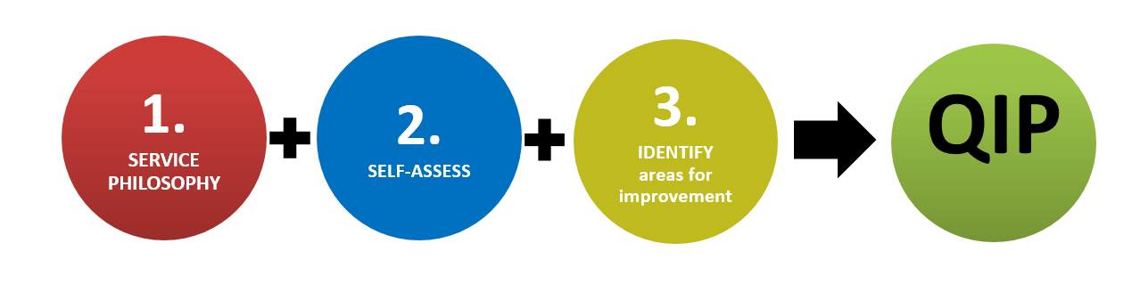identification of any areas that require improvement.

The approved provider must submit the QIP to the regulatory authority, on request (regulation 55). This is typically before an assessment and rating, but may be requested at any time.

The QIP must be reviewed and revised at least annually, and at any time when directed by the regulatory authority (regulation 56).**Self-assessment informs service delivery**

Self-assessment provides approved providers with an informed picture of current practice and the quality of education and care experienced by children and families attending the service. The process assesses service practice against the NQS, recognises strengths and identifies areas to be improved. A coordinated approach to self-assessment can also help the team see the service with fresh eyes and from a different perspective, and with that comes a greater understanding of service programs and practices as well as an increased confidence to articulate quality practice within the service.

*Self-assessment is about critically reflecting on your current practice, recognising strengths and identifying opportunities for improvement.*

|  |  |  |  |  |
| --- | --- | --- | --- | --- |
| **Key resources to support self-assessment**  Familiarity and understanding of these key resources may be useful to the team during the self-assessment process. | | | | |
| Education and Care National Law      Guide to the National Quality Framework      The Early Years Learning Framework | **Accessed** | Education and Care National Regulations      Quality Improvement Planning      The School Age Framework    * Including [other approved frameworks](https://www.acecqa.gov.au/nqf/national-law-regulations/approved-learning-frameworks) | | **Accessed** |
| **Resources to help navigate the NQF** | | | | |
| **Quest for Quality NQS Knowledge Game** | | | **NQF – Who Does What? card Game** | |
| [Image result for kahoot](https://www.acecqa.gov.au/resources/supporting-materials/games)**ACECQA developed Kahoot! quizzes** | | |  | |
| **Reflections and notes** | | | | |
| **When considering these key resources, you may like to consider:**   * *How are the resources accessed by team members?* * *Are they the most recent editions?* * *Who has access to these resources?* * *How could you make these resources more accessible?* | | | | |

5. Who self-assesses?

**Comparison between current and revised NQS- QA1**

The Regulations require the approved provider of an education and care service to prepare, review and revise a QIP**. However, it is not expected that they are solely responsible for carrying out the self-assessment**.

Self-assessment and quality improvement planning will benefit from being a **shared and collaborative process** involving all members of the team and the service community. Each member of the team, families and the service’s community will bring different perspectives, opinions and perceptions and have something different to offer. While not everyone is responsible for the self-assessment, they can actively contribute to it. Consider the involvement, roles and responsibilities the following may have in self-assessment:

|  |  |
| --- | --- |
| * Approved provider * Nominated supervisor * Service management * Coordinators * Educational leader | * Educators * Other service staff * Children * Families * School * The broader service community |

During the self-assessment, it is important to maintain an understanding of the way individuals use the service (e.g. employer, employee, service user, other stakeholders) as this can influence how they see and view the service and the quality of its practices.

**Children and self-assessment**

*The right of the child to be heard is set out under Article 12 of the*[*United Nations Convention on the Rights of the Child*](https://www.unicef.org/rightsite/files/uncrcchilldfriendlylanguage.pdf)*(UNCRC).*

*It establishes the right of every child to have their say in decisions that affect them and to have their opinions taken into account. This this should be recognised as a valid and fundamental part of service self-assessment.* **.**

Children can play an important role in the self-assessment process as they can be a good source of information and reflection on matters affecting them. As quality improvement goals mainly benefit children, it makes sense to engage children meaningfully and reflect their voices in the self-assessment process.

The NQF, NQS and [approved learning frameworks](https://www.acecqa.gov.au/nqf/national-law-regulations/approved-learning-frameworks) apply a strengths and rights-based approach. They position children **as active participants** in their learning and as owners of rights, respect and agency. Children’s ‘agency’ is integral to the NQS and approved learning frameworks.

The UNCRC articles are also embedded within the Guiding Principles of the NQF. These principles apply when making operational decisions and working to meet or exceed the NQS.

**Families and community involvement**

It is also important to think about how families and the community could be involved in your service self-assessment. While it can be challenging to get everyone engaged in the process, it is important to think about how they might be engaged. It doesn’t mean they have to be physically present and volunteer their time, but it does mean that the opportunities to be informed and contribute should be considered. This might also look different if you are a family day care service with a spread of educators or an outside school hours care service that needs to consider the role the school/s play in your self-assessment.

|  |  |
| --- | --- |
| **Who is participating in your service  self-assessment?** | Ideally, all members of your service community should have the opportunity to participate or be represented. |
| **Reflections questions** | Posing these reflective questions may support you in considering who should participate in the service’s self-assessment. |

|  |  |  |  |  |  |  |  |  |  |
| --- | --- | --- | --- | --- | --- | --- | --- | --- | --- |
| **Who might be involved**  Approved provider  Families  Children  Nominated supervisor  Service leaders and management  Coordinator(s)  Educational leader(s)  Educators  Other service staff  Broader service community representatives:   |  | | --- | |  | |  | **Reflective questions:**   * *List who is part of your ‘service community’? (see Resources below)*  |  | | --- | |  |  * *Are all service community members (see left-hand column) participating?*  |  | | --- | |  |  * *How can you encourage and support meaningful participation from all of your service community members?*  |  | | --- | |  |  * *How can children’s voices, feedback and opinions be included?*  |  | | --- | |  |  * *Are community members familiar with the* ***Key Resources****?*  |  | | --- | |  |  * *If not, how can you support this?*  |  | | --- | |  | |
| **Useful resources** | | |
| Information sheet: Supporting Agency  We Hear You blog: The role of community | | |

**Self-assessment requires reflection on each NQS quality area**

Self-assessment involves analysing ‘what you do’ against the National Law and Regulations (compliance) and the standards and elements of each NQS quality area. Analysing ‘what you do’ requires **reflection and evaluation** on service practice, policies and procedures. This reflection and evaluation will support you to confirm legislative compliance requirements are met and whether you consider that you are meeting the NQS.

6. Reflection and self-assessment

**Comparison between current and revised NQS- QA1**

To support your understanding of the NQS and to help you self-assess, the [Guide to the National Quality F](https://www.acecqa.gov.au/nqf/about/guide)ramework includes a set of reflective questions for each standard of each NQS quality area.

These reflective questions can be found with the guidance for each standard and are grouped as questions for all service types. These questions also address specific service types, such as family day care and outside school hours care.

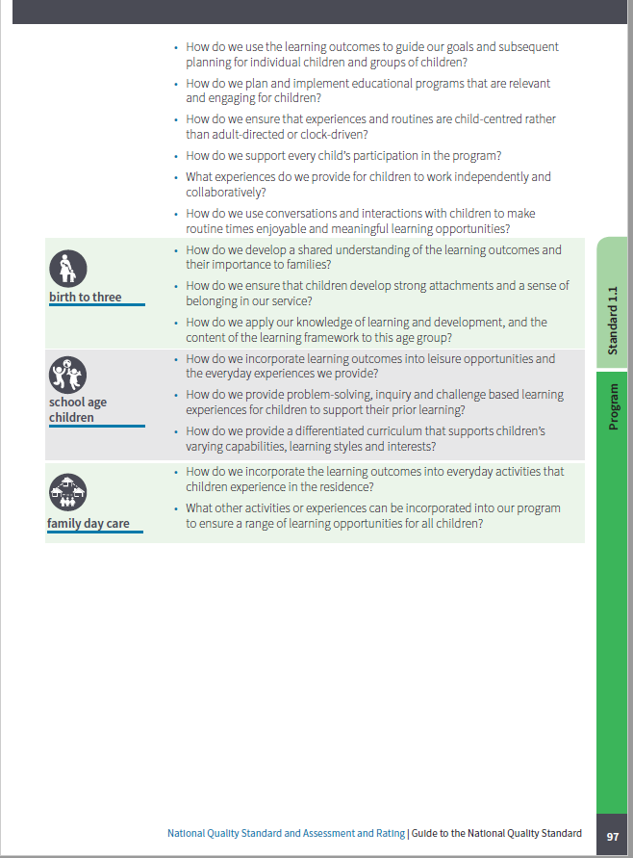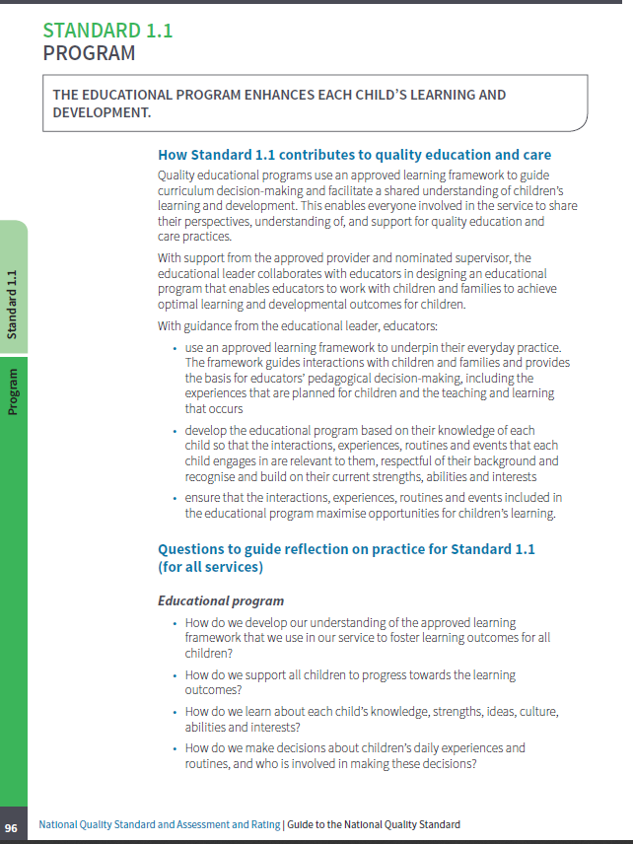

*The reflective questions can be prompts to explore your current practice, policies and procedures.*

They can assist you to think about ***how*** and ***why*** things are done in a particular way, while reflecting on current practices to consider if they are:

* effective for all children and families
* relevant to the service and community
* equal and fair for all children, families and educators
* consistent with the service philosophy.

|  |
| --- |
| **Reflective questions to consider for each NQS standard** |
| |  | | --- | | * *What practices do we implement that demonstrate this standard?* | | * *How are our practices improving outcomes for children and families?* | | * *How do we demonstrate that our practice is typical for our service?* | | * *How do/could we articulate what informs our practice?* | | * *How do we engage with families and/or the community?* | | * *What, if any, are the areas where we need to take immediate action?* | | * *What are the opportunities for quality improvement?* | |
| **Useful resources** |
| Information sheet: Developing a culture of learning through reflective practice |

**A rating of Exceeding NQS is applied at the standard level and means going above and beyond what is expected at the Meeting NQS level for a standard.**

7. Above and beyond Meeting NQS

**Comparison between current and revised NQS- QA1**

When you self-assess against the NQS and reflect on ‘what you do’, you may identify practice that you consider is above and beyond the ‘Meeting NQS’ level. To determine if such practice is consistent with an Exceeding NQS rating, three themes need to be demonstrated.

**Theme 1: Practice is embedded in service operations**

This theme means that high quality practice for the standard is demonstrated consistently and frequently across the service, regardless of the time of day or changes to staff. This ensures a sense of continuity and predictability for children.

**Theme 2: Practice is informed by critical reflection**

When practice is informed by critical reflection, services consider, question, research, analyse and re-evaluate the requirements for each standard. This supports a culture of ongoing self-assessment that helps identify continuous improvement and improved outcomes for children, families and educators.

**Theme 3: Practice is shaped by meaningful engagement with families and/or the community**

Every education and care service is unique, as are the children, families, and community at the service. This theme recognises that high quality practice is shaped by and tailored to the unique strengths and needs of children, families and the community.

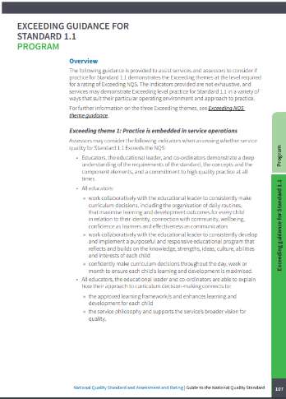

To support your understanding of the [Exceeding NQS themes](https://www.acecqa.gov.au/assessment/exceeding-nqs) and to help you self-assess, a number of resources are available.

ACECQA’s [Exceeding the NQS](https://www.acecqa.gov.au/assessment/exceeding-themes) webpage includes further information on the three Exceeding themes, as well as case studies that offer practical and illustrative examples of high quality practice for each standard.

The [Guide to the NQF](https://www.acecqa.gov.au/media/23811) includes general guidance on the Exceeding themes, reflective questions for services on Exceeding practice for each theme in each standard, as well as questions used by authorised officers to help establish whether Exceeding practice has been demonstrated.

You may demonstrate Exceeding NQS level practice in a variety of ways that suit your particular operating environment and approach to practice.

At the end of this tool is a useful resource activity (**Attachment A**) to support reflection on service practice and how it aligns with the Exceeding NQS themes. The Exceeding NQS themes activity can be used for any standard of the NQS.

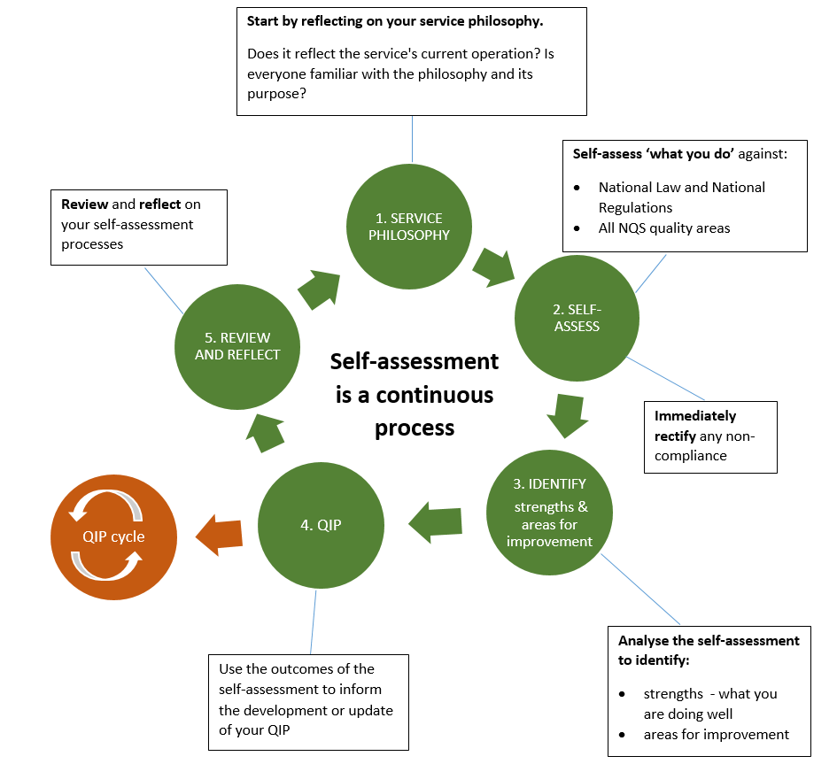

8. Self-assessment is part of a process

**Comparison between current and revised NQS- QA1**

|  |
| --- |
| **Reflections and notes** |
| **When considering your current self-assessment process, you may like to consider:**   * *How do you ensure self-assessment is a consistent, ongoing process and not just a once-a-year task?* * *When issues of non-compliance are rectified, how do you ensure quality improvement is embedded and this does not occur again?* |

8.1 Service philosophy

**Comparison between current and revised NQS- QA1**

**Step 1 in the self-assessment process should be reflecting on your service philosophy**

*NQS Element 7.1.1 requires a statement of philosophy that guides all aspects of the service’s operations.*

[*The National Regulations*](https://www.acecqa.gov.au/nqf/national-law-regulations/national-regulations)*(regulation 55) require the approved provider of an education and care service to ensure the service QIP contains a statement of the philosophy of service.*

Your service’s statement of philosophy should be a *living document* which is the foundation for daily practice.

The philosophy should be reflected in daily practice and guide decision making and service practice – outlining the purpose and principles under which the service operates. It should reflect the unique ‘personality’ and context of your service and incorporate the beliefs, goals, commitments, aspirations and intentions of those who belong to your service community.

The service philosophy should also express a shared understanding of the role of the service with educators, children, families and the community. These service community members should, ideally, be able to outline   
the central commitments of the philosophy and how these are enacted.

**Regularly reflecting on your service philosophy ensures that it is relevant to your service community and reflects ‘what you do’**

A service philosophy may change over time as children, families, staff and the community evolve and change. Practices can also often evolve as a result of this change.

Reviewing your philosophy in relation to ‘what you do’ – your current daily practices – ensures the service philosophy is consistent with practice and meeting the needs of your service community. It is also an opportunity to consider how your philosophy and practices align with the Guiding Principles of the NQF and the principles and outcomes of the approved learning framework/s.

Asking your families and community some key questions relevant to your service will support the review of and reflection on the philosophy. Following reflection, you may choose to review the philosophy or to review practices, to ensure they are in alignment.

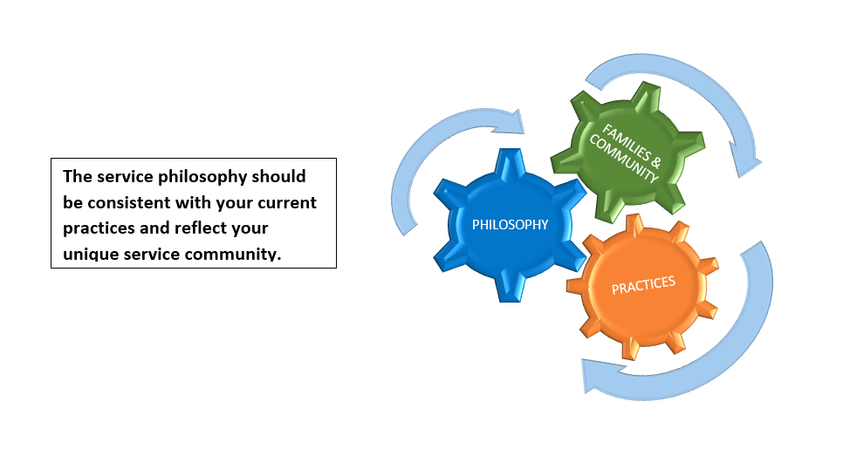

|  |
| --- |
| **Reflective questions when reviewing your philosophy** |
| * *When was the service philosophy developed?* * *When was the last review of the service philosophy?* * *What process was used to review it? Who was involved?* * *What are the key commitments in the current service philosophy?* * *Do all members of the service community have an understanding of the philosophy?* * *How does the philosophy reflect ‘what we do’ – our current daily practices? Are there inconsistencies?* * *If yes, should you revise the philosophy or realign your practices?* |
| **Useful resource** |
| Information Sheet: Reviewing your service philosophy |

8.2 Self-assess

**Comparison between current and revised NQS- QA1**

After considering your service philosophy, the next step is to assess the service’s practices against the NQS. Each service will determine what suits them best when doing the self-assessment. For example, everyone could consider each aspect and the team will work through it piece by piece, or maybe you’ll split tasks into smaller pieces of work for individuals or small groups to complete and then come back together to reflect on and discuss.

**To help with the next steps, you can use the following parts of this Self-assessment Tool to guide you through the self-assessment process using the following steps:**

**Consider your service**

* Review the compliance history at the service and how this can, or should, be considered in self-assessment.
* If applicable, revisit the outcomes of your previous assessment and rating report and rating.
* Consider previous self-assessments.
* Think about the key issues your service has faced or tried to address since your last self-assessment.
* Consider how your service type influences your practice.
* What legislative requirement changes need to be considered?

**Know the standards and elements of the NQS**

* For each quality area, standard and element, descriptors and concepts are provided.
* Reflect on the level of understanding of the quality area as well as the standard and elements in that quality area.
* If there are any areas where further understanding is needed, refer to Section 3 – National Quality Standard and Assessment and Rating in the Guide to the NQF.

**Legislative requirements**

* A checklist has been included to support your self-assessment against the legislation.
* The checklist details the legislation and, following your self-assessment, the opportunity to confirm compliance or non-compliance. An action to address any identified non-compliance should be recorded and rectified as a priority.
* Section 4 – Operational Requirements of the Guide to the NQF provides further information on the operational requirements of the NQF, including legislative requirements.
* You may need to discuss significant areas of non-compliance with your regulatory authority as these areas will need to be prioritised.

**Assessing against the National Quality Standard**

* For each Quality Area there will be the opportunity to record evidence against each of the elements within that standard.

8.3 Identify strengths and opportunities for improvement

**Comparison between current and revised NQS- QA1**

* When reflecting on the evidence gathered during the self-assessment determine if you consider the element to be met or not.

**Identify strengths and opportunities for improvement**

* After reviewing the outcomes of your self-assessment against the NQS and legislation it is now time to consider the strengths that have been identified and the areas for quality improvement.
* There is no need to record compliance as a strength unless it is identified that the service is going beyond the minimum requirements.
* For each quality area there is space to identify service strengths for that quality area.

8.4 Develop your Quality Improvement Plan

**Comparison between current and revised NQS- QA1**

* There is also the opportunity to record the elements/standards that the self-assessment identified as needing improvement or presenting opportunities for quality improvement.

**Use the outcomes of your self-assessment to develop your Quality Improvement Plan (QIP)**

* After identifying service strengths and areas for improvement, the summary can be transferred directly into your QIP. Remember, your self-assessment identifies areas for improvement. Where improvements need to be made, critically reflect on the issues and the way they can be addressed and use your QIP to prioritise these. **Your QIP does not need to cover all quality areas**, only those where you have identified improvements are needed to meet the NQS.

**Celebrate achievements**

8.5 Review and reflect

**Comparison between current and revised NQS- QA1**

* Don’t forget to use the QIP as a way of mapping and recording achievements to acknowledge, share and celebrate.

**Be sure to review and reflect on your self-assessment processes**

* As well as reviewing and reflecting on practice it is important to reflect on and review your self-assessment and quality improvement planning process.

Self-assessment documentation is not required to be submitted to the regulatory authority. However, evidence must demonstrate that self-assessment has informed the service QIP. You may wish to discuss your self-assessment process and show your self-assessment documentation to an authorised officer during your next assessment and rating visit.

For further information on completing your QIP, visit the [Quality Improvement Plan](https://www.acecqa.gov.au/assessment/quality-improvement-plans) page on the ACECQA website or the Assessment and Rating Process section of the [Guide to the National Quality Framework](https://www.acecqa.gov.au/media/23811).

The educational program and practice is stimulating, engaging and enhances children’s learning and development. In services for children over preschool age, the program nurtures the development of life skills and complements children’s experiences, opportunities and relationships at school, at home and in the community.

Quality Area 1 – Educational program and practice

**Comparison between current and revised NQS- QA1**

Quality Area 1 focuses on ensuring that the educational program and practice of educators are child-centred, stimulating and maximise opportunities for enhancing and extending each child’s learning and development. It recognises that a quality program that builds on children’s individual knowledge, strengths, ideas, culture, abilities and interests is likely to have long-term benefits for children and for the broader society.

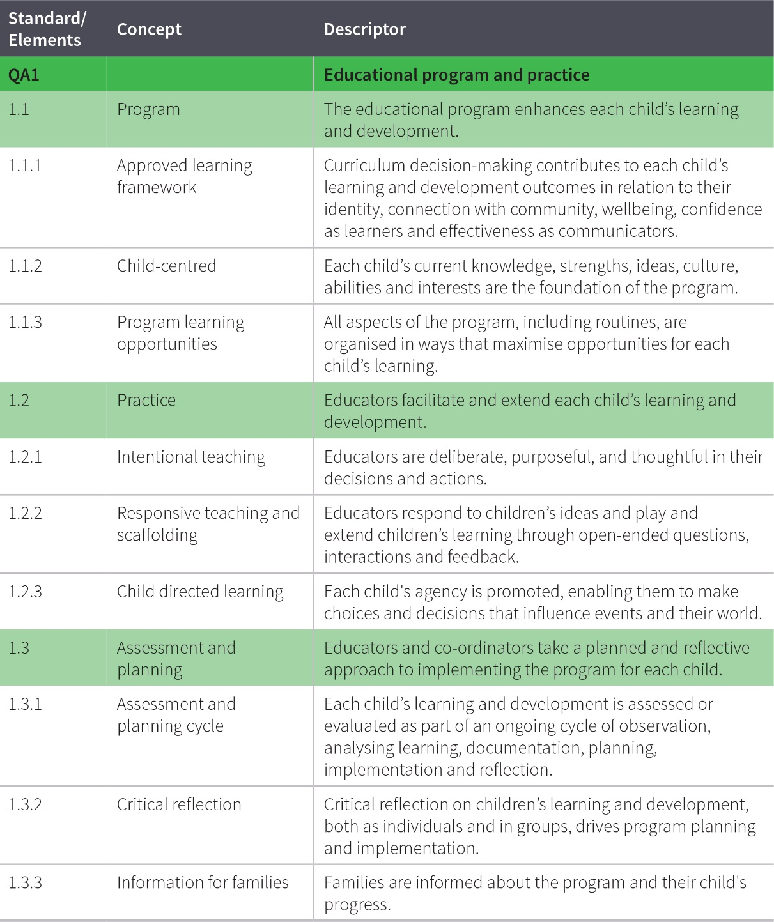

The table below shows the sections of the National Law and National Regulations underpinning Quality Area 1 and lists the most relevant element of the NQS associated with each section (S) and regulation (R). Please note that this table serves as a guide only and regulatory authorities have flexibility in how they assign non-compliance with the National Law and National Regulations against the quality areas, standards and elements of the NQS.

**Quality Area 1 – Legislative requirements**

**Comparison between current and revised NQS- QA1**

| **National Law and  National Regulations** | | **Associated element** | **Self-assessed status** | **Actions if non-compliant** |
| --- | --- | --- | --- | --- |
| S.51(1)(b) | Conditions on service approval (educational and developmental needs of children) | 1.1.1 | Compliant  Non-compliant |  |
| S.168 | Offence relating to required programs | 1.1.1  1.1.2 | Compliant  Non-compliant |  |
| R.73 | Educational program | 1.1.1 | Compliant  Non-compliant |  |
| R.74 | Documenting of child assessments or evaluations for delivery of educational program | 1.3.1 | Compliant  Non-compliant |  |
| R.75 | Information about educational program to be kept available | 1.3.3 | Compliant  Non-compliant |  |
| R.76 | Information about educational program to be given to parents | 1.3.3 | Compliant  Non-compliant |  |
| R.274A  NSW | Programs for children over preschool age | 1.3.1 | Compliant  Non-compliant |  |
| R.289A  NT | Programs for children over preschool age | 1.3.1 | Compliant  Non-compliant |  |
| R.298A  Queensland | Programs for children over preschool age | 1.3.1 | Compliant  Non-compliant |  |

Identify if the service meets the requirements of Quality Area 1: Educational program and practice.

**Quality Area 1 – National Quality Standard**

**Comparison between current and revised NQS- QA1**

**Standard 1.1: The educational program enhances each child’s learning and development.**

|  |  |  |  |  |  |
| --- | --- | --- | --- | --- | --- |
| **Concept** | **Element** | | **Identified practice/evidence from  self-assessment** | **Met** | **Not Met** |
| Approved learning framework | 1.1.1 | Curriculum decision-making contributes to each child’s learning and development outcomes in relation to their identity, connection with community, wellbeing, confidence as learners and effectiveness as communicators. |  |  |  |
| Child-centred | 1.1.2 | Each child’s current knowledge, strengths, ideas, culture, abilities and interests are the foundation of the program. |  |  |  |
| Program learning opportunities | 1.1.3 | All aspects of the program, including routines, are organised in ways that maximise opportunities for each child’s |  |  |  |

**Standard 1.2: Educators facilitate and extend each child’s learning and development.**

|  |  |  |  |  |  |
| --- | --- | --- | --- | --- | --- |
| **Concept** | **Element** | | **Identified practice/evidence from  self-assessment** | **Met** | **Not Met** |
| Intentional teaching | 1.2.1 | Educators are deliberate, purposeful, and thoughtful in their decisions and actions. |  |  |  |
| Responsive teaching and scaffolding | 1.2.2 | Educators respond to children’s ideas and play and extend children’s learning through open-ended questions, interactions and feedback. |  |  |  |
| Child directed learning | 1.2.3 | Each child’s agency is promoted, enabling them to make choices and decisions that influence events and their world. |  |  |  |

**Standard 1.3: Educators and co-ordinators take a planned and reflective approach to implementing the program for each child.**

|  |  |  |  |  |  |
| --- | --- | --- | --- | --- | --- |
| **Concept** | **Element** | | **Identified practice/evidence from  self-assessment** | **Met** | **Not Met** |
| Assessment and planning cycle | 1.3.1 | Each child’s learning and development is assessed or evaluated as part of an ongoing cycle of observation, analysing learning, documentation, planning, implementation and reflection. |  |  |  |
| Critical reflection | 1.3.2 | Critical reflection on children’s learning and development, both as individuals and in groups, drives program planning and implementation. |  |  |  |
| Information for families | 1.3.3 | Families are informed about the program and their child’s progress. |  |  |  |

**Practices that meet or exceed the expectations of the NQS**

**Identified strengths and improvement opportunities**

**Comparison between current and revised NQS- QA1**

**Quality Area 1: Service strengths**

|  |  |  |
| --- | --- | --- |
|  | | |
| **Practices identified that meet the Exceeding NQS themes** | | |
| Theme 1: Practice is embedded in service operations. | Theme 2: Practice is informed by critical reflection. | Theme 3: Practice is shaped by meaningful engagement with families and/or the community. |
|  |  |  |

**Continuous improvement opportunities**

**Quality Area 1: Areas for improvement**

|  |  |
| --- | --- |
| **Standard or element** | **Areas for improvement as identified in self-assessment** |
|  |  |
|  |  |
|  |  |

Every child’s health and wellbeing is safeguarded and promoted.

Quality Area 2 – Children’s health and safety

**Comparison between current and revised NQS- QA1**

Quality Area 2 reinforces children’s right to experience quality education and care in an environment that provides for their health and safety. Educators support this when they promote each child’s wellbeing and healthy lifestyle, and support each child’s growing competence, confidence and independence.

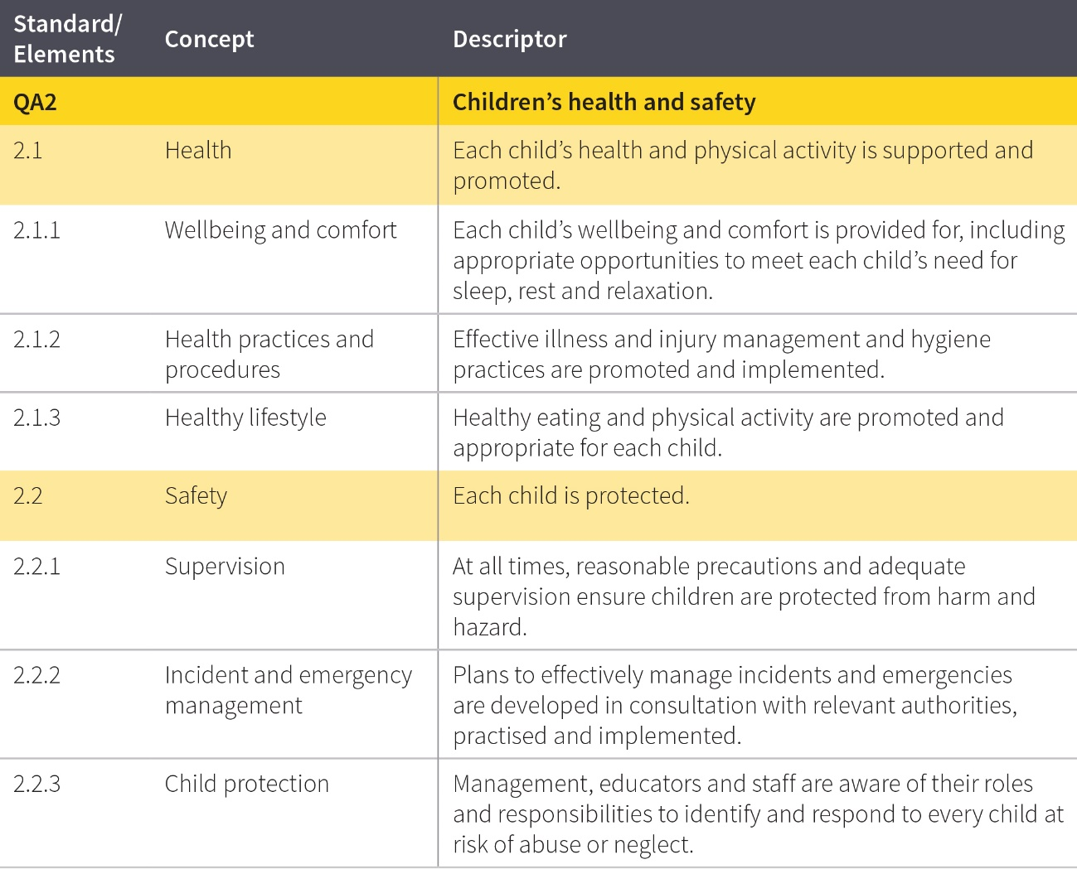

The table below shows the sections of the National Law and National Regulations underpinning Quality Area 2 and lists the most relevant element of the NQS associated with each section (S) and regulation (R). Please note that this table serves as a guide only and regulatory authorities have flexibility in how they assign non-compliance with the National Law and National Regulations against the quality areas, standards and elements of the NQS.

Quality Area 2 – Legislative requirements

**Comparison between current and revised NQS- QA1**

| **National Law and  National Regulations** | | **Associated element** | **Self-assessed status** | **Actions if non-compliant** |
| --- | --- | --- | --- | --- |
| S.51(1)(a) | Conditions on service approval (safety, health and wellbeing of children) | 2.1.1, 2.1.2  2.1.3, 2.2.1  2.2.2, 2.2.3 | Compliant  Non-compliant |  |
| S.162A | Persons in day-to-day charge and nominated supervisors to have child protection training | 2.2.3 | Compliant  Non-compliant |  |
| S.165 | Offence to inadequately supervise children | 2.2.1 | Compliant  Non-compliant |  |
| S.166 | Offence to use inappropriate discipline | 2.1.1  2.2.1 | Compliant  Non-compliant |  |
| S.167 | Offence relating to protection of children from harm and hazards | 2.2.1 | Compliant  Non-compliant |  |
| S.170 | Offence relating to unauthorised persons on education and care service premises | 2.2.1 | Compliant  Non-compliant |  |
| S.171 | Offence relating to direction to exclude inappropriate persons from education and care premises | 2.2.1 | Compliant  Non-compliant |  |
| R.77 | Health, hygiene and safe food practices | 2.1.2 | Compliant  Non-compliant |  |
| R.78 | Food and beverages | 2.1.3 | Compliant  Non-compliant |  |
| R.79 | Service providing food and beverages | 2.1.3 | Compliant  Non-compliant |  |
| R.80 | Weekly menu | 2.1.3 | Compliant  Non-compliant |  |
| R.81 | Sleep and rest | 2.1.1 | Compliant  Non-compliant |  |
| R.82 | Tobacco, drug and alcohol free environment | 2.2.1 | Compliant  Non-compliant |  |
| R.83 | Staff members and family day care educators not to be affected by alcohol or drugs | 2.2.1 | Compliant  Non-compliant |  |
| R.84 | Awareness of child protection law | 2.2.3 | Compliant  Non-compliant |  |
| R.85 | Incident, injury, trauma and illness policies and procedures | 2.1.2 | Compliant  Non-compliant |  |
| R.86 | Notification to parents of incident, injury, trauma and illness | 2.1.2 | Compliant  Non-compliant |  |
| R.87 | Incident, injury, trauma and illness record | 2.1.2 | Compliant  Non-compliant |  |
| R.88 | Infectious diseases | 2.1.2 | Compliant  Non-compliant |  |
| R.89 | First aid kits | 2.1.2 | Compliant  Non-compliant |  |
| R.90 | Medical conditions policy | 2.1.2 | Compliant  Non-compliant |  |
| R.91 | Medical conditions policy to be provided to parents | 2.1.2 | Compliant  Non-compliant |  |
| R.82 | Tobacco, drug and alcohol free environment | 2.2.1 | Compliant  Non-compliant |  |
| R.83 | Staff members and family day care educators not to be affected by alcohol or drugs | 2.2.1 | Compliant  Non-compliant |  |
| R.84 | Awareness of child protection law | 2.2.3 | Compliant  Non-compliant |  |
| R.85 | Incident, injury, trauma and illness policies and procedures | 2.1.2 | Compliant  Non-compliant |  |
| R.86 | Notification to parents of incident, injury, trauma and illness | 2.1.2 | Compliant  Non-compliant |  |
| R.87 | Incident, injury, trauma and illness record | 2.1.2 | Compliant  Non-compliant |  |
| R.88 | Infectious diseases | 2.1.2 | Compliant  Non-compliant |  |
| R.89 | First aid kits | 2.1.2 | Compliant  Non-compliant |  |
| R.90 | Medical conditions policy | 2.1.2 | Compliant  Non-compliant |  |
| R.91 | Medical conditions policy to be provided to parents | 2.1.2 | Compliant  Non-compliant |  |
| R.92 | Medication record | 2.1.2 | Compliant  Non-compliant |  |
| R.93 | Administration of medication | 2.1.2 | Compliant  Non-compliant |  |
| R.94 | Exception to authorisation requirement—anaphylaxis or asthma emergency | 2.1.2 | Compliant  Non-compliant |  |
| R.95 | Procedure for administration of medication | 2.1.2 | Compliant  Non-compliant |  |
| R.96 | Self-administration of medication | 2.1.2 | Compliant  Non-compliant |  |
| R.97 | Emergency and evacuation procedures | 2.2.2 | Compliant  Non-compliant |  |
| R.98 | Telephone or other communication equipment | 2.2.2 | Compliant  Non-compliant |  |
| R.99 | Children leaving the education and care premises | 2.2.1 | Compliant  Non-compliant |  |
| R.100 | Risk assessment must be conducted before excursion | 2.2.1 | Compliant  Non-compliant |  |
| R.101 | Conduct of risk assessment for excursion | 2.2.1 | Compliant  Non-compliant |  |
| R.102 | Authorisation for excursions | 2.2.1 | Compliant  Non-compliant |  |

Identify if the service meets the requirements of Quality Area 2: Children’s health and safety. Every child’s health and wellbeing is safeguarded and promoted.

Quality Area 2 – Children’s health and safety

**Comparison between current and revised NQS- QA1**

**Standard 2.1: Every child’s health and wellbeing is safeguarded and promoted.**

|  |  |  |  |  |  |
| --- | --- | --- | --- | --- | --- |
| **Concept** | **Element** | | **Identified practice/evidence from  self-assessment** | **Met** | **Not Met** |
| Wellbeing and comfort | 2.1.1 | Each child’s wellbeing and comfort is provided for, including appropriate opportunities to meet each child’s need for sleep, rest and relaxation. |  |  |  |
| Health practices and procedures | 2.1.2 | Effective illness and injury management and hygiene practices are promoted and implemented. |  |  |  |
| Healthy lifestyle | 2.1.3 | Healthy eating and physical activity are promoted and appropriate for each child. |  |  |  |

**Standard 2.2: Each child is protected.**

|  |  |  |  |  |  |
| --- | --- | --- | --- | --- | --- |
| **Concept** | **Element** | | **Identified practice/evidence from  self-assessment** | **Met** | **Not Met** |
| Supervision | 2.2.1 | At all times, reasonable precautions and adequate supervision ensure children are protected from harm and hazard. |  |  |  |
| Incident and emergency management | 2.2.2 | Plans to effectively manage incidents and emergencies are developed in consultation with relevant authorities, practised and implemented. |  |  |  |
| Child protection | 2.2.3 | Management, educators and staff are aware of their roles and responsibilities to identify and respond to every child at risk of abuse or neglect. |  |  |  |

**Practices that meet or exceed the expectations of the NQS**

**Identified strengths and improvement opportunities**

**Comparison between current and revised NQS- QA1**

**Quality Area 2: Service strengths**

|  |  |  |
| --- | --- | --- |
|  | | |
| **Practices identified that meet the Exceeding NQS themes** | | |
| Theme 1: Practice is embedded in service operations. | Theme 2: Practice is informed by critical reflection. | Theme 3: Practice is shaped by meaningful engagement with families and/or the community. |
|  |  |  |

**Continuous improvement opportunities**

**Quality Area 2: Areas for improvement**

|  |  |
| --- | --- |
| **Standard or element** | **Areas for improvement as identified in self-assessment** |

|  |  |
| --- | --- |
|  |  |
|  |  |
|  |  |

The physical environment is safe, suitable and provides a rich and diverse range of experiences which promote children’s learning and development.

Quality Area 3 – Physical environment

**Comparison between current and revised NQS- QA1**

Quality Area 3 of the NQS focuses on the physical environment. The physical environment is critical to:

* contributing to children’s wellbeing, creativity and developing independence
* providing a diverse range of experiences that promote children’s learning and development
* keeping children safe
* creating/organising spaces to reduce the risk of injury.

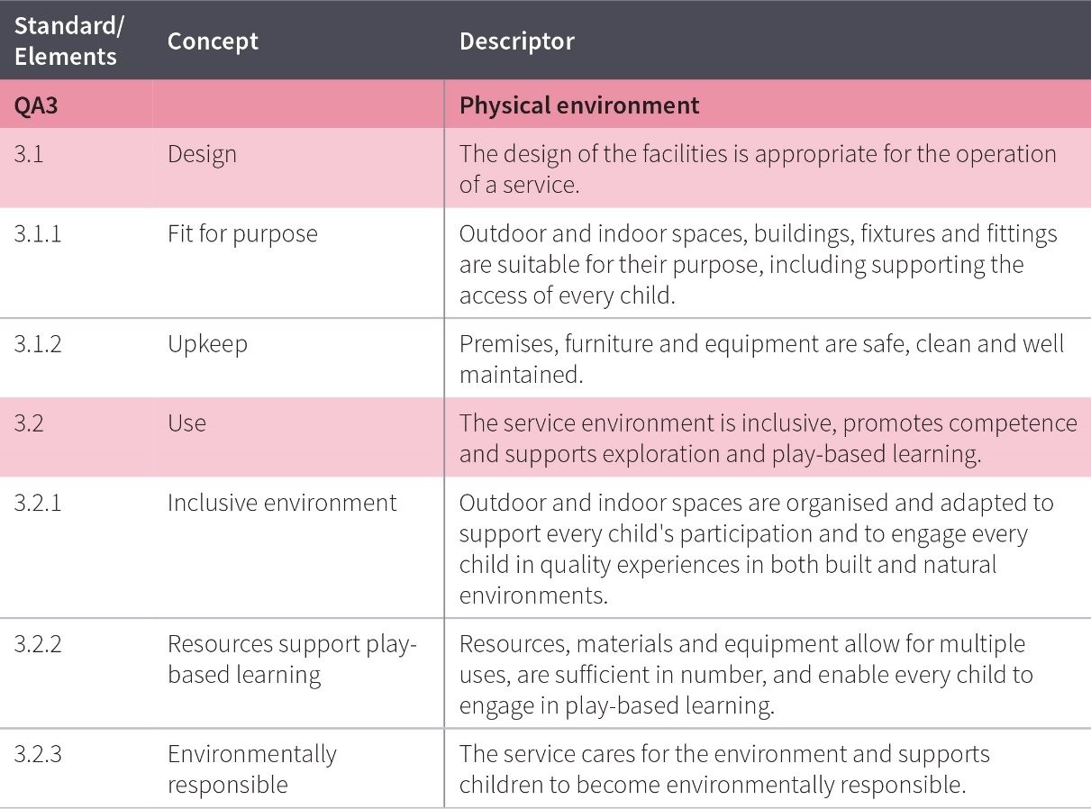

The table below shows the sections of the National Law and National Regulations underpinning Quality Area 3 and lists the most relevant element of the NQS associated with each section (S) and regulation (R). Please note that this table serves as a guide only and regulatory authorities have flexibility in how they assign non-compliance with the National Law and National Regulations against the quality areas, standards and elements of the NQS.

Quality Area 3 – Legislative requirements

**Comparison between current and revised NQS- QA1**

| **National Law and  National Regulations** | | **Associated element** | **Self-assessed status** | **Actions if non-compliant** |
| --- | --- | --- | --- | --- |
| R.103 | Premises, furniture and equipment to be safe, clean and in good repair | 3.1.2 | Compliant  Non-compliant |  |
| R.104 | Fencing | 3.1.1 | Compliant  Non-compliant |  |
| R.105 | Furniture, materials and equipment | 3.2.2 | Compliant  Non-compliant |  |
| R.106 | Laundry and hygiene facilities | 3.1.1 | Compliant  Non-compliant |  |
| R.107 | Space requirements—indoor | 3.1.1 | Compliant  Non-compliant |  |
| R.108 | Space requirements—outdoor | 3.1.1 | Compliant  Non-compliant |  |
| R.109 | Toilet and hygiene facilities | 3.1.1 | Compliant  Non-compliant |  |
| R.110 | Ventilation and natural light | 3.1.1 | Compliant  Non-compliant |  |
| R.111 | Administrative space | 3.1.1 | Compliant  Non-compliant |  |
| R.112 | Nappy change facilities | 3.1.1 | Compliant  Non-compliant |  |
| R.113 | Outdoor space—natural environment | 3.2.1 | Compliant  Non-compliant |  |
| R.114 | Outdoor space—shade | 3.1.1 | Compliant  Non-compliant |  |
| R.115 | Premises designed to facilitate supervision | 3.1.1 | Compliant  Non-compliant |  |
| R.116 | Assessments of family day care residences and approved family day care venues | 3.1.1 | Compliant  Non-compliant |  |
| R.117 | Glass (additional requirement for family day care) | 3.1.1 | Compliant  Non-compliant |  |
| R.274  NSW | Swimming pools | 3.1.2 | Compliant  Non-compliant |  |
| R.345  Tasmania | Swimming pool prohibition | 3.1.2 | Compliant  Non-compliant |  |

Identify if the service meets the requirements of Quality Area 3: Physical environment. The physical environment is safe, suitable and provides a rich and diverse range of experiences, which promote children’s learning and development.

Quality Area 3 – Physical environment

**Comparison between current and revised NQS- QA1**

**Standard 3.1: The design and location of the premises is appropriate for the operation of a service.**

|  |  |  |  |  |  |
| --- | --- | --- | --- | --- | --- |
| **Concept** | **Element** | | **Identified practice/evidence from  self-assessment** | **Met** | **Not Met** |
| Fit for purpose | 3.1.1 | Outdoor and indoor spaces, buildings, fixtures and fittings are suitable for their purpose, including supporting the access of every child. |  |  |  |
| Upkeep | 3.1.2 | Premises, furniture and equipment are safe, clean and well maintained. |  |  |  |

**Standard 3.2: The service environment is inclusive, promotes competence and supports exploration and play-based learning.**

|  |  |  |  |  |  |
| --- | --- | --- | --- | --- | --- |
| **Concept** | **Element** | | **Identified practice/evidence from  self-assessment** | **Met** | **Not Met** |
| Inclusive environment | 3.2.1 | Outdoor and indoor spaces are organised and adapted to support every child's participation and to engage every child in quality experiences in both built and natural environments. |  |  |  |
| Resources support play based learning | 3.2.2 | Resources, materials and equipment allow for multiple uses, are sufficient in number, and enable every child to engage in play-based learning. |  |  |  |
| Environmentally responsible | 3.2.3 | The service cares for the environment and supports children to become environmentally responsible. |  |  |  |

**Practices that meet or exceed the expectations of the NQS**

**Identified strengths and improvement opportunities**

**Comparison between current and revised NQS- QA1**

**Quality Area 3: Service strengths**

|  |  |  |
| --- | --- | --- |
|  | | |
| **Practices identified that meet the Exceeding NQS themes** | | |
| Theme 1: Practice is embedded in service operations. | Theme 2: Practice is informed by critical reflection. | Theme 3: Practice is shaped by meaningful engagement with families and/or the community. |
|  |  |  |

**Continuous improvement opportunities**

**Quality Area 3: Areas for improvement**

|  |  |
| --- | --- |
| **Standard or element** | **Areas for improvement as identified in self-assessment** |

|  |  |
| --- | --- |
|  |  |
|  |  |
|  |  |

Staffing arrangements create a safe and predictable environment for children and support warm, respectful relationships. Qualified and experienced educators and co-ordinators encourage children’s active engagement in the learning program. Positive relationships among educators, co-ordinators and staff members contribute to an environment where children feel emotionally safe, secure and happy.

Quality Area 4 – Staffing arrangement

**Comparison between current and revised NQS- QA1**

Quality Area 4 focuses on the provision of qualified and experienced educators who develop warm, respectful relationships with children, create predictable environments and encourage children’s active engagement in the learning program. A collaborative and ethical culture where professional standards guide all aspects of practice is critical to a quality service.

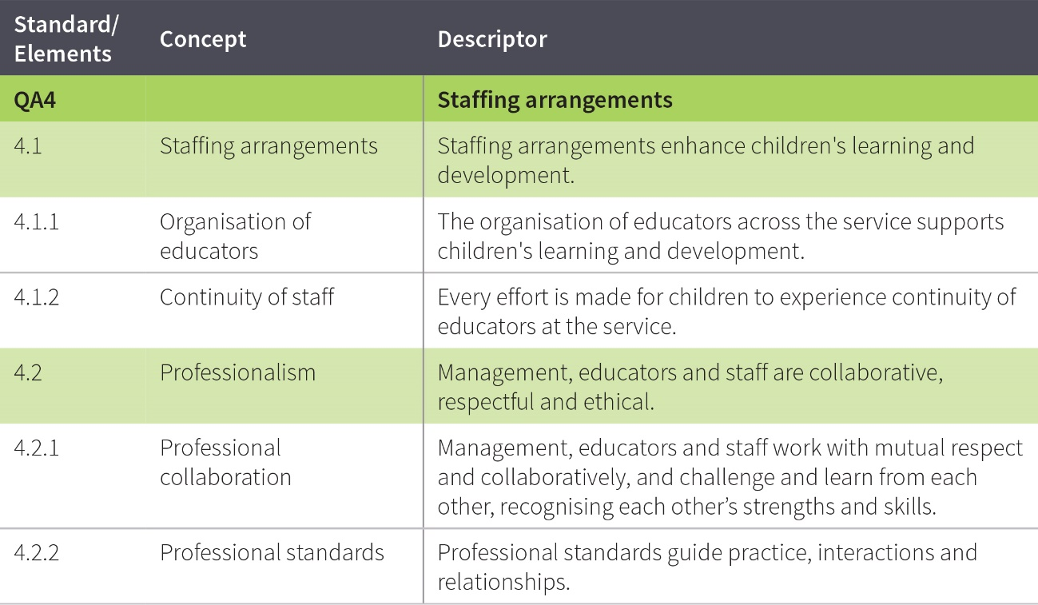

The table below shows the sections of the National Law and National Regulations underpinning Quality Area 4 and lists the most relevant element of the NQS associated with each section (S) and regulation (R). Please note that this table serves as a guide only and regulatory authorities have flexibility in how they assign non-compliance with the National Law and National Regulations against the quality areas, standards and elements of the NQS.

Quality Area 4 – Legislative requirements

**Comparison between current and revised NQS- QA1**

| **National Law and  National Regulations** | | **Associated element** | **Self-assessed status** | **Actions if non-compliant** |
| --- | --- | --- | --- | --- |
| S.51(2) | Conditions on service approval (FDC Coordinators) | 4.1.1 | Compliant  Non-compliant |  |
| S.161 | Offence to operate education and care service without nominated supervisor | 4.1.1 | Compliant  Non-compliant |  |
| S.161A | Offence for nominated supervisor not to meet prescribed minimum requirements | 4.1.1 | Compliant  Non-compliant |  |
| S.162 | Offence to operate education and care service unless responsible person is present | 4.1.1 | Compliant  Non-compliant |  |
| S.163 | Offence relating to appointment or engagement of family day care co-ordinators | 4.1.1 | Compliant  Non-compliant |  |
| S.164 | Offence relating to assistance to family day care educators | 4.1.1 | Compliant  Non-compliant |  |
| S.164A | Offence relating to the education and care of children by family day care service | 4.1.1 | Compliant  Non-compliant |  |
| S.169 | Offence relating to staffing arrangements | 4.1.1 | Compliant  Non-compliant |  |
| S.269 | Register of family day care educators, co-ordinators and assistants | 4.1.1 | Compliant  Non-compliant |  |
| R.117A | Placing a person in day-to-day charge | 4.1.1 | Compliant  Non-compliant |  |
| R.117B | Minimum requirements for a person in day-to-day charge | 4.1.1 | Compliant  Non-compliant |  |
| R.117C | Minimum requirements for a nominated supervisor | 4.1.1 | Compliant  Non-compliant |  |
| R.118 | Educational leader | 4.1.1 | Compliant  Non-compliant |  |
| R.119 | Family day care educator and family day care educator assistant to be at least 18 years old | 4.1.1 | Compliant  Non-compliant |  |
| R.120 | Educators who are under 18 to be supervised | 4.1.1 | Compliant  Non-compliant |  |
| R.123 | Educator to child ratios – centre based services | 4.1.1 | Compliant  Non-compliant |  |
| R.123A | Family day care co-ordinator to educator ratios—family day care service | 4.1.1 | Compliant  Non-compliant |  |
| R.124 | Number of children who can be educated and cared for – family day care educator | 4.1.1 | Compliant  Non-compliant |  |
| R.126 | Centre-based services – general educator qualifications | 4.1.1 | Compliant  Non-compliant |  |
| R.127 | Family day care educator qualifications | 4.1.1 | Compliant  Non-compliant |  |
| R.128 | Family day care co-ordinator qualifications | 4.1.1 | Compliant  Non-compliant |  |
| R.130 | Requirement for early childhood teacher – centre-based services – fewer than 25 approved places | 4.1.1 | Compliant  Non-compliant |  |
| R.131 | Requirement for early childhood teacher – centre-based services – 25 or more approved places but fewer than 25 children | 4.1.1 | Compliant  Non-compliant |  |
| R.132 | Requirement for early childhood teacher – centre-based services – 25-59 children | 4.1.1 | Compliant  Non-compliant |  |
| R.133 | Requirement for early childhood teacher – centre-based services – 60 to 80 children | 4.1.1 | Compliant  Non-compliant |  |
| R.134 | Requirement for early childhood teacher – centre-based services – more than 80 children | 4.1.1 | Compliant  Non-compliant |  |
| R.135 | Early childhood teacher illness or absence | 4.1.1 | Compliant  Non-compliant |  |
| R.136 | First aid qualifications | 4.1.1 | Compliant  Non-compliant |  |
| R.143A | Minimum requirements for a family day care educator | 4.1.1 | Compliant  Non-compliant |  |
| R.143B | Ongoing management of family day care educators | 4.1.1 | Compliant  Non-compliant |  |
| R.144 | Family day care educator assistant | 4.1.1 | Compliant  Non-compliant |  |
| R.145 | Staff record | 4.1.1 | Compliant  Non-compliant |  |
| R.146 | Nominated Supervisor | 4.1.1 | Compliant  Non-compliant |  |
| R.147 | Staff members | 4.1.1 | Compliant  Non-compliant |  |
| R.148 | Educational leader | 4.1.1 | Compliant  Non-compliant |  |
| R.149 | Volunteers and students | 4.1.1 | Compliant  Non-compliant |  |
| R.150 | Responsible person | 4.1.1 | Compliant  Non-compliant |  |
| R.151 | Record of educators working directly with children | 4.1.1 | Compliant  Non-compliant |  |
| R.152 | Record of access to early childhood teachers | 4.1.1 | Compliant  Non-compliant |  |
| R.153 | Register of family day care educators, co-ordinators and assistants | 4.1.1 | Compliant  Non-compliant |  |
| R.154 | Record of staff other than family day care educators, family day care co-ordinators and family day care educator assistants | 4.1.1 | Compliant  Non-compliant |  |

Identify if the service meets the requirements of Quality Area 4: Staffing arrangements. Staffing arrangements create a safe and predictable environment for children and support warm, respectful relationships. Qualified and experienced educators and co-ordinators encourage children’s active engagement in the learning program. Positive relationships among educators, co-ordinators and staff members contribute to an environment where children feel emotionally safe, secure and happy.

Quality Area 4 – Staffing arrangement

**Comparison between current and revised NQS- QA1**

**Standard 4.1: Staffing arrangements enhance children’s learning and development.**

|  |  |  |  |  |  |
| --- | --- | --- | --- | --- | --- |
| **Concept** | **Element** | | **Identified practice/evidence from  self-assessment** | **Met** | **Not Met** |
| Organisation of educators | 4.1.1 | The organisation of educators across the service supports children's learning and development. |  |  |  |
| Continuity of staff | 4.1.2 | Every effort is made for children to experience continuity of educators at the service. |  |  |  |

**Standard 4.2: Management, educators and staff are collaborative, respectful and ethical.**

|  |  |  |  |  |  |
| --- | --- | --- | --- | --- | --- |
| **Concept** | **Element** | | **Identified practice/evidence from  self-assessment** | **Met** | **Not Met** |
| Professional collaboration | 4.2.1 | Management, educators and staff work with mutual respect and collaboratively, and challenge and learn from each other, recognising each other’s strengths and skills. |  |  |  |
| Professional standards | 4.2.2 | Professional standards guide practice, interactions and relationships. |  |  |  |

**Practices that meet or exceed the expectations of the NQS**

**Identified strengths and improvement opportunities**

**Comparison between current and revised NQS- QA1**

**Quality Area 4: Service strengths**

|  |  |  |
| --- | --- | --- |
|  | | |
| **Practice identified that meet the Exceeding NQS themes** | | |
| Practice is embedded in service operations. | Practice is informed by critical reflection. | Practice is shaped by meaningful engagement with families and/or the community. |
|  |  |  |

**Continuous improvement opportunities**

**Quality Area 4: Areas for improvement**

|  |  |
| --- | --- |
| **Standard or element** | **Areas for improvement as identified in self-assessment** |

|  |  |
| --- | --- |
|  |  |
|  |  |
|  |  |

Relationships that are responsive, respectful and promote children’s sense of security and belonging free them to explore the environment and engage in learning.

Quality Area 5 – Relationships with children

**Comparison between current and revised NQS- QA1**

Quality Area 5 focuses on educators developing responsive, warm, trusting and respectful relationships with children that promote their wellbeing, self-esteem, sense of security and belonging. Relationships of this kind encourage children to explore the environment and engage in play and learning.

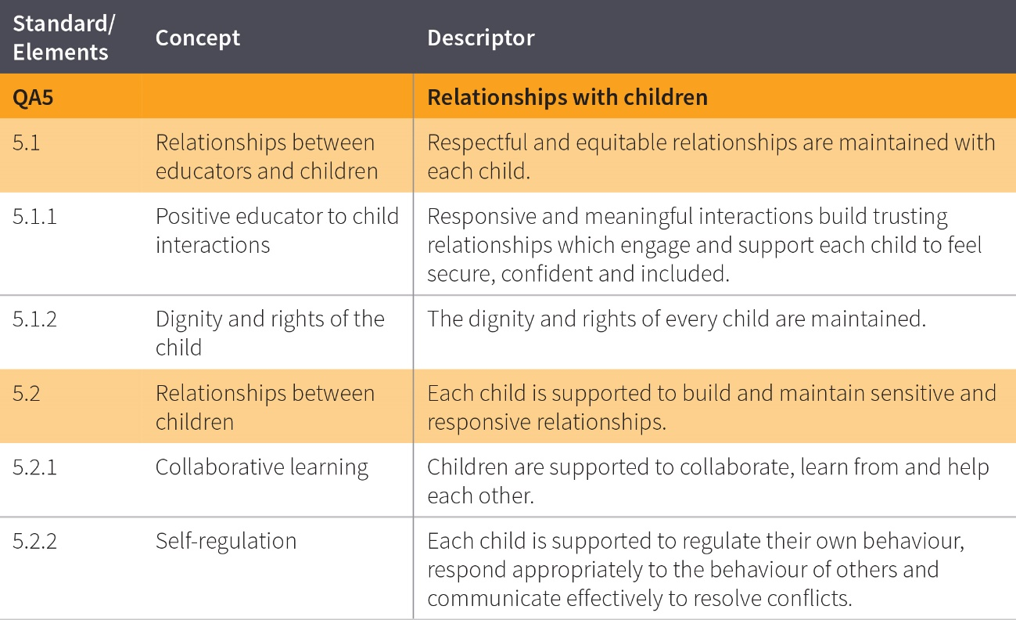

The table below shows the sections of the National Law and National Regulations underpinning Quality Area 5 and lists the most relevant element of the NQS associated with each section (S) and regulation (R). Please note that this table serves as a guide only and regulatory authorities have flexibility in how they assign non-compliance with the National Law and National Regulations against the quality areas, standards and elements of the NQS.

Quality Area 5 – Relationships with children

**Comparison between current and revised NQS- QA1**

| **National Law and  National Regulations** | | **Associated element** | **Self-assessed status** | **Actions if non-compliant** |
| --- | --- | --- | --- | --- |
| S.166 | Offence to use inappropriate discipline | 5.1.1  5.1.2  5.2.2 | Compliant  Non-compliant |  |
| R.155 | Interactions with children | 5.1.1  5.1.2  5.2.2 | Compliant  Non-compliant |  |
| R.156 | Relationships in groups | 5.2.2 | Compliant  Non-compliant |  |

Identify if the service meets the requirements of Quality Area 5: Relationships with children. Relationships that are responsive, respectful and promote children’s sense of security and belonging free them to explore the environment and engage in learning.

Quality Area 5 – Relationships with children

**Comparison between current and revised NQS- QA1**

**Standard 5.1: Respectful and equitable relationships are maintained with each child**

|  |  |  |  |  |  |
| --- | --- | --- | --- | --- | --- |
| **Concept** | **Element** | | **Evidence of practice from self-assessment** | **Met** | **Not Met** |
| Positive educator to child interactions | 5.1.1 | Responsive and meaningful interactions build trusting relationships which engage and support each child to feel secure, confident and included. |  |  |  |
| Dignity and rights of the child | 5.1.2 | The dignity and rights of every child are maintained. |  |  |  |

**Standard 5.2: Each child is supported to build and maintain sensitive and responsive relationships.**

|  |  |  |  |  |  |
| --- | --- | --- | --- | --- | --- |
| **Concept** | **Element** | | **Evidence of practice from self-assessment** | **Met** | **Not Met** |
| Collaborative learning | 5.2.1 | Children are supported to collaborate, learn from and help each other. |  |  |  |
| Self-regulation | 5.2.2 | Each child is supported to regulate their own behaviour, respond appropriately to the behaviour of others and communicate effectively to resolve conflicts. |  |  |  |

**Practices that meet or exceed the expectations of the NQS**

**Identified strengths and improvement opportunities**

**Comparison between current and revised NQS- QA1**

**Quality Area 5: Service strengths**

|  |  |  |
| --- | --- | --- |
|  | | |
| **Practice identified that meet the Exceeding NQS themes** | | |
| Practice is embedded in service operations. | Practice is informed by critical reflection. | Practice is shaped by meaningful engagement with families and/or the community. |
|  |  |  |

**Continuous improvement opportunities**

**Quality Area 5: Areas for improvement**

|  |  |
| --- | --- |
| **Standard or element** | **Areas for improvement as identified in self-assessment** |

|  |  |
| --- | --- |
|  |  |
|  |  |
|  |  |

Quality Area 6 – Collaborative partnerships with families and communities

Quality Area 6 focuses on supportive, respectful relationships with families which are fundamental to achieving quality outcomes for children. Community partnerships that are based on active communication, consultation and collaboration also contribute to children’s inclusion, learning and wellbeing.

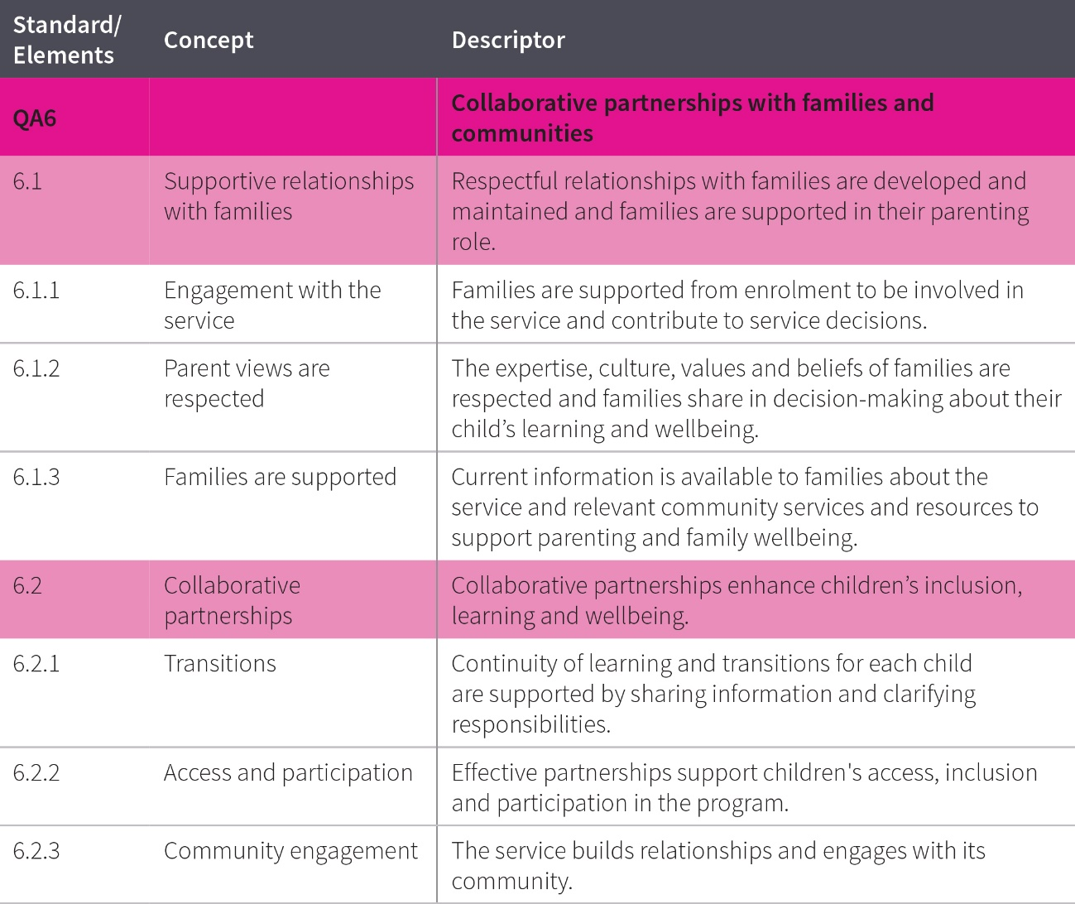

The table below shows the sections of the National Law and National Regulations underpinning Quality Area 6 and lists the most relevant element of the NQS associated with each section and regulation. Please note that this table serves as a guide only and regulatory authorities have flexibility in how they assign non-compliance with the National Law and National Regulations against the quality areas, standards and elements of the NQS.

Quality Area 6 – Legislative requirements

**Comparison between current and revised NQS- QA1**

| **National Law and  National Regulations** | | **Associated element** | **Self-assessed status** | **Actions if non-compliant** |
| --- | --- | --- | --- | --- |
| S.175 | Offence relating to requirement to keep enrolment and other documents | 6.1.3  6.2.1 | Compliant  Non-compliant |  |
| R.157 | Access for parents | 6.1.1 | Compliant  Non-compliant |  |

Identify if the service meets the requirements of Quality Area 6: Collaborative partnerships with families and communities. Collaborative relationships with families are fundamental to achieve quality outcomes for children. Community partnerships that focus on active communication, consultation and collaboration also contribute to children’s learning and wellbeing.

Quality Area 6 – Collaborative partnerships with families and communities

**Comparison between current and revised NQS- QA1**

**Standard 6.1: Respectful relationships with families are developed and maintained and families are supported in their parenting role.**

|  |  |  |  |  |  |
| --- | --- | --- | --- | --- | --- |
| **Concept** | **Element** | | **Identified practice/evidence from  self-assessment** | **Met** | **Not Met** |
| Engagement with the service | 6.1.1 | Families are supported from enrolment to be involved in the service and contribute to service decisions. |  |  |  |
| Parent views are respected | 6.1.2 | The expertise, culture, values and beliefs of families are respected and families share in decision-making about their child’s learning and wellbeing. |  |  |  |
| Families are supported | 6.1.3 | Current information is available to families about the service and relevant community services and resources to support parenting and family wellbeing. |  |  |  |

**Standard 6.2Collaborative partnerships: Collaborative partnerships enhance children’s inclusion, learning and wellbeing.**

|  |  |  |  |  |  |
| --- | --- | --- | --- | --- | --- |
| **Concept** | **Element** | | **Identified practice/evidence from  self-assessment** | **Met** | **Not Met** |
| Transitions | 6.2.1 | Continuity of learning and transitions for each child are supported by sharing information and clarifying responsibilities. |  |  |  |
| Access and participation | 6.2.2 | Effective partnerships support children's access, inclusion and participation in the program. |  |  |  |
| Community engagement | 6.2.3 | The service builds relationships and engages with its community. |  |  |  |

**Practices that meet or exceed the expectations of the NQS**

**Identified strengths and improvement opportunities**

**Comparison between current and revised NQS- QA1**

**Quality Area 6: Service strengths**

|  |  |  |
| --- | --- | --- |
|  | | |
| **Practice identified that meet the Exceeding NQS themes** | | |
| Practice is embedded in service operations. | Practice is informed by critical reflection. | Practice is shaped by meaningful engagement with families and/or the community. |
|  |  |  |

**Continuous improvement opportunities**

**Quality Area 6: Areas for improvement**

|  |  |
| --- | --- |
| **Standard or element** | **Areas for improvement as identified in self-assessment** |

|  |  |
| --- | --- |
|  |  |
|  |  |
|  |  |

Effective leadership contributes to sustained quality relationships and environments that facilitate children’s learning and development. Well documented policies and practices that are developed and regularly evaluated in partnership with educators, co ordinators, staff members and families contribute to the ethical management of the service. There is a focus on continuous improvement.

Quality Area 7 – Governance and leadership

**Comparison between current and revised NQS- QA1**

Quality Area 7 focuses on effective leadership and governance of the service to establish and maintain quality environments for children’s learning and development. Effective leaders establish shared values for the service that reflect the service context and professionalism and set clear direction for the service’s continuous improvement. Governance refers to the systems in place to support effective management and operation of the service, consistent with the service’s statement of philosophy.

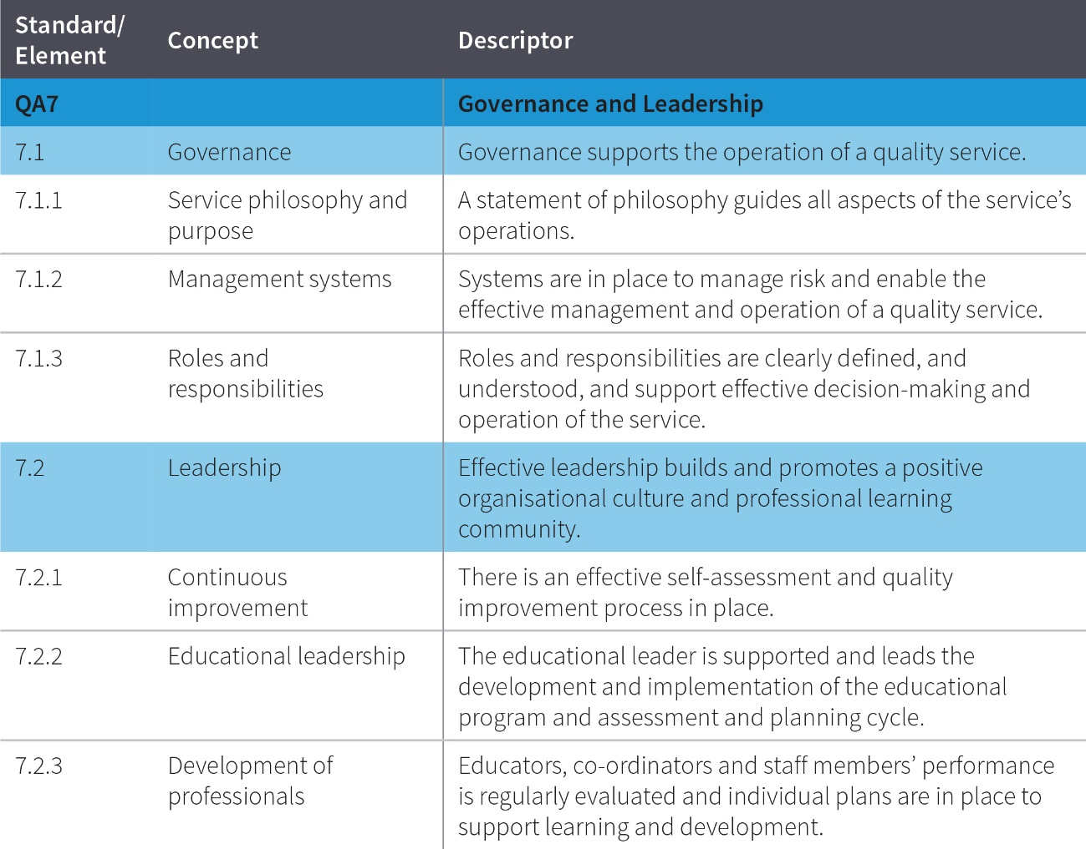

The table below shows the sections of the National Law and National Regulations underpinning Quality Area 7 and lists the most relevant element of the NQS associated with each section (S) and regulation (R). Please note that this table serves as a guide only and regulatory authorities have flexibility in how they assign non-compliance with the National Law and National Regulations against the quality areas, standards and elements of the NQS.

Quality Area 7 – Legislative requirements

**Comparison between current and revised NQS- QA1**

| **National Law and  National Regulations** | | **Associated element** | **Self-assessed status** | **Actions if non-compliant** |
| --- | --- | --- | --- | --- |
| S.21 | | Reassessment of fitness and propriety (provider approvals) | 7.1.2 | Compliant  Non-compliant |  |
| S.51(2) | | Conditions on service approval (FDC co-ordinators) | 7.1.2, 7.1.3 | Compliant  Non-compliant |  |
| S.56 | | Notice of addition of nominated supervisor | 7.1.2 | Compliant  Non-compliant |  |
| S.56A | | Notice of change of a nominated supervisor's name or contact details | 7.1.2 | Compliant  Non-compliant |  |
| S.161 | | Offence to operate education and care service without nominated supervisor | 7.1.2 | Compliant  Non-compliant |  |
| S.161A | | Offence for nominated supervisor not to meet prescribed minimum requirements | 7.1.2 | Compliant  Non-compliant |  |
| S.162 | | Offence to operate education and care service unless responsible person is present | 7.1.2 | Compliant  Non-compliant |  |
| S.162A | | Persons in day-to-day charge and nominated supervisors to have child protection training | 7.1.2 | Compliant  Non-compliant |  |
| S.163 | | Offence relating to appointment or engagement of family day care co-ordinators | 7.1.2, 7.1.3 | Compliant  Non-compliant |  |
| S.164 | | Offence relating to assistance to family day care educators | 7.1.2 | Compliant  Non-compliant |  |
| S.164A | | Offence relating to the education and care of children by family day care service | 7.1.2, 7.1.3 | Compliant  Non-compliant |  |
| S.165 | | Offence to inadequately supervise children | 7.1.2 | Compliant  Non-compliant |  |
| S.166 | | Offence to use inappropriate discipline | 7.1.2 | Compliant  Non-compliant |  |
| S.167 | | Offence relating to protection of children from harm and hazards | 7.1.2 | Compliant  Non-compliant |  |
| S.168 | | Offence relating to required programs | 7.1.2 | Compliant  Non-compliant |  |
| S.169 | | Offence relating to staffing arrangements | 7.1.2 | Compliant  Non-compliant |  |
| S.170 | | Offence relating to unauthorised persons on education and care service premises | 7.1.2 | Compliant  Non-compliant |  |
| S.171 | | Offence relating to direction to exclude inappropriate persons from education and care service premises | 7.1.2 | Compliant  Non-compliant |  |
| S.172 | | Offence to fail to display prescribed information | 7.1.2 | Compliant  Non-compliant |  |
| S.173 | | Offence to fail to notify certain circumstances to regulatory authority | 7.1.2 | Compliant  Non-compliant |  |
| S.174 | | Offence to fail to notify certain information to regulatory authority | 7.1.2 | Compliant  Non-compliant |  |
| S.174A | | Family day care educator to notify certain information to approved provider | 7.1.2, 7.1.3 | Compliant  Non-compliant |  |
| S.175 | | Offence relating to requirement to keep enrolment and other documents | 7.1.2 | Compliant  Non-compliant |  |
| S.188 | | Offence to engage person to whom prohibition notice applies | 7.1.2 | Compliant  Non-compliant |  |
| S.269 | | Register of family day care educators, coordinators and assistants | 7.1.2 | Compliant  Non-compliant |  |
| R.31 | | Condition on service approval-quality improvement plan | 7.2.1 | Compliant  Non-compliant |  |
| R.55 | | Quality improvement plans | 7.2.1 | Compliant  Non-compliant |  |
| R.56 | | Review and revision of quality improvement plans | 7.2.1 | Compliant  Non-compliant |  |
| R.158 | | Children’s attendance record to be kept by approved provider | 7.1.2 | Compliant  Non-compliant |  |
| R.159 | | Children’s attendance record to be kept by family day care educator | 7.1.2 | Compliant  Non-compliant |  |
| R.160 | | Child enrolment records to be kept by approved provider and family day care educator | 7.1.2 | Compliant  Non-compliant |  |
| R.161 | | Authorisations to be kept in enrolment record | 7.1.2 | Compliant  Non-compliant |  |
| R.162 | | Health information to be kept in enrolment record | 7.1.2 | Compliant  Non-compliant |  |
| R.163 | | Residents at family day care residence and family day care educator assistants to be fit and proper persons | 7.1.2 | Compliant  Non-compliant |  |
| R.164 | | Requirement for notice of new persons at residence | 7.1.2 | Compliant  Non-compliant |  |
| R.165 | | Record of visitors | 7.1.2 | Compliant  Non-compliant |  |
| R.166 | | Children not to be alone with visitors | 7.1.2 | Compliant  Non-compliant |  |
| R.167 | | Record of service’s compliance | 7.1.2 | Compliant  Non-compliant |  |
| R.168 | | Education and care service must have policies and procedures | 7.1.2 | Compliant  Non-compliant |  |
| R.169 | | Additional policies and procedures—family day care service | 7.1.2 | Compliant  Non-compliant |  |
| R.170 | | Policies and procedures to be followed | 7.1.2 | Compliant  Non-compliant |  |
| R.171 | | Policies and procedures to be kept available | 7.1.2 | Compliant  Non-compliant |  |
| R.172 | | Notification of change to policies or procedures | 7.1.2 | Compliant  Non-compliant |  |
| R.173 | | Prescribed information to be displayed | 7.1.2 | Compliant  Non-compliant |  |
| R.174 | | Time to notify certain circumstances to regulatory authority | 7.1.2 | Compliant  Non-compliant |  |
| R.174A | | Prescribed information to be notified to accompany notice | 7.1.2 | Compliant  Non-compliant |  |
| R.175 | | Prescribed information to be notified to regulatory authority | 7.1.2 | Compliant  Non-compliant |  |
| R.176 | | Time to notify certain information to regulatory authority | 7.1.2 | Compliant  Non-compliant |  |
| R.176A | | Prescribed information to be notified to approved provider by family day care educator | 7.1.2 | Compliant  Non-compliant |  |
| R.177 | | Prescribed enrolment and other documents to be kept by approved provider | 7.1.2 | Compliant  Non-compliant |  |
| R.178 | | Prescribed enrolment and other documents to be kept by family day care educator | 7.1.2 | Compliant  Non-compliant |  |
| R.179 | | Family day care educator to provide documents on leaving service | 7.1.2 | Compliant  Non-compliant |  |
| R.180 | | Evidence of prescribed insurance | 7.1.2 | Compliant  Non-compliant |  |
| R.181 | | Confidentiality of records kept by approved provider | 7.1.2 | Compliant  Non-compliant |  |
| R.182 | | Confidentiality of records kept by family day care educator | 7.1.2 | Compliant  Non-compliant |  |
| R.183 | | Storage of records and other documents | 7.1.2 | Compliant  Non-compliant |  |
| R.184 | | Storage of records after service approval transferred | 7.1.2 | Compliant  Non-compliant |  |
| R.185 | | Law and regulations to be available | 7.1.2 | Compliant  Non-compliant |  |
| R.344  Tasmania | | Working with vulnerable people registration – staff members | 7.1.2 | Compliant  Non-compliant |  |
| R.358  Victoria | | Working with children check to be read | 7.1.2 | Compliant  Non-compliant |  |
| R.359  Victoria | | Criminal history record check to be read and considered | 7.1.2 | Compliant  Non-compliant |  |

Identify if the service meets the requirements of Quality Area 7: Governance and Leadership. Effective leadership contributes to sustained quality relationships and environments that facilitate children’s learning and development. Well documented policies and practices that are developed and regularly evaluated in partnership with educators, co-ordinators, staff members and families contribute to the ethical management of the service. There is a focus on continuous improvement.

Quality Area 7 – Governance and leadership

**Comparison between current and revised NQS- QA1**

**Standard 7.1: Governance supports the operation of a quality service.**

|  |  |  |  |  |  |
| --- | --- | --- | --- | --- | --- |
| **Concept** | **Element** | | **Identified practice/evidence from  self-assessment** | **Met** | **Not Met** |
| Service philosophy and purpose | 7.1.1 | A statement of philosophy guides all aspects of the service’s operations. |  |  |  |
| Management systems | 7.1.2 | Systems are in place to manage risk and enable the effective management and operation of a quality service. |  |  |  |
| Roles and responsibilities | 7.1.3 | Roles and responsibilities are clearly defined, and understood, and support effective decision-making and operation of the service. |  |  |  |

**Standard 7.2: Effective leadership builds and promotes a positive organisational culture and professional learning community.**

|  |  |  |  |  |  |
| --- | --- | --- | --- | --- | --- |
| **Concept** | **Element** | | **Identified practice/evidence from  self-assessment** | **Met** | **Not Met** |
| Continuous improvement | 7.2.1 | There is an effective self-assessment and quality improvement process in place. |  |  |  |
| Educational leadership | 7.2.2 | The educational leader is supported and leads the development and implementation of the educational program and assessment and planning cycle. |  |  |  |
| Development of professionals | 7.2.3 | Educators, co-ordinators and staff members’ performance is regularly evaluated and individual plans are in place to support learning and development. |  |  |  |

**Practices that meet or exceed the expectations of the NQS**

**Identified strengths and improvement opportunities**

**Comparison between current and revised NQS- QA1**

**Quality Area 7: Service strengths**

|  |  |  |
| --- | --- | --- |
|  | | |
| **Practice identified that meet the Exceeding NQS themes** | | |
| Practice is embedded in service operations. | Practice is informed by critical reflection. | Practice is shaped by meaningful engagement with families and/or the community. |
|  |  |  |

**Continuous improvement opportunities**

**Quality Area 7: Areas for improvement**

|  |  |
| --- | --- |
| **Standard or element** | **Areas for improvement as identified in self-assessment** |

|  |  |
| --- | --- |
|  |  |
|  |  |
|  |  |

**Attachment A** – Self-assessment against the Exceeding NQS themes activity is a useful resource to support reflection on service practice and how it aligns with the [Exceeding NQS themes](https://www.acecqa.gov.au/assessment/exceeding-nqs). The Exceeding NQS reflection activity can be used for any standard of the NQS.

**Self-assessment against the Exceeding NQS themes activity**

**Comparison between current and revised NQS- QA1**

You can print the double-sided activity on pp. 77-78 or visit the [ACECQA website](https://www.acecqa.gov.au/resources/supporting-materials/games#ENQS) for a [free PDF download](https://www.acecqa.gov.au/media/27466).

