Worksheet 1 – Critical thinking - Reflective practice

Your Task

To better understand your own learning journey, it is useful to be able to evaluate what you have heard, seen, experienced, and your responses to these. This process enables you to look at your responses to your situation, and critically evaluate how you could continue to implement effective behaviours, or moderate and improve in others.

For example, you may have submitted an assignment on time and received an excellent grade. You can ask your self what measures you put in place to achieve this, so that you can repeat this for future tasks. Alternatively, you may have missed a couple of classes, submitted an assignment late and under the word count, and failed. What went wrong? If you can evaluate the process, you can decide what you need to change and plan accordingly.

Gibbs (1988) designed the reflective cycle below, which lays out the steps clearly, and is easy to follow.

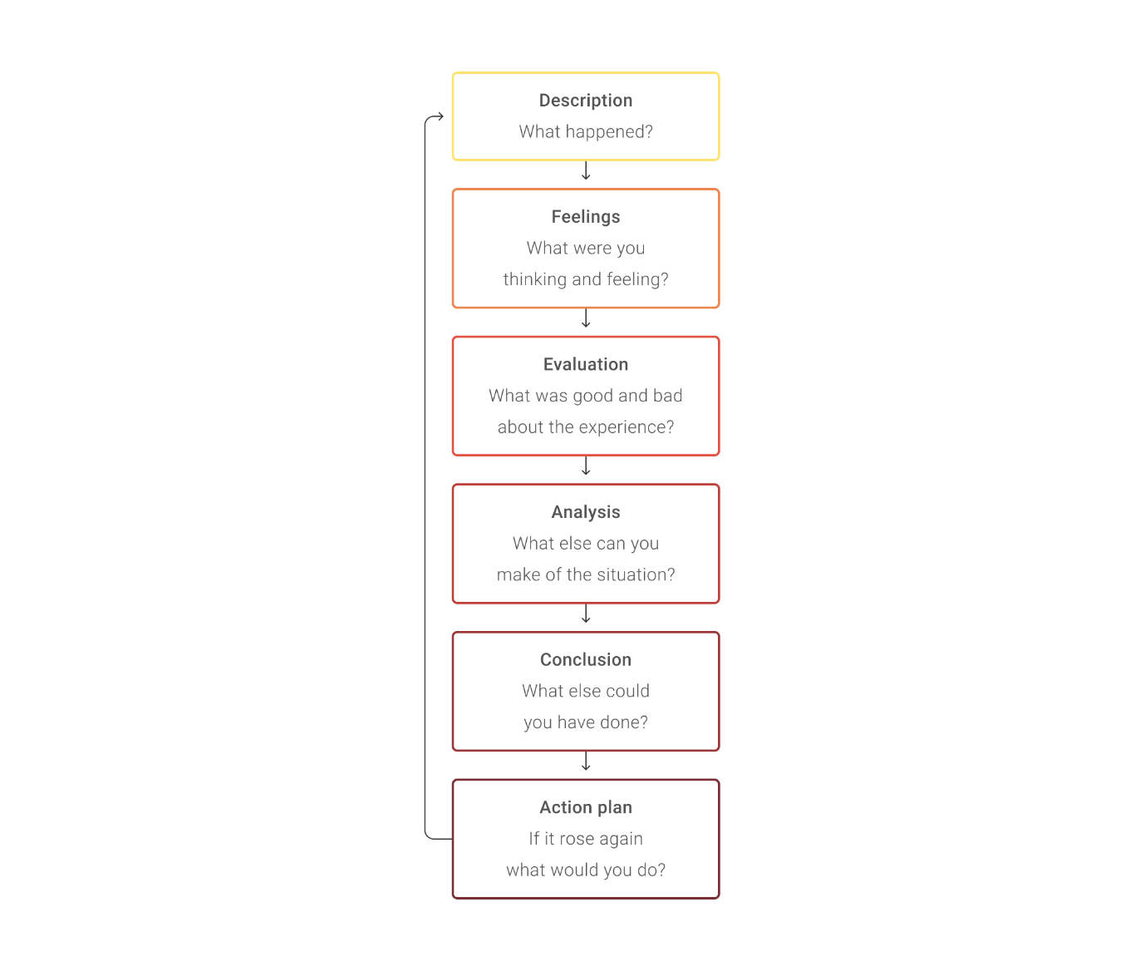

Adapted from *Learning by doing: a guide to teaching and learning methods,* by G Gibbs1988, CopyrightOxford Polytechnic.

The best way to start is at the top, with a concise description of a situation. At each stage, answer the questions below:

1. What happened?
2. What did I think at the time?
3. How was I feeling at the time?
4. What was good about the experience?
5. What was bad about the experience?
6. What else stands out for you in this experience?
7. What else could I have done?
8. What will I do if this happens again?

It is important to separate out your thoughts and your feelings, as feelings can be emotions such as stress, dismay, happiness, whereas thoughts are more deliberate e.g. ‘What do I do now?’ or ‘Where can I find the information I need?’ You also need to be honest with yourself.

In completing a reflective piece of writing, you must use the first person, ‘I’, as this is personal, about you, and no-one else. You can use your reflection to give advice to others later, but in the first instance, you are focusing on yourself, your own situation, your response and your learning.

Consider the text from a student below:

‘While on a tube at the river we came across a chicken that had escaped from a houseboat and was swimming towards shore, so I jumped in to rescue it. While returning it to the houseboat I was focusing on swimming and I didn’t realize I'd dunked the chicken under water for a few seconds until someone yelled out to me. Feeling embarrassed I internally beat myself up for focusing on being the heroine as opposed to completing the task with utmost attention. Luckily, the chicken was only a little ruffled, and I returned him safely. This experience reiterated to me the importance of not focusing solely on an end goal but paying attention to details and my surroundings. While this situation is unlikely to occur again, I can apply its teachings of keeping focus on what is important, and not dreaming of being the heroine, but completing tasks properly and to my utmost ability.’

White, A March 17 2021, personal communication.

Activity 1:

Split the story above to answer the questions posed in the reflective cycle. Set this out below.

1. What happened?
2. What did I think at the time?
3. How was I feeling at the time?
4. What was good about the experience?
5. What was bad about the experience?
6. What else stands out for you in this experience?
7. What else could I have done?
8. What will I do if this happens again?

Activity 2:

Use the cycle to reflect on your learning from Week 1 of the BBUS course. Add this as part of the learning forum activities and read through other class members’ posts to evaluate how they have responded to each part of the cycle.